Cardiff Metropolitan University
Report of the Catering & Hospitality Services Manager
Drinking Water
Drinking water is available across all catering outlets on campus either by mains fed water fonts or the hydra chill water vending machines providing free water for staff and students.
In total there are 14 hydra chill machines in total located in catering areas and social spaces spread across two campuses.
See link below for further evidence
http://www.hydrachill.com/news6.html

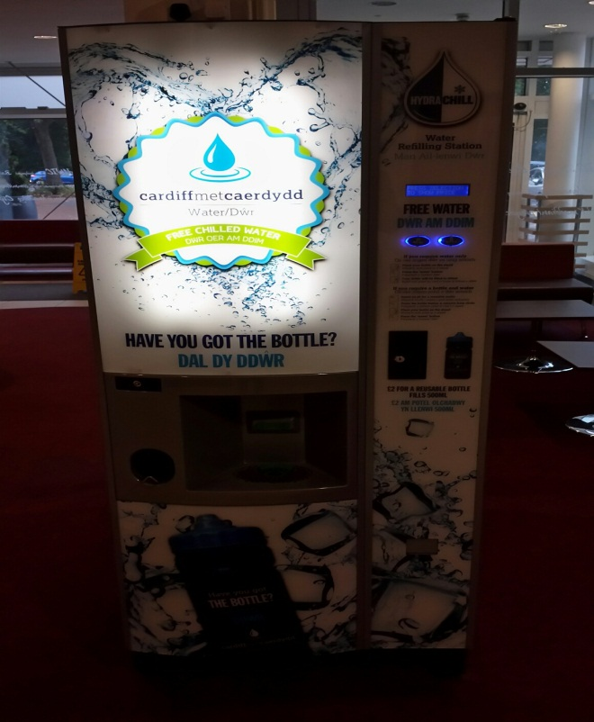
We have also introduced a bottled 'mains fed' water system for bottled water used in the hospitality service .

We are also developing a Keep a cup style reusable coffee mug launching in early September to reduce the amount paper cups used on campus.
Andrew Phelps
Catering & Hospitality Services Manager

