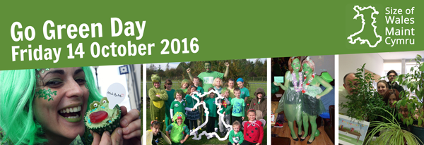
Plans for GO Green Day 14th October 2016 - Stalls – Llandaff Campus, CSM Atrium
*staff / student volunteers required to assist
 | Activity | Location | Time
1 | Cycle Training Wales – Bike MOT (donation requested for charity) | Front of M Block and Rear of CSAD | 11am – 2pm
2 | Police bike marking (donation requested for charity) | Front of M Block and Rear of CSAD | 11am – 2pm
3 | Fairtrade promotion –  Is it or isn’t it ?  Fairtrade chocolate testing | CSM – Atrium | 10am – 3pm
4 | Smalls for All  (donation of unwanted bras and new pants for charity) | CSM – Atrium | 10am – 3pm
5 | Cardiff Met – Waste awareness – pledge tree and waste board game | CSM – Atrium | 10am – 3pm
6 | Sustainable Travel  (promotion of metrider and Bikes – purchase raffle tickets to win a staff or student metrider annual pass) | CSM – Atrium | 10am – 3pm
7 | Cardiff Met – Catering Service – sale of re-usable cups, water bottles. Food samples | CSM – Atrium | 10am – 3pm
8 | Community Garden | CSM – Atrium | 10am – 3pm
9 | Smart water promotion | CSM – Atrium | 10am – 3pm
10 | Gavin Jones – Grounds maintenance contractor – Bird Boxes (donation to charity required) | CSM – Atrium | 10am – 3pm
11 | Sustainable Campus | CSM – Atrium | 10am – 3pm
12 | Environmental Champions / Cardiff Digs | CSM – Atrium | 10am – 3pm
13 | Cynnal Cymru – promotion of Business Leadership for Sustainable Development Course | CSM – Atrium | 10am – 3pm
14 | Cardiff Met Catering – Freebies. Green smoothies - shot samples | CSM – Atrium | 10am – 3pm
15 * | Bag packing Tesco Western Avenue to fund raise for Size of Wales | Tesco – Western Ave | 10am – 3pm
16 | Community Garden Lecture | CSM – O0.20 | 12 noon for 30 mins
17 * | Cardiff Digs – Student / staff litter picking | Perimeter of Llandaff Campus | 11.30am - 1.30pm
18 | SU – Sustainable Thinking – Cardiff Met award | CSM – Atrium | 10am – 3pm
19 | Tour to Viridor plant | Names to be collected on 14/10/16 | 7/11/16, 13.30 – 15.30
20 | Energy Awareness – Elec buzzer machine, light bulbs available for charity donation and pledge | CSM – Atrium | 10am – 3pm
21 | Cardiff Council Waste  Management – staff and student awareness of waste in the Cardiff area | CSM – Atrium | 10am – 3pm
22 | Love Food, Hate Waste / WRAP | CSM – Atrium | 10am – 3pm
23 | Natural Dye Garden | CSM – Atrium | 10am – 3pm
24 | Introduction to Dye Garden Talk | CSM – O0.20 | 12.45 for 30 mins
25 | Residence Life | CSM – Atrium | 10am – 3pm
26 | Centralised Print promotion – raffle for bike locks | CSM – Atrium | 10am – 3pm
27 | Equality and Diversity | CSM – Atrium | 10am – 3pm
28 | Size of Wales | CSM – Atrium | 10am – 3pm

