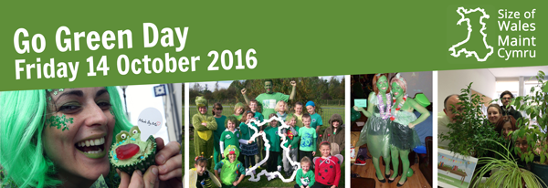
Every October Size of Wales runs Go Green Day and asks businesses throughout Wales to join in and help protect an area of tropical forest the size of Wales. Cardiff Metropolitan is promoting Healthy University - Go Green Day, on 14th October, 2016 at Llandaff Campus.
All money raised will be doubled by Size of Wales. This year Cynnal Cymru – Sustain Wales and the Size of Wales are working in partnership to promote Go Green Day. There are lots of activities planned, fundraising, raffles, samples, lectures, awareness and volunteering opportunities to get involved.
Any queries, please contact, Sustainability@cardiffmet.ac.uk
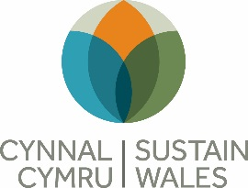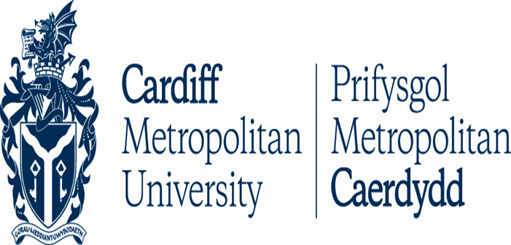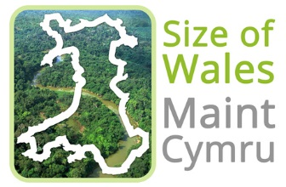
FUNDRAISING FOR Size of Wales CHARITY no. 1143178

