I have lived all my life in the city of Irpin, which is near Kyiv in Ukraine, but in May 2022 I moved to Wales due to the ongoing war in my homeland. The war disrupted my peaceful life and forced me to seek refuge in a safer environment. My city was occupied and was subject to heavy shelling, as a result of which about half of the residential buildings and infrastructure were destroyed.
I moved to Wales under the Homes for Ukrainian scheme, which helped me find my host family. I really like life here, the Welsh are amazing people, very kind and smiling. Many people were ready to help in case of anything, for which I am still very grateful.
At the start of the war, I was studying at Kyiv University, but unfortunately, I could no longer continue to study there. Then I found out about a grant that would help me pay for my studies in Cardiff and decided to go to university. This was not an easy decision for me as I did not know the application processes and was also worried whether I would be able to study, since English is not my first language. But the people who met me along the way were always happy to help me. Now I am already in my second year of university, I really like it here and I am incredibly grateful that I am studying here.
My experience in Wales has been marked by the support and understanding of the local community. Shelter initiatives as well as other assistance have played an important role in helping me rebuild my life.
Looking to the future, my goals include integrating into the local community, making a positive contribution and taking advantage of the educational opportunities the country provides. As I continue my journey, I am grateful for the support I have received and am optimistic about the future.
This is the view from my window. My friend used to live in that house, with whom we often played in the yard, and I also remember how we played hide and seek in the entrance of that house. Now, unfortunately, it is impossible to live there now, but I still have good memories.
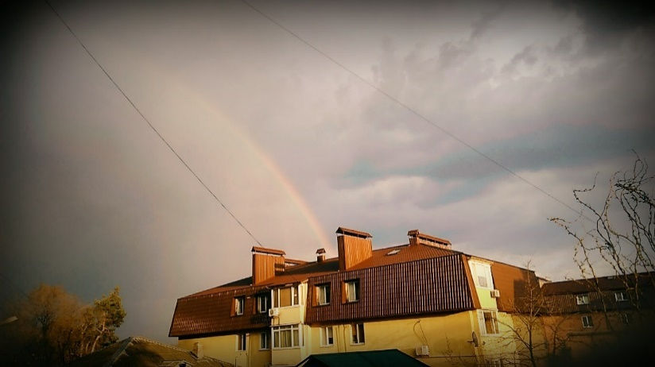
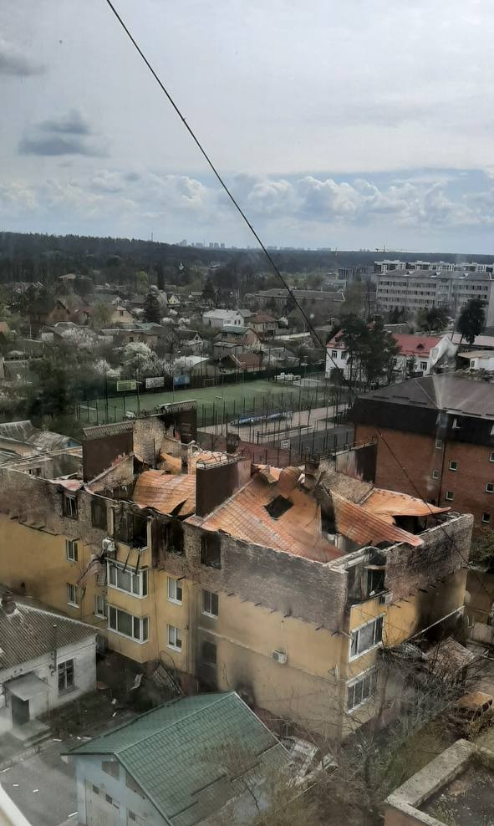

This photo is associated with peace and kindness. It was taken when I first arrived in Wales and it was in this place that I finally felt peace and tranquility.

