CARDIFF METROPOLITAN UNIVERSITY
Academic Year 2016/2017

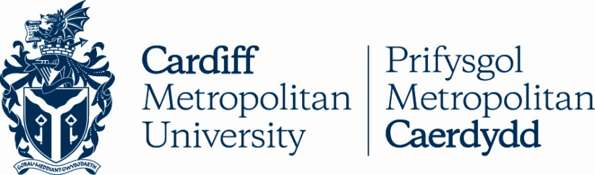

Name of Institution: | Cardiff Metropolitan University
Erasmus University Charter Code: | UK CARDIFF 05
European Erasmus  Co-ordinator: | Ms Rowena Walters  00 44 2920 416034  Erasmus@cardiffmet.ac.uk
Relevant Websites: | http://www.cardiffmet.ac.uk/international/erasmus/keyaction1/Pages/default.aspx  www.cardiffmet.ac.uk
Inter-Institutional Agreement | http://www.cardiffmet.ac.uk/international/erasmus/keyaction1/Pages/Inter-institutional-Agreement.aspx
Application Procedure: | http://www.cardiffmet.ac.uk/international/erasmus/keyaction1/Pages/Incoming-Students.aspx
Deadline dates for Academic Year 2016/2017: | Application Deadline for students wanting to study in September 2016 – 1st May 2016  Application Deadline for students wanting to study in January 2017  – 10th October 2016
Cardiff Met Term Dates | http://www.cardiffmet.ac.uk/registry/Pages/Term-Dates.aspx
Is Housing Provided? | All accepted incoming Erasmus students must find their own accommodation. Further information can be found on:-  http://www.cardiffmet.ac.uk/accommodation/Pages/default.aspx

