CARDIFF METROPOLITAN UNIVERSITY
Academic Year 2020/2021

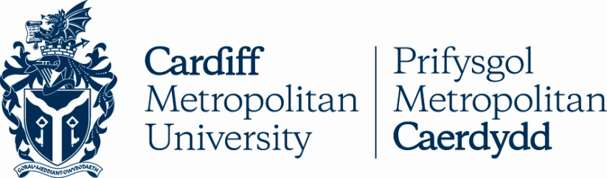

Name of Institution: | Cardiff Metropolitan University
Erasmus University Charter Code: | UK CARDIFF 05
Global Opportunities Manager | Ms Rowena Kidger  00 44 2920 416034  Incominexchange@cardiffmet.ac.uk
Relevant Websites: | http://www.cardiffmet.ac.uk/international/erasmus/keyaction1/Pages/default.aspx  www.cardiffmet.ac.uk
Inter-Institutional Agreement | http://www.cardiffmet.ac.uk/international/erasmus/keyaction1/Pages/Inter-institutional-Agreement.aspx
Application Procedure: | http://www.cardiffmet.ac.uk/international/erasmus/keyaction1/Pages/Incoming-Students.aspx
Deadline dates for Academic Year 2020/2021: | Application Deadline for students wanting to study in September 2020 –  1st May 2020  Application Deadline for students wanting to study in January 2021 -  15th October 2020
Cardiff Met Term Dates | http://www.cardiffmet.ac.uk/registry/Pages/Term-Dates.aspx
Is Housing Provided? | All accepted incoming Erasmus students must find their own accommodation. Further information can be found on:-  http://www.cardiffmet.ac.uk/accommodation/Pages/default.aspx

