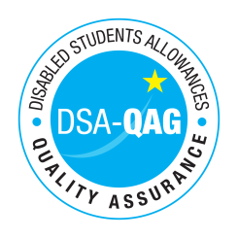
Cardiff Metropolitan University - NMH Rates

Period covered - 01/04/2016 through to 31/03/2017

The table below shows NMH rates. The greyed out cells indicate that the NMH provider does not offer these services.

Note: NMH Support Rates shown per hour in the table below.
Band 1 Support Assistants | Net | VAT | Total
Practical Support Assistant | £16.68 | £0.00 | £16.68
Library Support Assistant |  |  | £16.68
Reader | £16.68 | £0.00 | £16.68
Scribe | £16.68 | £0.00 | £16.68
Workshop / Laboratory Assistant | £16.68 | £0.00 | £16.68
Sighted Guide
Proof Reader
Band 2 Enhanced Support Assistants
Study Assistant |  |  | £16.68
Examination Support Worker |  |  | £16.68
Manual Note Taker | £16.68 | £0.00 | £16.68
Band 3 Specialist Enabling Support
Communication Support Worker
Electronic Note taker
Specialist Transcription Services
Mobility Trainer
Band 4 Specialist Access and Learning Facilitators
Specialist Mentor (Autism Spectrum Connections Cymru) |  |  | £31.95
Specialist One to One Study Skills Support | £53.00 | £0.00 | £53.00
BSL Interpreter
Language Support Tutor for deaf students
Assistive Technology Trainer | £53.00 | £0.00 | £53.00

