Community of Practice | Quality Enhancement

Re-cap –providing background / Context

The introduction should briefly re-cap why the university is interested in exploring student engagement.

It would also be useful to re-cap on the meetings that have taken place so far and to give an overview of the discussion held and the materials used (outlined below).

The purpose of this meeting is to consider the work undertaken so far by academic colleagues and structure a conversation with students that provides opportunity for them to input and shape any future direction.

The context for this is to recognise the importance of the student voice and increasingly there is a drive in the UK to co-design the curriculum with students.

These points are relevant to both those modules taught with international providers and those modules taught as part of the national programme.

Materials:

- Slides from workshop “Students as partner”
- Aligning teaching for constructing learning (John Biggs)
- Syllabus of Modules:
Student Engagement:
There are three mini conversations which might be useful to have with the students:

- Introduction to CoP and Student Engagement in the Curriculum

Introduce the importance of student engagement and working with students as partners.

It is important to set the context and also to use this opportunity to think of students as active learners and partners.
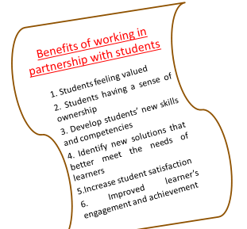
You may wish to use the slides from the workshop as a guide.

.

- Student Engagement Shaping the Learning and Teaching Environment
This can then lead into an introduction on “constructive alignment” so that students are aware of its purpose. It is important for constructive alignment to provide a frame of reference so that the three points of the learning environment -ILO / Assessment / Learning Activities- are always aligned.

Thus as you think about making changes or doing things differently, the concept of constructive alignment can be used as a tool to ‘check and challenge’.

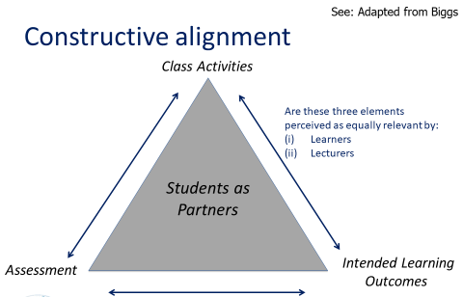

This should then lead into a discussion around learning activities and perhaps assessment. This would be especially useful as the initial surveys and scoping revealed that teaching seems more ‘teacher-led’ and perhaps rather reliant on power point presentations, case studies and group discussions.

It would be beneficial to discuss other ways in which the learning experience could be delivered, and the desire to achieve ‘deep learning’. An example of some of these areas which were discussed in the project are below.

It would also be beneficial to discuss this with students in relation to the modules discussed in Workshop 2 at the same time as retaining constructive alignment as a relevant frame of reference

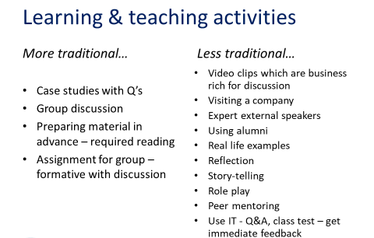

It would be good to discuss some of the suggestions included but there are many more ways of engaging students as active learners. For example, what would happen if you didn’t use power point in some lectures – how would the lecturer feel and how would the student feel? Role play has been raised and this would be interesting alongside consideration of group posters, group projects, exhibition and role play.

An issue you may wish to consider as part of the conversation is developing an understanding of the type of activities for L&T and / or assessment (as indicated above) compared to developing a philosophy of learning that is student centred and seeks to create deep learning. Developing autonomous learners is about students learning independently and outside of the classroom and creating the opportunity for students to be stimulated to spend their study time productively. This may be an issue to consider in a separate session but you may find the discussion naturally moves in this direction.

- Student Engagement and Wider Context
The third discussion area to raise with students (if there is time) would be to consider some of the themes identified as part of the CoP that include (i) graduate employability and (ii) local cultural context.
The reference points for this mini conversation are the surveys undertaken and the workshop on Student Skills for Employment. It may be useful to see whether the students present can see opportunities to develop the Learning and Teaching environment so that these two elements can be brought in more explicitly.
You may then want to develop some principles and these are then considered in relation to the different modules that you have. These themes may also offer the opportunity to develop context related examples as part of the teaching activities previously discussed.
