10th June 2022
Objective 1 - scoping report outlining the findings of the scoping exercises and outcomes of the desk-based review of national and institutional approaches to qualification benchmarking

Table of Contents

1. Introduction 3
2. Activity 1- A desk-based analysis of in-country and regional approaches to qualifications bench- marking in Viet Nam and UK (17 January – 28 January 2022) 4
2.1 UK National Approach to Qualifications Benchmarking 4
2.1.1 UK Regulation 4
2.1.2 Regulation in Wales 4
2.1.3 The Scope of UK Academic Quality 5
2.1.4 UK External Reference Points for Benchmarking Qualifications 5
2.2 Vietnamese National Approach to Qualifications Benchmarking 7
2.2.1 Meeting with QAA 25 January 2022 7
2.2.2 QAA Country Report 7
2.2.3 World Bank Report 8
2.2.4 ECCTIS 9
2.3 Conclusions 9
2.4 Next Steps 10
3. Activity 2- Confirming Programmes for Benchmarking Activities (17 January – 21 January 2022) 10
3.1 Survey to Determine Selection of Programmes 10
3.2. List of Selected Programmes 11
3.3 List of PhD Programmes Selected 11
4. Activity 3- Review of quality processes, programme approval processes, curriculum specifications and supporting material for the selected provision (24 January – 11 February 2022) 12
4.1 Validation/Programme Design and Approval 12
4.2 Programme Descriptors 13
5. Activity 4 – Analysis of survey of Academic Staff Gauging Perceptions and Knowledge of Quality Assurance and Professional Development Needs 14
5.1 Question 1 a-c: Institutional Rules for Programme Structures 14
5. 2 Question 2 a-c: Institutional Regulations for Undergraduate (Bachelor), Masters and Doctoral Programmes 16
5.3 Question 3a-c: Institutional Assessment Regulations 17
5.4 Question 4a-c: Institutional Degree Award Algorithms 18
5.5 Question 5a-b: National and International Reference Points 20
5.6 Question 6a-d: Procedure for Approving New Programmes 20
5.7 Question 7a-d: Guidance on the Design and Development of New Programmes 21
5.8 Question 8: Use of Internal Expertise in Developing New Programmes 22
5.9 Question 9: Use of External Expertise in Developing New Programmes 22
5.10 Question 10: Consulting with Students when Developing New Programmes 22
5.11 Conclusions about Responses to Questions 5-10 22
6. Summary of Possible Areas in Need of Development 23
6.1 Benchmarking: 23
6.2. Staff Development: 23
6.2.1 Quality Processes 23
6.2.2. Programme Approval Processes 23
Appendices 24
APPENDIX 1 24
Initial Survey Questions to Partner Quality Office Contacts 24
APPENDIX 2 25
Questions to Gauge Perceptions and Knowledge of Quality 25
APPENDIX 3a 26
Criteria for Survey of Partners to Confirm Selection of Programmes for Benchmarking Activities 26
APPENDIX 3b 26
Additional/Subsequent Survey Questions Focussed on PhD Provision at Vietnamese Partners 26
APPENDIX 4 27
Schedule and Coverage of 1-2-1 Meetings of Partners 27
APPENDIX 5 28
High-Level Processes of Approach to Validation 28

1. Introduction
In support of the Government of Viet Nam’s aim of raising quality standards within HE over the next 3 years to 2024 and the prioritisation of international education collaborations, the overarching aim of the EQUIP proposal aims to facilitate international recognition of Viet Nam HE qualifications by forging an enabling environment that supports the deepening of engagement in UK-Viet Nam TNE; creating an environment through which international collaborations in TNE and student mobility can flourish. The project will focus on enabling an environment of quality for international partnerships in the field of Artificial Intelligence (AI), which aligns to the Vietnamese government strategy and ambition of becoming an AI Hub in the Association of Southeast Asian Nations (ASEAN). Focusing on qualifications benchmarking and robust quality standards and processes, specifically in the field of AI, this project will enable international collaboration and increase potential for TNE in this field. Quality enhancement within HE is a priority for the Vietnamese government, and an area identified by some for development has been graduate skills. As part of this project, the aim of objective 1 is to analyse the current situation at Hanoi University of Science and Technology (HUST), Ho Chi Minh University of Technology (HCMUT), and Viet Nam National University (VNU) to identify areas of best practice and areas in need of development.
This scoping report outlines the findings of the following activities carried out to deliver this objective which were:
Activity 1: A desk-based analysis of in-country and regional approaches to qualifications benchmarking in Viet Nam and UK. This is the subject of Section 2 of the Scoping Report.
Activity 2: Confirmation of the programmes that will form part of benchmarking activities. This is the subject of Section 3.
Activity 3: Review of quality processes, programme approval and review processes, curriculum specification and supporting materials for the chosen provision. This is the subject of Section 4.
Activity 4: Survey to Gauge Perceptions and Knowledge of Quality. This is the subject of Section 5.

2. Activity 1- A desk-based analysis of in-country and regional approaches to qualifications bench- marking in Viet Nam and UK (17 January – 28 January 2022)

2.1 UK National Approach to Qualifications Benchmarking

2.1.1 UK Regulation
There are separate regulatory arrangements in Wales, England, Scotland and Northern Ireland, which come under the auspices of, respectively, Higher Education Funding Council Wales (HEFCW), the Office for Students, the Scottish Funding Council and the Department for the Economy Northern Ireland (DfENI). All four regulators are members of the UK Standing Committee for Quality Assessment (UKSCQA) which provides UK sector-led oversight of quality assessment. Further cohesion is provided by the UK Quality Code which is an integral part of the regulatory framework in Wales, along with the European Standards and Guidelines Part 1 (ESG1) for the European Higher Education Area.

2.1.2 Regulation in Wales
Higher education providers’ Boards of Governors have a statutory duty under the 2015 Higher Education Act (Wales) for the oversight of the quality of the higher education their institutions provide. That Act also established the Higher Education Funding Council Wales (HEFCW) as the regulator for the sector in Wales. HEFCW ensures a framework is in place for assessing the quality of higher education, including approaches taken to benchmark qualifications, through its Quality Assessment Framework for Wales QAFW (see table below).
As regulated institutions, higher education providers in Wales are subject to the following HEFCW arrangements for established providers under the QAFW:
- Risk-based review arrangements;
- HEFCW scrutiny of provider data/Institutional Risk Review;
- Annual assurance to HEFCW from providers’ governing body;
- HEFCW triennial assurance visits to providers.
The first of the above-listed, the arrangements for risk-based review, are currently carried out via the Quality Assurance Agency’s (QAA) Quality Enhancement Review (QER) methodology. This incorporates HEFCW’s requirements for external review, which include meeting the expectations and core and common practices of the UK Quality Code, the requirements of the national qualification frameworks the Credit and Qualifications Framework Wales (CQFW) and the UK Framework for Higher Education Qualifications (FHEQ), and the requirements of European Standards and Guidelines Part 1 which can be found here: https://www.enqa.eu/wp-content/uploads/2015/11/ESG_2015.pdf.

Quality Assessment Framework for Wales
Gateway | Arrangements for established providers | Tailored but rapid intervention | Degree Standards and Comparability | International Reputation
Gateway Quality Review: Wales | Risk-based review arrangements;  Scrutiny of data;  Annual assurance from the governing body;  Triennial visits;  Working in partnership with students. | HEFCW complaints process;  Guidance;  HEFCW’s Quality Assessment Committee | Understanding degree algorithms;  Grade inflation/improvement;  UK-wide degree classification: statement of intent;  Institutional statements on degree standards;  External examining, professional development and calibration. | UK Standing Committee for Quality Assessment  Transnational oversight.

The degree standards and comparability column in the table above features aspects of the QAFW that are pertinent to the national approach to qualifications benchmarking.

2.1.3 The Scope of UK Academic Quality
The HE sector via the UK Quality Code has agreed that academic quality encompasses the following broad areas of the student academic experience: admissions, recruitment and widening access; assessment of student performance culminating in a degree classification; concerns, complaints and appeals; course design and development; student support including student welfare and library and learning resources; the appointment of external examiners to establish the comparability of programmes and student achievement within the sector; the effectiveness of learning and teaching; the annual and periodic monitoring and evaluation of programmes; partnership working with students, employers and professional, statutory and regulatory bodies; student engagement in quality assurance and enhancement processes; and arrangements for work-based learning.

2.1.4 UK External Reference Points for Benchmarking Qualifications
UK sector reference points promoting comparability and good practice in course design and development including benchmarking of qualifications include the UK Quality Code’s Expectation for Standards – courses meet the requirements of the relevant national qualifications framework; and Expectation for Quality: courses are well designed, provide a high-quality academic experience for all students and enable a student’s achievement to be reliably assessed; and the Code’s Advice and Guidance on Course Design and Development including Core and Common Practices for Standards and Quality, and 7 Guiding Principles.
Another key external reference points relevant to benchmarking UK qualifications are the Frameworks for Higher Education Qualifications of UK Degree-Awarding Bodies in England, Wales and Northern Ireland (FHEQ). The FHEQ, set out a hierarchy of qualification levels and describe the general achievement expected of the main qualification type and each of the levels. UK degree-awarding

bodies in England, Wales and Northern Ireland are required to ensure the requirements of the FHEQ are met when setting and maintaining their academic standards and when awarding their qualifications. The FHEQ are also recommended for use by Professional, Statutory and Regulatory Bodies (PSRBs) in their professional recognition and accreditation processes.
The FHEQ are a constituent part of the Credit and Qualifications Framework for Wales. The FHEQ are supplemented by Qualification Characteristics Statements which, describe qualifications in terms of their purpose, general characteristics and generic outcomes, but not subject level detail. The third key reference point are sector-agreed Subject Benchmark Statements which, describe the nature of study and the academic standards expected of graduates in specific subject areas and show what graduates might reasonably be expected to know, do and understand at the end of their studies.
Higher Education Institutions (HEIs) are required, to produce and approve specific statements of programme learning outcomes (or award criteria for research degrees) which are aligned with the qualification descriptor for the relevant level and with any relevant subject benchmark statement. These learning outcomes are expressed in a programme specification approved by the awarding body that, constitutes the reference point for delivery, assessment, monitoring and review of the programme and for the provision of records of study.
Cardiff Metropolitan University (CMET) successfully mapped its related processes and procedures to these external reference points for its Quality Enhancement Review by the QAA in 2021. Providers in Wales when benchmarking qualifications also take cognisance of the eight High Level Principles of the Credit and Qualifications Framework for Wales (CQFW), which is, a national qualifications framework for learners in Wales providing a common currency for learning achievement and which supports the recognition of credit and qualifications across all levels and which facilitates transferability within Europe and the international community. The eight principles cover credit value, learning time, recognised standards, levels/level descriptors, title, purpose, learning outcomes and assessment criteria. The credit value is based on one credit for those learning outcomes achievable in 10 hours of learning. The Higher Education Pillar of the CQFW outlines the HE system in Wales; the types of learning available in HE (HNCs, HNDs, Certs HE,
Foundation Degrees, Bachelor Degrees, Master’s, PG Certs/Diplomas and Doctorates); and the QAA/FHEQ.
QAA’s Qualifications Can Cross Boundaries guide summarises the correspondence of the UK and Irish Frameworks with European frameworks including the European Qualifications Framework and the Framework for Qualifications of the European Higher Education Area. In doing so it also illustrates the congruence of the CQFW with the qualifications frameworks of England and Northern Ireland, and Scotland. The CQFW has also been mapped against the European Qualifications Framework (EQF).

2.2 Vietnamese National Approach to Qualifications Benchmarking
This section draws on a meeting with QAA, the QAA Country Report on Viet Nam, the World Bank Report and ECCTIS sources.

2.2.1 Meeting with QAA 25 January 2022
Viet Nam was not currently listed amongst the QAA’s international partners. The QAA International Membership scheme has recently launched though no organisation in Viet Nam is currently eligible; full membership requires QAA’s International Quality Review (IQR) accreditation. There is a process for QAA to be approved to deliver its IQR in Viet Nam which it is undertaking. INQAAHE: QAA is a member as are CEA-AVVC.edn.vn; CEA.VNU.edu.vn; IEQA. QAA engages with British Council and Vietnamese Ministry of Education and Training (MoET). QAA has not as yet carried-out TNE reviews in Viet Nam.

2.2.2 QAA Country Report
The Ministry of Education and Training (MoET) manages quality assurance and educational quality accreditation for HE providers. Its Quality Control Department advises on sector-wide QA and accreditation, issuing policy, procedure and guidance including quality and standards regulations at both provider and programme levels, cyclical review processes for accreditation of providers and domestic quality accreditation bodies. The Department of Higher Education within MoET oversees the implementation of QA standards, institutional charters, policies for provider autonomy, teacher training and the establishment of HE providers and guides the implementation of the Vietnamese Qualifications Framework (VQF).
The VQF sets out the minimum standards for knowledge and skills at all levels of study from primary to doctoral education and enables flexibility in programme development and design. It is designed to be comparable with international and regional qualifications frameworks and requires providers to consider international qualifications frameworks as reference points to enable mutual recognition of qualifications.
QA of HE set out in Law No. 34/2018/QH34 established an internal QA system and an external QA system through HE quality assessment. Provider-level QA uses the Association of Southeast Asian Nations (ASEAN) Quality Assurance Network (AQAN) University QA Network model implemented according to strategic, systemic and functional QA principles. QA at the programme level is standardised and uses the Framework for QA of Training Programmes of the ASEAN and underpinned by three elements: quality of input, quality of process, quality of output.
Three types of accreditation bodies are permitted to assess Higher Education (HE) quality and confer accreditation status: overseas national/regional quality bodies licensed to provide international accreditation; state accreditation bodies; and private accreditation bodies. The International bodies are AQAS , ASIIN and FIBAA . MoET has established four public Centres of Education Accreditation, which are independent of government and HE providers and which accredit at the provider and programme level: CEA Viet Nam National University Hanoi ; Education Accreditation Centre, Ho Chi Minh City National University ; Centre for Education Accreditation University of Danang; and

Centre for Education Accreditation University of Vinh. There is one current private accrediting body, which is the CEA Association of Viet Nam Universities and Colleges.
Accreditation of providers is mandatory and comprises three steps:
- Self-assessment of quality including effectiveness of teaching and learning, research, facilities and resources;
- External assessment based on quality standards by an external quality accreditation body;
- Review, judgement and accreditation which are carried out by the Education Accreditation Council and the CEA to determine the quality of either a programme or a provider.
Accreditation cycle is five years for both providers and programmes.
- Providers: MoET has established accreditation regulations based on 25 quality standards consisting of 111 criteria. These are based on the AUN-QA standards but integrate with the European Association for QE in HE (ENQA) European Standards and Guidelines.
- Programmes: MoET has established six sets of standards based on AUN-QA approach. In addition to areas of focus mentioned above, these standards also focus on programme descriptions, teaching and learning methodologies, learning outcomes, and quality enhancement.
Regarding Transnational Education (TNE) there are conditions and regulations governing international co-operation including TNE under Decree 86/2018/ND-CP which include facilities, quality assurance arrangements and programme assessments and examinations. Providers who meet Articles 32.2 and 45 do not need MoET approval to establish TNE. There are regulations (38/2020/TT-BGDDT) for collaborations involving on-line and blended learning.
Article 32.2 covering the Autonomy and Accountability of HE Institutions obliges providers to: maintain accreditation status by a recognised accreditation body; have effective internal regulations in quality assurance that meet state mandated standards; make their quality assurance processes publicly available; produce annual reports on performance; and demonstrate how their academic and professional autonomy interrelate with their quality assurance processes and standards.
Article 45.5 covering International Co-operation in Education requires providers to quality assure their provision.

2.2.3 World Bank Report
The World Bank report, 2020 Improving the Performance of HE in Viet Nam notes the following features: the Ministry of Education and Training (MoET); the National Accreditation Council under MoET that oversees the accreditation process; mandatory internal Quality Assurance Unit at providers; the eight-level National Qualifications Framework that provides guidance to HE about the expected standards of learning outcomes at different levels. The report describes the national quality assurance system as still emerging with existing quality assurance mechanisms either only partially applied or meeting with potential bottlenecks.

2.2.4 ECCTIS
A search of ECCTIS resources revealed that a Vietnamese bachelor’s degree equates to a UK ordinary bachelor’s degree; Vietnamese master’s equate to UK master’s degree (since 2014); and a Vietnamese doctorate equates to a UK MPhil and MRes. The VQF has 8 levels of which levels 6-8 apply to higher education; one credit equates to 45 learning hours including formal class time and self-study. Required credits are: 120 for bachelor’s degree (including 10-credit thesis) which take four years to complete; 60 credits for masters if university graduate or 150 credits if upper secondary school graduate and take one or two years to complete; 90 credits for doctorate if master’s degree holder or 120 credits if university graduate; post-masters minimum of two to three years to complete, vast majority three years.

2.3 Conclusions

Points of similarity
- Both countries have regulators with oversight of HE quality assurance: HEFCW and MoET.
- In both countries, providers are subject to periodic external review arrangements.
- Both countries have credit and qualification frameworks against which to benchmark qualifications, and both of these are comparable with regional and international frameworks. Both the UK and Vietnamese frameworks take cognisance of the ESG1.
- In both countries, compliance with the respective credit and qualifications frameworks including their provisions for benchmarking qualifications is mandatory.
Points of contrast
- Universities in Wales are autonomous and through their degree-awarding powers may approve and re-approve their own awards provided due cognisance is taken of national
external reference points relating to qualifications benchmarking. Approaches to using external reference points including those for benchmarking qualifications audited by the QAA every six years on behalf of HEFCW.
- Vietnamese HE providers appear to have comparatively less autonomy. Programme approval and re-approval appear to be at the national level. Clarification of degree awarding powers and the authority to approve and re-approve programmes needs to be sought from each partner to the project.

- Universities in Wales refer to UK sector subject benchmark statements in benchmarking the subject content of their degrees. There appears to be a national curriculum for each subject in Viet Nam. This needs to be clarified with project partners.
- Whilst the levels of study look similar (degrees at Level 6, Master’s at Level 7 and doctorates at Level 8) there are different bases for the volume of credit. In Wales and the
UK, one credit equates to learning outcomes achievable in 10 hours of learning whilst in Viet Nam one credit equates to 45 learning hours.

2.4 Next Steps
Drawing on the above study of the respective national approaches, an initial survey was developed which was subsequently completed by the main quality office contact at each of the project partners, including CMET. The survey questions can be found at Appendix 1. The results of the survey helped inform a series of subsequent meetings with the staff of each partner (see Appendix 4) to clarify their internal quality processes governing programme approval and qualification benchmarking. The findings from these next steps were instrumental in the design of the survey of partner academic staff outlined in Section 5 below, the questions for which are contained in Appendix 2.

3. Activity 2- Confirming Programmes for Benchmarking Activities (17 January – 21 January 2022)

The principal focus of Objective 2 of the Project was to be the benchmarking of the academic level and curriculum content of at least one programme at each level of each of the Vietnamese partners with programmes at Cardiff Metropolitan University in the fields of Artificial Intelligence and Computer Science.

3.1 Survey to Determine Selection of Programmes
In preparation for that, one of the aims of Objective 1 was to make an initial selection of programmes that might be suitable for benchmarking. To this end, a survey was designed to elicit appropriate information from partners to inform the selection of programmes that could be earmarked for benchmarking. From the survey, for example, it was discerned that Artificial Intelligence was not a standalone degree subject in Cardiff School of Technology, but integrated into different thematic areas in data science and computer science. The fields comprising the survey are contained in Appendix 3a.

3.2. List of Selected Programmes
The following table lists the initial selection of programmes:
Programmes Initially Selected for Benchmarking Activities: Cardiff School of Technologies, CMET
Undergraduate  Level | BSc (Hons) Computer Science  BSc (Hons) Applied Data Science  BSc (Hons) Computer Games Design and Development  BSc (Hons) Computer Security  BSc (Hons) Software Engineering  BSc (Hons) Business Information Systems
PG Level | MSc Data Science  MSc Advanced Computer Science
Research Level | PhD
Programmes Initially Selected for Benchmarking Activities: HCMUT
Undergraduate  Level | Bachelor of Computer Science (International Programme)  Bachelor of Computer Engineering
PG Level | Master of Computer Science (Cyber Security)
Programmes Initially Selected for Benchmarking Activities: VNU
Undergraduate  Level | Bachelor Data Analytics  Bachelor Management of Information Systems  Bachelor Informatics and Computer Engineering
PG Level | Master Informatics and Computer Engineering
Research Level | PhD in Informatics and Computer Engineering
Programmes Initially Selected for Benchmarking Activities: HUST
Undergraduate  Level | Bachelor Data Science and AI  Bachelor Information Technology – Global ICT  Bachelor Cyber Security
PG Level | Master Data Science and AI
Research Level | PhD in Data Science
 | PhD in Software Engineering
 | PhD in Information Systems
 | PhD in Computer Engineering

3.3 List of PhD Programmes Selected
To refine understanding of the doctoral programmes, a second survey to elicit more information to inform the selection process was sent to partners. The questions are in Appendix 3b. As a result of the PhD survey, the programme selection was reduced to those listed in the table below.

PhD Programmes Selected for Benchmarking Activities
CST | PhD
VNU | PhD in Informatics and Computer Engineering
HUST | PhD Data Science

The prima facie initial selection above was subject to further scrutiny of the associated programme specification/descriptors gathered during the next activity as outlined in Section 4 below.

4. Activity 3- Review of quality processes, programme approval processes, curriculum specifications and supporting material for the selected provision (24 January – 11 February 2022)
This section covers Activity 3 of Objective 1, which was aimed at an initial high-level review the quality processes of the Vietnamese partners with a view to comparing them with those at Cardiff Metropolitan University (CMET). This was achieved through:
a) each partner producing a high-level process map of their respective validation/programme design processes with a view to enabling a comparison;
b) each partner making available a copy of the programme descriptors/specifications for each of the programmes selected in Section 2.
The comparison process was facilitated by series of one to one (1-2-1) meetings with each of the quality office equivalent contacts at each of the Vietnamese partners with their equivalents at CMET. These meetings also provided an opportunity to discuss and confirm the outcomes from Activities 1 and 2 described in Sections 2 and 3 above. A schedule of these meetings and what they covered is in Appendix 4.

4.1 Validation/Programme Design and Approval
Whilst English language versions of Vietnamese partners’ programme and module descriptions (see below) were unsurprisingly available given that these programmes are delivered in English, the availability of quality procedures in English was problematic, as the primary audience for these were not English-speaking students but the quality assurance and academic colleagues at the partners. It was therefore agreed instead to produce or translate into English, high-level process flow diagrams focussing on the approaches to validation of new programmes, including their design and approval. These descriptions then formed the basis for discussion at the 1-2-1 meetings referred to above.
For each partner, a systematic approach to validation was evident. For example, at VNU there was an 8-step process for the Development of a Scheme for Opening a Training Programme. In this process, after approval has been given that a proposed programme addresses institutional mission and strategy, an expert group including representatives of lecturers, managers at all levels and external experts develops the training programme and outline and the modules according to outcome standards for knowledge, competence, skills and ethical qualities. The developing programme is then subject to input and approval from the Council of Science and Training. At HUST there was their 15-step Education Programme Approval Process and at HCMUT a 12-step Process of Approving a New Training Programme. For the latter, the first six steps were devolved to the Department of Computer Science level with step 7 marking the point at which a submission was made to the Department of Academic Affairs which then in turn made recommendations to the Institutional Council of Science and Training. Approval by the Ministry is then carried out by Vietnam National University on behalf of MoET. The whole process can take between a minimum of 5-6 months and 18 months. Guidance was available for each of the 12 steps, which was based on a template from MoET.

Appendix 5 contains the high-level descriptions referred to above plus the high-level description for the process at CMET. Points of similarity were evident. For instance, the initial signing-off at institutional level of a proposal to ensure alignment with mission and strategy, devolution of programme design to the departmental level with help and guidance available from the quality office or equivalent, the use of external expertise and reference points in the calibration of programme content, input from industry and students, peer review and approval at the institutional level again using external expertise. A point of difference was the need for accreditation by MoET for Vietnamese partners whereas there is no requirement for CMET to seek ministry approval for its new degrees.
The findings were used to inform the design of the validation process-related questions in the subsequent survey of partners’ academic staff Gauging Perceptions and Knowledge of Quality described in Section 5 below and in Appendix 2.

4.2 Programme Descriptors
The partners submitted both programme/syllabus descriptors and a sample of module/unit descriptors for the programmes selected in Activity 2 and listed above, including for doctoral programmes in some cases e.g. the PhD programme in Computer Science at HUST and PhD Informatics and Computer Engineering at VNU.
The programme/syllabus descriptors comprised a consistent format and followed in each case an institutional template. Programme objectives and learning outcomes were evident as was information on the curriculum structure and teaching methods. The title of the programme, its degree level/type, duration, language of instruction, mode of study, award provenance and a summary of teaching and assessment methods were all evident, as was a breakdown of the structure of the curriculum including the title of units/modules, their credit values, their credit hours split into theory, practice and self-study and the identification of prerequisite modules, and semester of delivery. Similarly, in the sample of module/unit descriptors (sometimes referred to as course outlines/syllabus) there was evidence of a consistency of approach using institutional templates with the title of the module, its credit volume and level, learning aims and outcomes, assessment methods, schedule/teaching plan, indicative content and recommended reading all in evidence.
In conclusion, there was commonality between the format and content of the Vietnamese programme and unit descriptors with the equivalent programme specification and module descriptor templates utilised by CMET. This suggested that there was a promising platform upon which to base the subject and level benchmarking exercises that would be undertaken in Objective 2 of the Project.

5. Activity 4 – Analysis of survey of Academic Staff Gauging Perceptions and Knowledge of Quality Assurance and Professional Development Needs
Appendix 2 sets out the survey questions which were compiled via Google forms. These were designed to elicit perceptions and knowledge of a sample of academic colleagues at each of the partners who teach on the programmes selected and referred to in Section 3 above. The questions themselves were informed by what was learned from the initial survey of quality office equivalent staff referred to in Section 2 above and in Appendix 1 and the subsequent 1-2-1 meetings referred to in Appendix 4, which included discussions about quality processes, the high-level validation processes and the design of and intended audience for this survey. The intention of this survey was to gain a preliminary indication of possible areas for staff development, which could be followed up in the staff development-related objectives in following phases of the Project.
The survey was designed within Google Forms and partners were requested to distribute this amongst their staff. We have noted that the survey will be completed anonymously to ensure we get honest responses from those completing the survey to hopefully be able to provide us with an indication on possible areas of staff development.
The first four questions focussed on academic colleagues’ perceptions and knowledge of key quality processes whilst questions five to ten focussed on their perceptions and knowledge of the programme approval process. In total, there were 34 responses to each of the questions comprising the survey.
The four quality processes surveyed were rules for programme structures; programme regulations; assessment regulations; and degree award algorithms.

5.1 Question 1 a-c: Institutional Rules for Programme Structures
This set of three questions asked respondents to rate their knowledge of their institution’s rules governing programme structures and their ease of access to these rules and to give short descriptions (maximum 100 words) of occasions when they had applied them in practice.
Overall, 97% of respondents said that they had at least a good working knowledge of programme structure rules, with 85% responding that their knowledge was either very good (41.2%) or expert (44.1%), whilst overall, 85% of respondents reported that access was either easy or very easy.
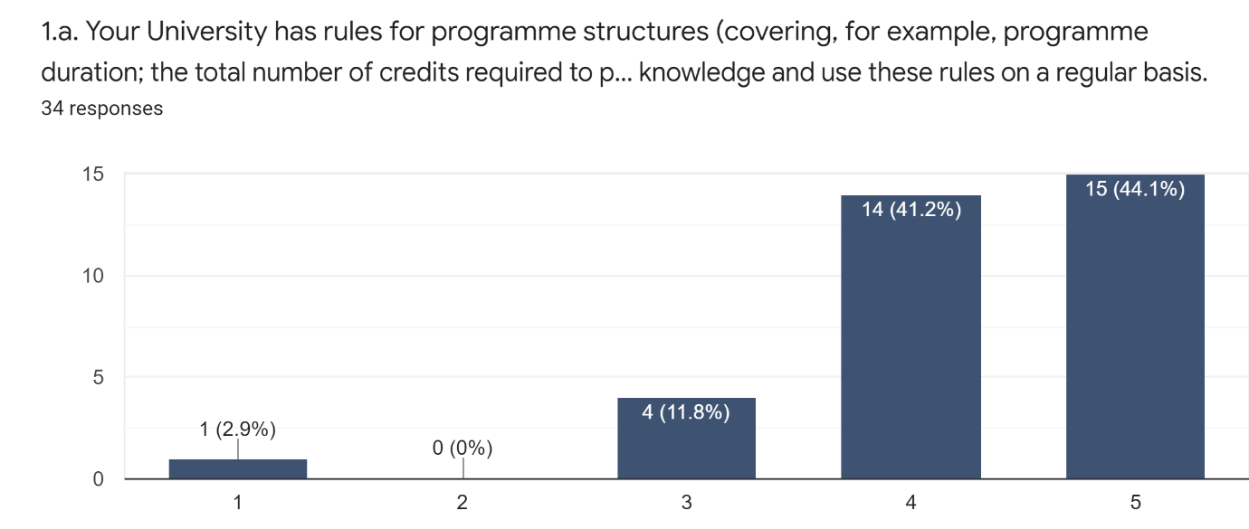
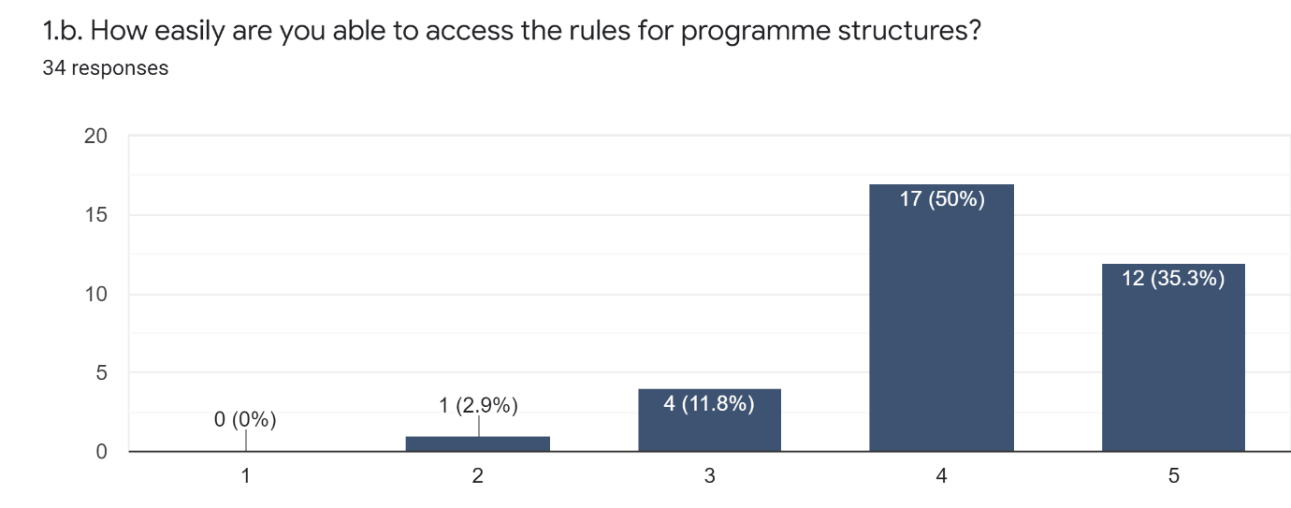

Excluding responses of N/A and clear misunderstandings of the question, there were 31 responses describing applications in practice, which in the main cited appropriate instances (sometimes more than one) of the application of the programme structure rules with 22 related to curriculum development and approval (including programme validation, review and modification; teaching (including at seminars, when preparing lectures, exams and assessments, and for understanding outcomes, rules, regulations and academic level of each year of study); and pastoral (including advising/explaining structures to students). There were two responses that were vague and ambiguous.
At face value, the above findings indicate that perceptions and knowledge of programme structures was good and perhaps not of primary concern for future staff development activity. That said, relatively few responses contained enough detail to support the self-assessment that 41% had expert knowledge of the programme structure rules. With 15% reporting that access was less than easy, there may be a need to raise the profile of the rules.

5. 2 Question 2 a-c: Institutional Regulations for Undergraduate (Bachelor), Masters and Doctoral Programmes
This set of three questions asked respondents to rate their knowledge of their institution’s regulations for undergraduate, masters and doctoral programmes and their ease of access to them and to give short descriptions (maximum 100 words) of occasions when they had applied them in practice.
Overall, 94% of respondents said that they had at least a good working knowledge of the regulations, with 82% responding that their knowledge was either very good (44.1%) or expert (38.2%), whilst overall 85% of respondents reported that access to the regulations was easy or very easy.
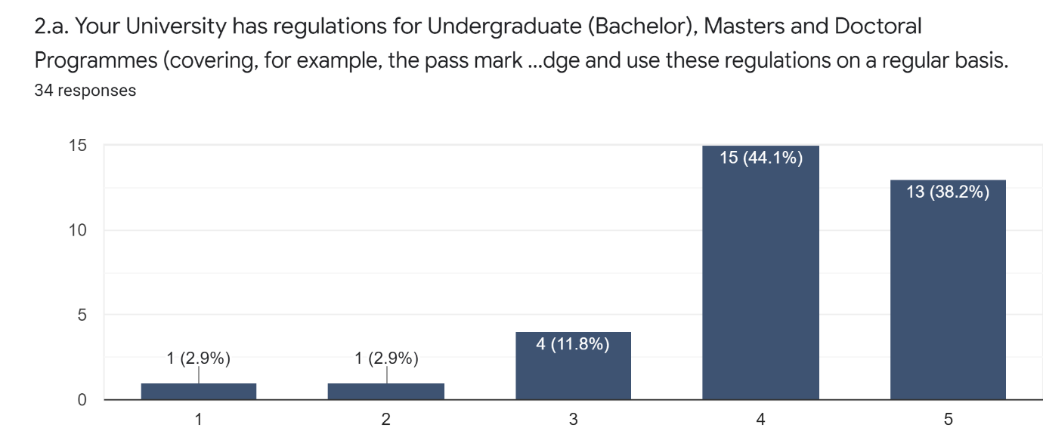
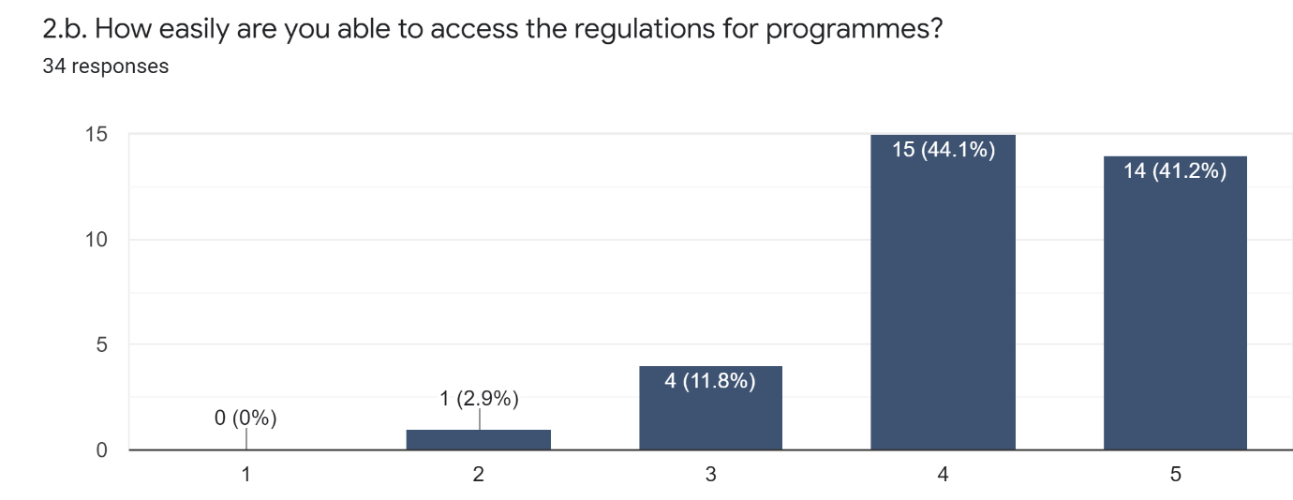
Excluding responses of N/A and clear misunderstandings of the question, there were 28 responses describing applications in practice, which in the main cited appropriate instances (sometimes more than one) of the application of the regulations with 11 related to curriculum development/approval (programme validation, review and modification and curriculum design); 6 related to teaching (examining, marking, and assessment; preparing lectures, exams and assessments; understanding and applying principles to the programme; and assessing student academic level); informing decision-making (at exam boards and academic committees, about student profiles; course delivery; pastoral (advising students and answering their questions); quality assurance; staff development (supporting/training colleagues). There was one response that was vague/ambiguous.

In conclusion the above findings indicate that perceptions and knowledge of the regulations for undergraduate, masters and doctoral programmes was good and perhaps not of primary concern for future staff development activity. That said and as with the finding for Q1c, relatively few responses contained enough detail to support the self-assessment that 38.2% had expert knowledge of these regulations. For Q1, with 15% reporting that access was less than easy, there may be a need to raise the profile of the regulations.

5.3 Question 3a-c: Institutional Assessment Regulations
This set of three questions asked respondents to rate their knowledge of their institution’s assessment regulations and their ease of access to them and to give short descriptions (maximum 100 words) of occasions when they had applied the assessment regulations in practice.
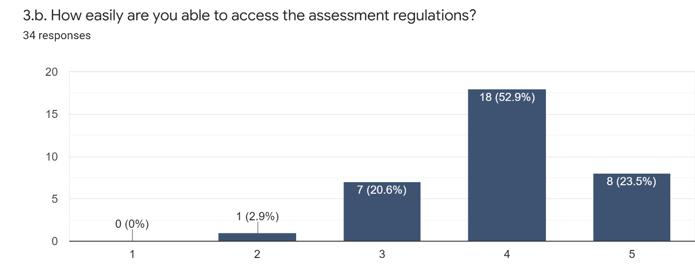
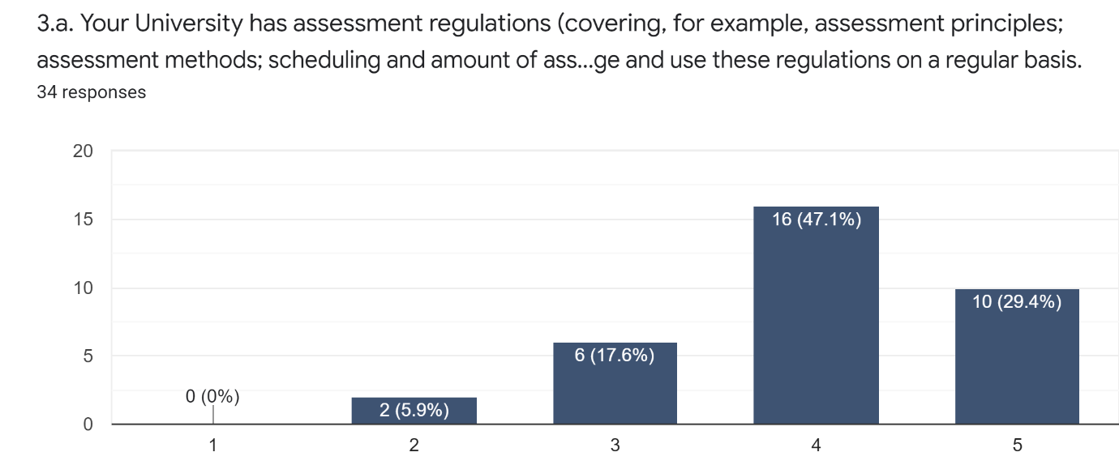
Overall, 94% of respondents said that they had at least a good working knowledge of the assessment regulations, with 76.5% responding that their knowledge was either very good (47.1%) or expert (29.4%). The expert 29.4% self-rating was however lower than that for knowledge of programme regulations (Q2a 38.2%) and programme structures (Q1a 44.1%). Overall, 76% of respondents said that access to the assessment regulations was easy or very easy, which was lower than the 85% rating given to the ease of access to both programme regulations and programme structure rules.

Excluding responses of N/A and clear misunderstandings of the question, there were 30 responses describing applications in practice, which in the main cited appropriate instances, sometimes more than one. These included 9 citations related to grading (evaluating student grades, grading exams, grading student knowledge, assessing/evaluating student outcomes, assessing student achievement by level); 11 related to assessment/preparation of assessment (preparation for exam board/ preparations for exams and assignments, proof of learning outcomes, source of assessment method, use to build assessment/exam for the programme, conducting assessment, creating exam questions); 4 relating to course design and approval (course evaluation, building programmes/modules in accordance with regulations); and citations of their use in moderation, lecturing to students and guiding visiting lecturers. However, there was a relatively high number of 8 citations of applications that were either vague or ambiguous. If this is taken with the general lack of detail that typified the responses, this seems to contradict the overall self-assessed claim by the respondents in 3a, that their knowledge was predominantly (76.5%) very good or expert.
To conclude, the above findings indicate that perceptions and knowledge of their institution’s assessment regulations might be a possible topic for staff development. And with 24% reporting that access to was less than easy, there may be a need to raise the profile of the assessment regulations.

5.4 Question 4a-c: Institutional Degree Award Algorithms
This set of three questions asked respondents to rate their knowledge of their institution’s degree award algorithm and their ease of access to it, and to give short descriptions (maximum 100 words) of occasions when they had applied the algorithm in practice.
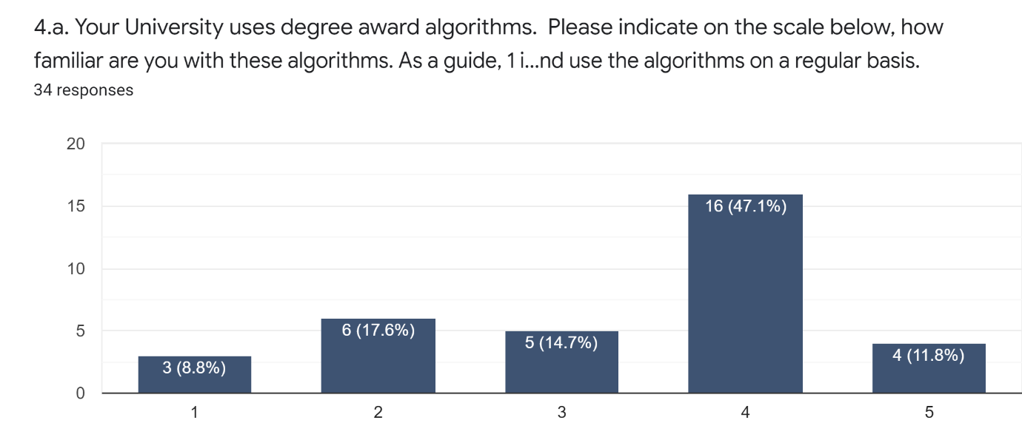
Overall, 73.6% said that they had a good working knowledge of their university’s degree algorithms. This was predominantly (61.8%) in the good (14.7%) to very good (47.1%) range. However, only 11.8% self-assessed that they had expert knowledge, the lowest rated of the set of four questions about quality processes. Over a quarter of respondents (26.4%) self-assessed that they did not have a good working knowledge, with 8.8% saying that they were not familiar and a further 17.6% saying that they were not very familiar with their university’s award algorithm. 55.9% reported that access was easy or very easy. However, 20.6% said that access was very difficult (11.8%) or difficult (8.8%), which was higher than that for programme structure rules, degree regulations and assessment regulations.

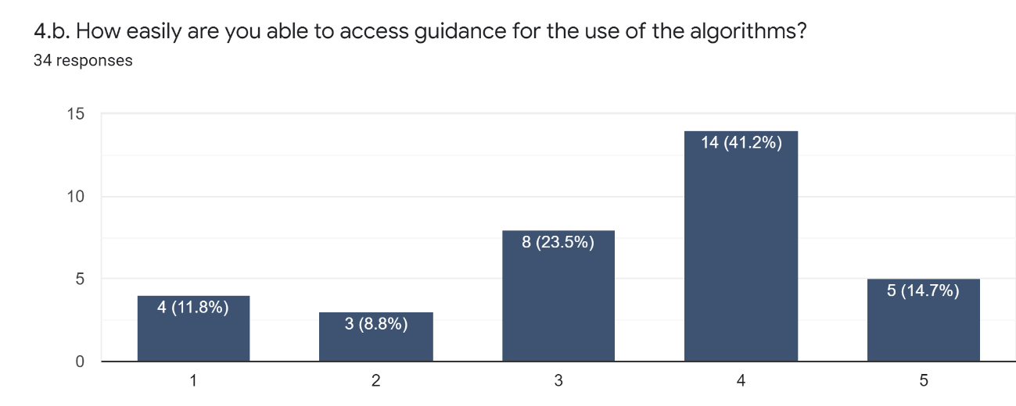
Excluding responses of N/A and clear misunderstandings of the question, there were 27 responses describing applications of the algorithm in practice, which in the main cited appropriate instances, sometimes more than one. These included 8 related to exam board decision-making (including discussion at exam board, understanding rules for upgrade, defining outstanding student achievement) and included references to the automatic application of the algorithm via programmed software, though it was observed that faculty should still have knowledge of the principles of the algorithm. There were 5 references related to explaining the algorithm to students (how degree award calculated, answering/consulting students); four responses revealed an understanding of the detail of the algorithm; two responses related to curriculum development; and two to sources of information about the algorithm (exam board training, the programme document). A further two references were either vague or ambiguous.
The types of use cited in these responses were generally appropriate suggesting there was practical understanding of the application of the degree algorithm in practice. This supports the finding in 4a that over 73% of respondents self-assessed a good working knowledge of their university’s degree algorithm.
The relatively high percentage (26.4%) of those self-assessing that they did not have a good working knowledge of the award algorithm, the relatively low percentage (11.8%) of those self-assessing that they have expert knowledge taken together with the relatively high percentage (20.6%) of those assessing accessibility to the algorithm as difficult suggest that degree award algorithms may be a topic for staff development.
Questions 5 to 10 of the survey focussed on academic colleagues’ perceptions and knowledge of the programme approval process. The aspects of the process covered were the use of national and international reference points, the procedure for approving new programmes, guidance for the design and development of the content of new programmes, the use of internal expertise in developing new programme content, the use of external expertise in developing new programme content, and consulting with students when developing new programme content.

5.5 Question 5a-b: National and International Reference Points
This set of two questions asked respondents (5a) about what national and international reference points they used to set the level of their programme, to describe its aims and learning outcomes and to determine subject content, and (5b) what advice and assistance they got in using them.
There were 32 responses to Question 5a, some of which cited more than one reference point. The agency associated with the reference point accounted for 20 citations: ABET (6), ACM (5), IEE (3), AUN-QA (1) and CDIO (1) in the Vietnamese context and QAA (2), SEEC (1) and PSRBs requirements (1) in the Cardiff Metropolitan University context. This confirms that national and international external reference points were used and illustrates the range of agencies, but despite being give 100 words in which to respond, in the main, when citing an agency, the description went little further than the acronym and no mention was made of the detail of the reference points themselves. There were 7 references to Vietnamese accreditor requirements including the requirements of Vietnam National University (2), MoET standards/national qualifications framework (3), Viet Nam Circular 04/2016/QD-
BGDDT (1) and Vietnamese law of tertiary education national frame of educational academic level standards (1), so accreditor requirements are an important national reference points in Vietnam. There were 17 citations of using the programmes and curriculum content of other national and international universities as reference points.
There were 31 responses to Question 5b, some of which cited more than one instance of advice and assistance in using reference points. Again, little use was made of the full 100-word limit, with most responses very short. There were only 7 citations that attempted to describe what assistance was available.

In contrast, there were 23 citations of possible sources of advice including the Quality Office or equivalent (10), School/Faculty (5), University (4) and External Sources (4). There were 5 citations of a lack of advice or the respondent having to rely on their own resources whilst 8 of the responses were either vague or ambiguous category suggesting perhaps a misunderstanding of the purpose of national and international reference points.

The responses to Questions 5a-b seem to suggest a possible lack of knowledge about the substance of national and international reference points and also about the substance of the assistance and guidance available when using them that could be explored as a topic for staff development.

5.6 Question 6a-d: Procedure for Approving New Programmes

This question was in four parts and was concerned with (6a) a self-assessment on a 5-point scale of the respondents familiarity with procedures; (6b) a rating on a 5-point scale of the perceived ease of access to the procedures; (6c) asked for a brief description of the main features of the procedure and (6d) asked for a brief description from personal experience (max 100 words) of the application of the procedure in practice.
There were 34 responses Question 6a with 73.6% self-assessing that they were very familiar (47.1%) or had an expert knowledge (26.5%) of the procedures for new programme development and use the knowledge of procedures on a regular basis. For 6b, 67.7% of respondents rated access to the procedures as either easy (41.2%) or very easy (26.5%). For 6c, a range of respondents gave answers

indicating some were very familiar and had views enabled through experience. Other respondents had not had experience and could not address the question with confidence and 2 respondents were not able to provide a description of the main features. In relation to 6d, 10 respondents had not been involved in the approval process and could therefore not give an example drawn from personal experience. The level of detail provided by the remaining 24 respondents was variable with some reporting recent experience of bringing a new programme forward for approval and one was due to participate in the process.
Although nearly three quarters of the respondents self-assessed themselves as very familiar with or expert in their institution’s procedure for approving new programmes, this should be contrasted with the lack of detail about the substance of the procedure that respondents could relate drawn from their own practical experience. This might suggest a possible topic for staff development. However, it might also suggest that detailed knowledge might be more apparent when the validation process is being undertaken and experienced in real time, but otherwise is not so readily suggested or recollected.

5.7 Question 7a-d: Guidance on the Design and Development of New Programmes

This question was in four parts and was concerned with (7a) a self-assessment on a 5-point scale of the respondents familiarity with their university’s guidance for the design and development of new programmes; (7b) a rating on a 5-point scale of the perceived ease of access to the guidance; (7c) asked for a brief description of the main features of the guidance; (7d) asked for a brief description from personal experience (max 100 words) of the application of the guidance in practice.
Of the 34 respondents to 7a, relatively few (58.8%) self-assessed that they had a very high level of familiarity (41.2%) or expert knowledge (17.6%) of the guidance. A relatively high proportion (11.8%) had little or no familiarity with the guidance for the design and development of new programmes. For 7b, 64.7% of respondents rated access to the guidance as easy (47.1%) or very easy (17.6%), whilst 11.8% rated access in the difficult to very difficult range. For 7c, responses were variable and indicated a range of experience, once again with some respondents indicating detailed knowledge and others indicating limited or no knowledge and the design and development process. For 7d, the descriptions of the application of the guidance in practice were again variable in terms of the detail suppled.

The data above suggests a relatively low self-assessed familiarity with the guidance which is borne out by the variable detail included in responses to naming the guidance’s main features and describing instances of its application in practice drawn from personal experience. This suggests that the guidance for the design and development of new programmes might be a suitable topic for staff development. However, as in the conclusion to Question 6a-c, it might also suggest that detailed knowledge is more apparent when the guidance is actively being used to prepare for a real-time validation, but otherwise is not so readily suggested or recollected.

5.8 Question 8: Use of Internal Expertise in Developing New Programmes

This question asked respondents to describe (max 100 words) how they had, or planned to, use any internal expertise to assist with developing new programme content, for example, expertise provided by the University department responsible for quality.
In response to this question a couple of the 34 respondents were unsure how to answer. Those who did respond, some wrote briefly about the importance of internal subject expertise whilst others responded that they use internal quality expertise. The answers were varied with few respondents providing an answer close to the 100 maximum word count.

5.9 Question 9: Use of External Expertise in Developing New Programmes
This question asked respondents to describe (max 100 words) how they had or planned to use any external expertise to assist with developing new programme content, for example, advice from subject experts and employers?
Respondents provided a range of examples of techniques for garnering external expertise including surveys and focus group meetings. In retrospect there appeared to be a little confusion about what constituted internal and external expertise. Some respondents did not know how external expertise was gathered but the general sense was that external expertise to help inform programme content was important.

5.10 Question 10: Consulting with Students when Developing New Programmes
This question asked respondents to describe (max 100 words) how they had or planned to, consult with current enrolled and graduated students in developing new programme content.
All respondents answered the question and a range of examples of vehicles to garner feedback from students and former students (open day, seminars, surveys, focus group) were provided. Views about the involvement of students or alumni were expressed positively, including how important it was to hear the student views on programme titles and content.

5.11 Conclusions about Responses to Questions 5-10
The responses to Questions 5–10 indicated broad understanding of the processes in place for new programme development in the respective universities, and respondents could access the information about process they required. Responses suggest that it was not clear exactly what was being referred to in Question 8 regarding internal expertise but respondents were clear about the value of external expertise and student/ alumni feedback in the formulation of course content.

Suggested areas for development would be around best practice for securing external engagement and student involvement in programme design.

6. Summary of Possible Areas in Need of Development

The following summarises the analysis of the current situation at the partners to the Project, based on the activities undertaken and related above in Sections 2-to-5.

6.1 Benchmarking:
The desk-based analysis in Section 2, the selection of programmes in Section 3 and the analysis of programme descriptors in Section 4 suggest that there are firm foundations for the benchmarking activity that will be undertaken in Objective 2 of the Project.

6.2. Staff Development:
The survey of a sample of academic colleagues teaching on the selected programmes suggests the following are possible areas that a staff development programme to be developed later in later staged of the Project might usefully include:

6.2.1 Quality Processes
- Raising the profile of programme structure rules and the regulations for Undergraduate Masters and Doctoral Programmes;

- Assessment Regulations – although three quarters of respondents self-assessed a very good/expert knowledge, this appeared not to be supported when respondents were asked to expand on this;

- Award Algorithms – a quarter of respondents self-assessed that that they did not have a good working knowledge of their university’s award algorithm whilst a fifth rated access to them as difficult. The effect of the automatic application of algorithms via software may be worth further exploration.

6.2.2. Programme Approval Processes
- National and International Reference Points – to improve knowledge of the substance of these plus raising the profile of advice and guidance about their use/application;

- Procedure for New Programme Approval – to improve knowledge of the substance of the substance of these;

- Guidance on Design and Development of New Programmes – there was a relatively low self-assessment of familiarity with these;

- Best practice for securing external engagement and student involvement in programme design.

Appendices

APPENDIX 1

Initial Survey Questions to Partner Quality Office Contacts

Link to Google forms where survey was compiled and administered on the 24th January 2022 –
https://docs.google.com/forms/d/e/1FAIpQLSfxeW5ZYtN4XgqXKdb2uwREbF1pCn0YLJdRnIGaDIS-MysA2g/viewform?usp=sf_link

APPENDIX 2

Questions to Gauge Perceptions and Knowledge of Quality

The survey questions were administered via Google Forms which was administered between the 26th April and 10th May 2022. Link to the survey and its questions can be found here:
https://docs.google.com/forms/d/e/1FAIpQLSf6P9-aN1Eb_huK8nEYkM59KwFtyDxgB_9PEPMLNtO4k_23lg/viewform?usp=sf_link

APPENDIX 3a

Criteria for Survey of Partners to Confirm Selection of Programmes for Benchmarking Activities
Level | Programme Nomenclacture (ie BA Hone, BSc Hons, Beng, MSc, MEng, Doctorate, MPhil) | Programme Title | Programme Duration (years) | Language of Instruction | Year Programme Launched | Total Student Nos on Programme | Gender Balance on Programme (female/male) | Programme Mode | Accrediting Body? | Name of Accrediting Body
UG
PG
Research

APPENDIX 3b

Additional/Subsequent Survey Questions Focussed on PhD Provision at Vietnamese Partners
This survey was administered via Google forms and link to the survey and its questions can be found here:
https://docs.google.com/forms/d/e/1FAIpQLSdEMARnK_DL38PIV5foCj5_aao6PbbwkwGkpIgSeKfPGKGmeQ/viewform?usp=sf_link

APPENDIX 4

Schedule and Coverage of 1-2-1 Meetings of Partners
Schedule
08 March: 1-2-1 between CMET and HUST
09 March: 1-2-1 between CMET and VNU
10 March: 1-2-1 between CMET and HCMUT
29 March: 1-2-1 between CMET and HCMUT
29 March: 1-2-1 between CMET and VNU
30 March: 1-2-1 between CMET and HUST
4 April: 1-2-1 between CMET and HCMUT
Coverage
- Review the desk-based analysis of international approaches to benchmarking produced as a result of Activity 1, including a discussion about how academic credit works in Viet Nam.
- Discuss the findings of the initial survey of quality processes derived from the desk-based survey.
- Discuss the process for partner’s programme approval process in relations to CMET’s with reference to the respective high-level process flow-charts.
- Discuss the programme/syllabus descriptors.
- Discuss and agree the survey of academic staff - clarity of the draft questions/format/terminology and intended audience to gauge their understanding of quality assurance process and programme approval.

APPENDIX 5

High-Level Processes of Approach to Validation
Ho Chi Minh University of Technology (HCMUT) Process of Approving a New Training Programme
1. Identifying needs and requirements for the new training program
2. Building overall objectives, specific objectives of learning outcomes
3. Identifying training structures, required knowledge volume of the new training program
4. Benchmarking and comparing the new program with other training programs from different institutions
5. Designing curriculum
6. Organizing workshops to collect opinions about the new training program
7. Proposing the curriculum to the institutional council of science and training for evaluation
8. Evaluating the new training program
9. Proposing the revised curriculum to the institutional council of science and training for approval
10. Issuing the operating the training program
11. Announcing the training program on the official website
12. Saving documents and conducting evaluation processes and regularly updating and revising the training program

Hanoi University of Science and Technology (HUST) Education Programme Approval Process
Step 1: The School/Faculty/Institute proposes a new education program based on:
- Researching and preparation of reports about survey, analysis and assessment of human resource demand
- Researching domestic and foreign training/education experience
- Compare the new education programs with the programs of other schools/universities
- Report on scientific arguments to develop new education programs
- Drafting a project to build a new education program
Step 2: The School/Faculty/Institute decides to establish a compilation team or a council to develop education programs.
Step 3: The education program development Council prepares a project to build the new education program. Making minutes of meeting to agree on the proposal and submit it to the Scientific and Education Council of the Faculty/Institute.
Step 4: The School/Faculty/Institute establishes a Council to appraise the training quality assurance conditions, including: lecturers, facilities, machinery, equipment, laboratories, learning materials, and library…
Step 5: The Faculty/Institute Council considers and accepts the project to develop a new education program.
Step 6: Dean of Faculty/Institute sends a letter to President of University to request opening of new education program.
Step 7: The President establishes a education program appraisal council (an independent council consisting of experts)
Step 8: The appraisal Council meets to assess all of the conditions for training and ensure training quality.
Step 9: The President makes a decision to approve the project, learning outcome and education program.
Step 10: The Scientific and Training Council of the University meets to agree new education program and allow to implement new program.
Step 11: The President issues a decision to implement new education program and to enroll students. The education program is published on the official website of the School/Faculty/Institute.
Step 12: The University sends an official letter to the Ministry of Education and Training about opening of new education program.
Step 13: During the training process, the Education Program Development Council updates the content of the modules/subjects to complete the education program.
Step 14: After finishing of a training course (usually 5 years later), the Faculty/Institute is responsible for international accreditation of the education program.
Step 15: The Faculty/Institute develop and innovate the education program to adapt the actual conditions and demands of society.

Vietnam National University (VNU) Process of Approving a New Training Programme
1. Educational unit develops a plan in phases, in terms each year, in order of priority in terms of major development orientation in accordance with the mission, development strategy of the unit and VNU. Based on the proposed plan, the unit establishes a group of experts to compile the project, develop the training program and outline the modules according to the outcome standards of knowledge, competence, skills and ethical qualities. The expert group includes representatives of lecturers; managers at all levels; domestic and foreign experts related to major; institutions employing graduates after graduation.
2. The group of experts researches the current programs (inside and outside VNU), develops the outcome standards and plans the training program framework with knowledge modules. How to build a training program:
- Choose a training program in the same discipline of a foreign university with up-to-date knowledge at the world's level of scientific and technological development and meet the requirements of socio-economic development, science and technology of Vietnam and appropriate the conditions of VNU;
- Supplement the courses required by relevant ministries, VNU, and units;
- Adjust the subjects of foreign universities to appropriate the conditions of Vietnam. Arrange the subject list into knowledge modules according to the training regulations of VNU.
3. Organize a survey social needs on output standards and training programs. The unit uses the data from survey to accomplish the program.
4. Develop the outcome standards for each subject in the 2nd draft according to following order:
- Organize the seminar on building outcome standards for the subjects.
- Develop outcome standards for each subject on the basis of the outcome standards of program.
- Organize a meeting of The Council of Science and Training to evaluate the outcome standards of subjects.
- Adjust the outcome standards according to the conclusions of The Council of Science and Training.
5. Building the outcome standard matrix of the training program. The Council of Science and Training determines the optimal order of implementation of knowledge modules and subjects that meet the outcome standards.
6. Organize an open seminar to get comments from managers, scientists, experts, graduate recruitment agencies, lecturers, students and alumni... and accomplish the training program.
7. The Council of Science and Training from appraisal unit gives comments; compares the training program with the outcome and quality standards, reviews resources, analyzes socio-economic efficiency, plan the career positioning of training products.
8. The head of the unit submits the complete training program for VNU’s approval and officially issue.

Cardiff Met Validation Process

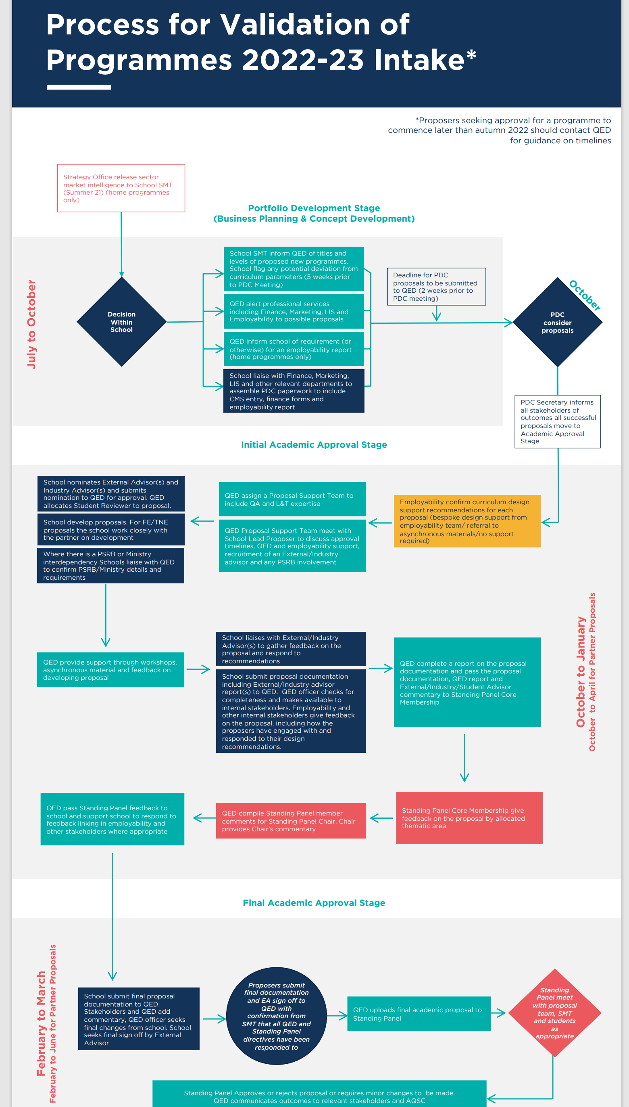

Referencing the CQFW to the EQF Report.
ESG 2015 1.2 Design and Approval of Programmes: ‘Institutions should have processes for the design and approval of their programmes. The programmes should be designed so that they meet the objectives set for them, including the intended learning outcomes. The qualification resulting from a programme should be clearly specified and communicated, and refer to the correct level of the national qualifications framework for higher education and, consequently, to the Framework for Qualifications of the European Higher Education Area.
OfS How to apply for degree awarding powers ; QAA The Right to Award UK Degrees
There are recordings of these meeting which can be made available on request, subject to the agreement of all participants.

