

11.5 Transferring Doctoral Study to Cardiff Metropolitan University

POLICY COVERSHEET

Key Details
POLICY TITLE | Transferring Doctoral Study to Cardiff Metropolitan University
DATE APPROVED | September 2023
APPROVING BODY | University Research Degrees Group
VERSION | 1
PREVIOUS REVIEW DATES | September 2023
NEXT REVIEW DATE | September 2026
OUTCOME OF EQUALITY IMPACT ASSESSMENT
RELATED POLICIES / PROCEDURES / GUIDANCE | Regulations and Guidance (Research Degrees) | Cardiff Metropolitan University
IMPLEMENTATION DATE | September 2023
POLICY OWNER (JOB TITLE) | University Graduate Studies Lead
UNIT / SERVICE | Research & Innovation Services
CONTACT EMAIL | graduatestudies@cardiffmet.ac.uk

Version Control
VERSION | DATE | REASON FOR CHANGE
1 | September 2023

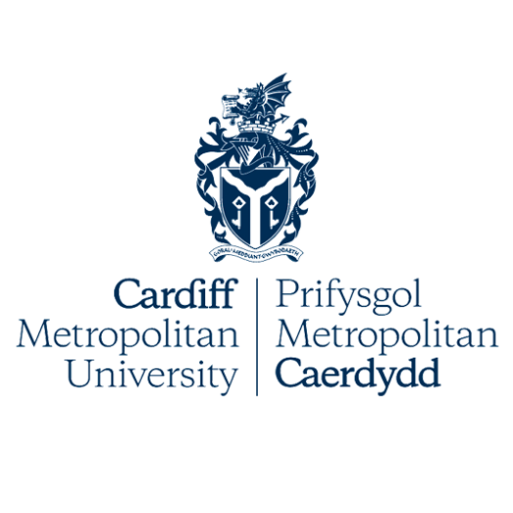

Transferring Doctoral Study to Cardiff Metropolitan University

- Introduction
  - By exception, the University accepts applications from students who have completed part of their Doctoral studies elsewhere and who wish to continue with the same study to completion at Cardiff Metropolitan University (Cardiff Met). However, this is subject to a formal review and approval through the University admissions process. To facilitate this review, all individuals must apply through the standard application process.
- Application Process
  - In addition to the standard application requirements, the following documents must also be supplied (failure to do so will result in an automatic rejection of the application):
- Existing approved Research Project Proposal, confirming work already completed, the remaining works necessary to fulfil the requirements of the award and the proposed submission date.
- Any work already completed for the Doctoral Award the applicant is currently pursuing.
- Formal statements of registration from the original institution, including dates of registration, degree type and mode of study.
- Formal statements of academic progress from the original institution with details (including dates) of interim assessments / progress reviews.
- Formal agreement over Intellectual Property ownership with the original institution.
- A report from the lead supervisor on the applicant’s work to date and the remaining works necessary to fulfil the requirements of the award.
- A report from the applicant stating their reasons for moving institution, and how fees are to be funded.
- Where applicable, a letter from any sponsor or funding body to confirm that they agree with the proposed transfer.
  - For those individuals considering applying to transfer to the Professional Doctorate or one of the Taught Doctorates at Cardiff Met, it is important to note that if successful with the application, all taught modules on the Doctorate must be completed. An applicant may request for exemption or Recognition of Prior Learning (RPL) from completing modules on any of the Doctoral programmes at Cardiff Met. Any request for exemption/RPL must include the following document, on application:
- Previously assessed work deemed a pass at the original institution.
- Formal recognition of passed work from the original institution.
- A ‘map’ of how the learning outcomes addressed in the previously assessed modules address the relevant module learning outcomes within the Doctoral programme at Cardiff Met that the individual is requesting exemption/RPL from.
- Module handbooks that illustrate the addressed criteria.
- Application Review
  - There are five schools within Cardiff Met. All applications will first be reviewed by members of the relevant School’s Research Degree Group (SRDG).
  - The members of the SRDG will:
- Review the quality of the submitted project proposal against the significance, rigour, originality and proposed impact of the work and review any other submitted work completed at the original institution.
- Review the supplementary documentation detailed in 1.1 and, where relevant, 1.2 of this document.
- Consider whether there are suitable and available supervisors to support the applicant throughout the Doctoral Journey.
- Consider whether the relevant school has the necessary equipment/facilities to support the remaining work.
- Consider the proposed timeline to submission. In cases where applicants are close to completing their studies (e.g., 3 years into a 4 year full-time PhD), a strong and robust rationale will need to be presented as to why the transfer is being requested. This is to avoid unfairly disadvantaging the existing institution where the majority of works will have been supported and completed.
- Confirm the proposed start date in relation to the available entry points for the relevant Doctorate programme. For Taught Doctorates, confirmation of start date would involve consideration of any supported exemption and modules still to be completed.
- Confirm the proposed candidature length with consideration of the work already completed, the mode of study (i.e., part-time or full-time), and the maximum candidature for the Doctoral programme being applied for (with consideration of the mode of study).
  - Applications may be referred to the University Research Degree Group (RDG), for further deliberation on the work, supervisory arrangements and/or candidature length.
  - Where members of the SRDG (or RDG, if referred) approve an application, the applicant will be invited for an entry interview. Here, the applicant will be asked to discuss further their reasons for transfer and their current programme of work. The applicant will also be expected to discuss their commitment to Doctoral study, including scheduling of work.
- Successful Applications
  - Should the application be supported and suitable supervisors available, the applicant will be informed and invited to review the terms and conditions (including the candidature length) and enrol.
  - The start date will be dependent on the entry points available for the Doctoral programme that the applicant is applying to transfer onto, when the application is approved, and when the applicant accepts the terms and conditions.
  - The length of candidature will depend on the maximum candidature of the programme, mode of study and work already completed. The annual fee will be that advertised for the relevant Doctoral programme for the academic year the applicant choses to transfer to Cardiff Met.
  - Once enrolled, the Doctoral Researcher must undertake the same Progression Reviews as other Doctoral Researchers enrolled at Cardiff Met. That is, the 1 Month ‘Launchpad’, the 6 Month Progression Review, the 12 Month Progression Review and, where applicable, the Annual Progression Reviews.

