Accommodation Self Selection Guide
How to select your accommodation
This guide explains how to select accommodation in either Campus or Partner halls.
Before you begin:
- Check the date and time of your room selection session,
- Set up multi-factor authentication (MFA) & make sure you can log in to the Accommodation Portal
- Have your payment card ready if selecting Campus halls
- Allow enough time to complete the full process
- Use one device and one browser window
Your application recorded your preferences. It did not reserve a room. The accommodation shown will depend on availability and your eligibility.
There are two booking routes within the portal, each have slightly different processes.
For Partner Housing: You select a partner location and your preferred room type. The provider will contact you separately within two business days about your room offer and next steps. For more details on our partners, visit: Partner Halls | Cardiff Metropolitan University
For Campus Housing (Cyncoed or Plas Gwyn Campus Accommodation): You select an available Cardiff Met room from the list, accept the occupation contract and pay the £130 pre-payment through the portal.
Visit: Halls of Residence | Cardiff Metropolitan University for more information.
The process should take an average of 10 to 15 minutes to complete.
How rooms are released
A proportion of rooms are released for each booking session. The number released is based on eligible applicants, available rooms and students’ campus of study. This gives students in each session fair access to the accommodation portfolio.
Popular locations and room types may still be selected quickly. If no campus rooms are available during your session, the portal will direct you to the partner accommodation currently available.
Step by Step Guide

- Log in to the Accommodation Portal
https://cardiffmet.starrezhousing.com/StarRezPortalX/
To log in please use your Student (ST) Number and Password (this is included on university correspondence/emails) STXXXX@outlook.cardiffmet.ac.uk
In order to enhance the security of your account, you'll need to register for Multi Factor authentication (MFA). This will involve you periodically using your phone as a secondary form of authentication. Please visit: https://library.cardiffmet.ac.uk/help/mfa where there are full instructions and a video guidance on how to set up authentication using particular devices.
If you have forgotten your password, please visit: Password Management

- Term Selector
When you are logged in, go to your application and select continue on the Term selector

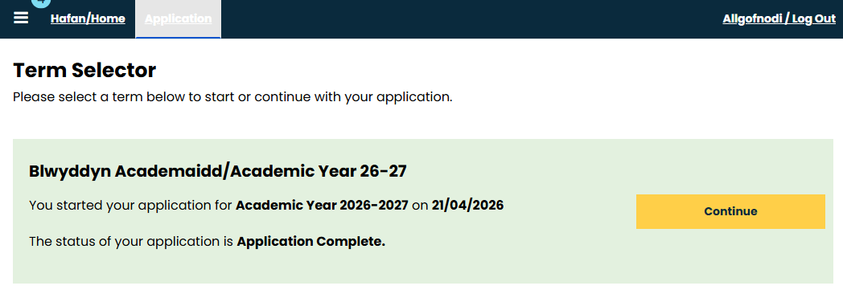

- Page Selector
Select ‘Page Selector’ from the left-hand menu. 

- Partner or Campus Housing Selection
Select either Partner or Campus Housing from the drop-down list & continue 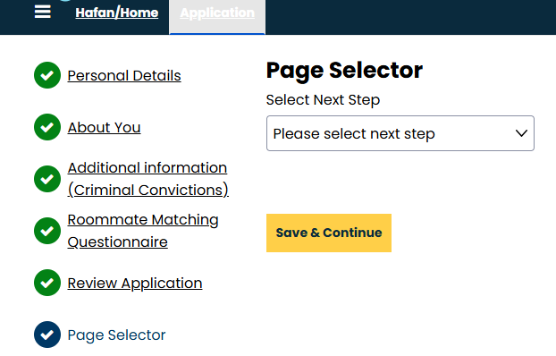

If you select Partner Housing, make a selection from the drop-down menu then confirm selection. For instructions on Campus Housing, go to step 6.

- Partner Housing Confirmation Page

You will see a confirmation page which explains the next steps. If you would like email confirmation, click on the yellow “Request Email Confirmation & Return to Home Page” button. The screen includes the contact details of your chosen provider, we recommend you save this information for further reference.

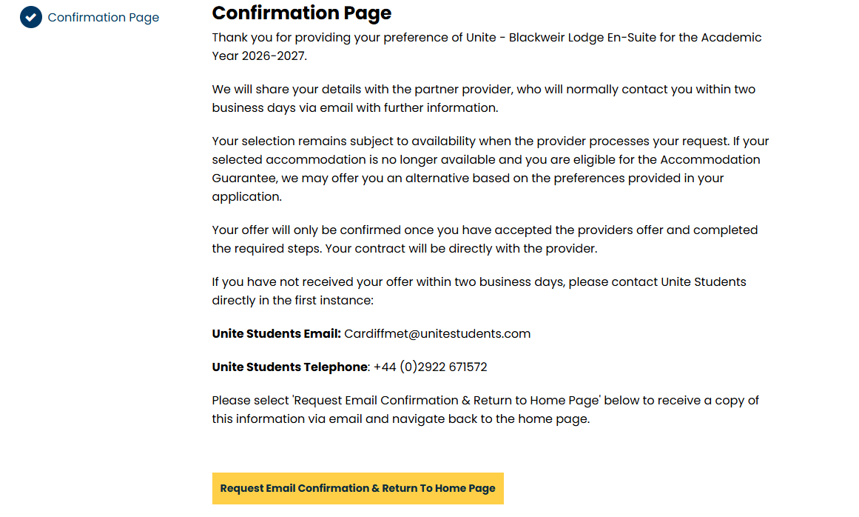

Note: Selecting partner accommodation records your preferred provider. It does not confirm a booking at this stage. We will send them your information securely, and they will contact you with a room offer, and details on how to view and accept your contract and next steps. Please check your emails regularly, including your junk or spam folder.

- Campus Housing
If you selected Campus Housing from the page selector, click Save and Continue


- Initial Selection
In the initial selection page, you will see any available room types. Select an available room type to get to the next step. 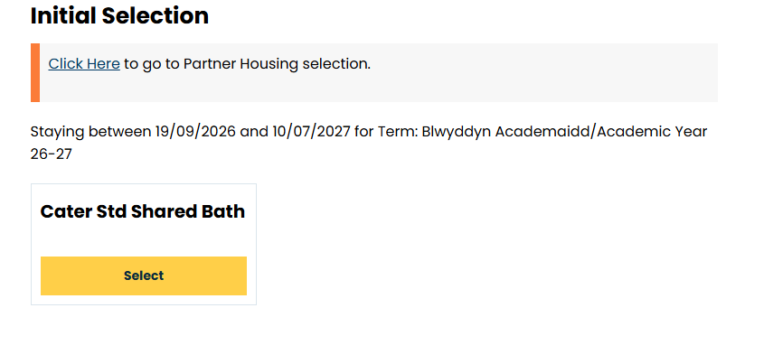
- Return to Partner Housing
You can return to the partner housing selection screen at this point if you have changed your mind, or if you don’t see any of your preferred campus options available.
If all the campus accommodation is booked for your booking session, you will see a message re-directing you to partner accommodation.

- Room List
- The room list shows you the available rooms within the selected room type.
- To find out more about the room, click on ‘Show room info’ 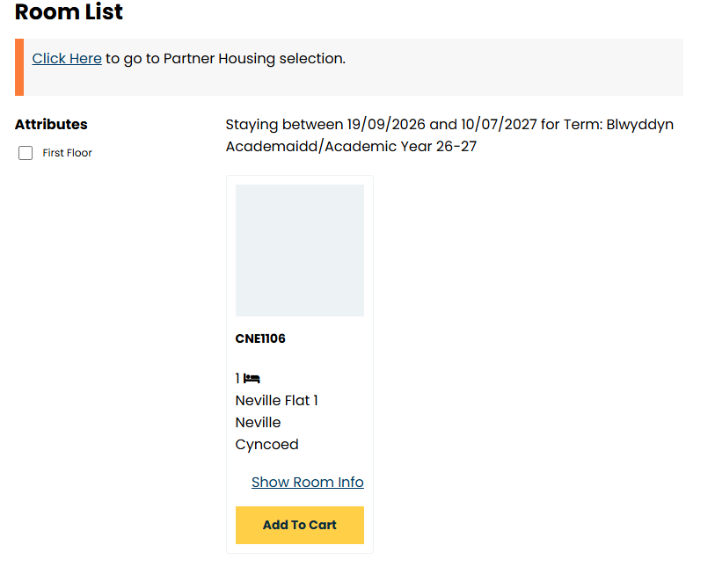

- Before you click ‘Add to cart’
Check:
- The building and room number
- The room type and description
- Whether the room is catered or self-catered
- The total fee
- Any community profile, such as alcohol-free, quiet/low stim, or social living.
Tip: Most rooms at Cyncoed Campus are catered. The catered package includes breakfast and an evening meal, seven days a week during the catering period.
Selecting Add to Cart does not secure the room: Adding a room to your cart does not complete your booking. There is a timed hold of 15 minutes on your cart. You must continue through all the remaining stages, accept the accommodation contract and make the £130 prepayment.
- Confirmation Screen
At the confirmation screen, you can go back to the previous screen or save and continue.
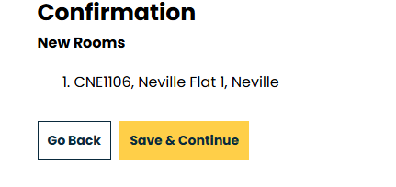
- Electronic Document Delivery Acknowledgement
To proceed to the next step, you will need to read the following statement, tick the box to confirm you have read and understood and select ‘confirm’ to proceed.
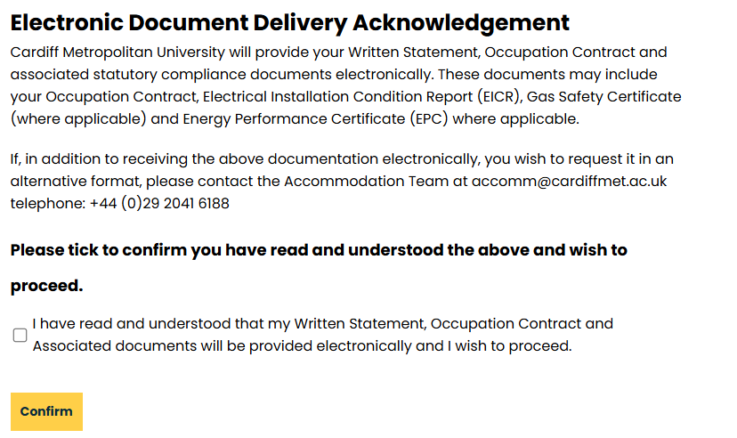
- Offer Summary
The offer Summary screen will present you with information about the room, room type, location and the fee payable. Check the information carefully. If the details are correct, select Accept from the drop-down menu and continue. Don’t accept the offer if the room details or community profile are not suitable for you.
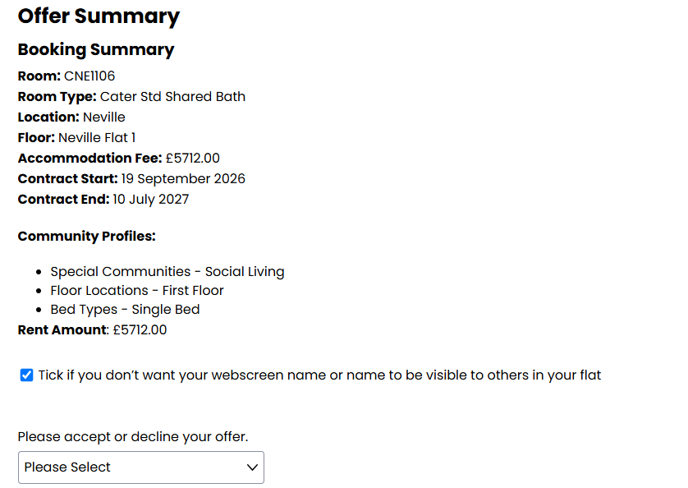

- Accept Offer
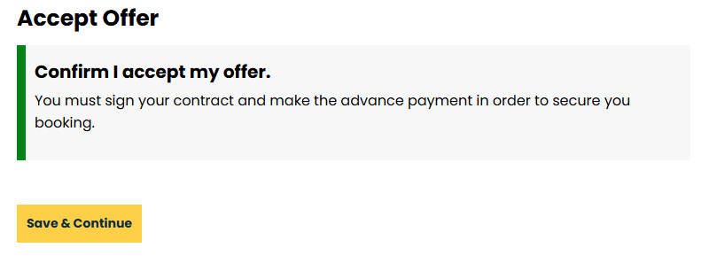
- When you get to this page, save and continue to proceed to the contract

- The Occupation Contract
- Read the contract carefully.
- Download and save a copy for your records.
- Tick the confirmation box only after you have downloaded & read the contract and agree to its terms.
- Select save and continue to proceed to payment.
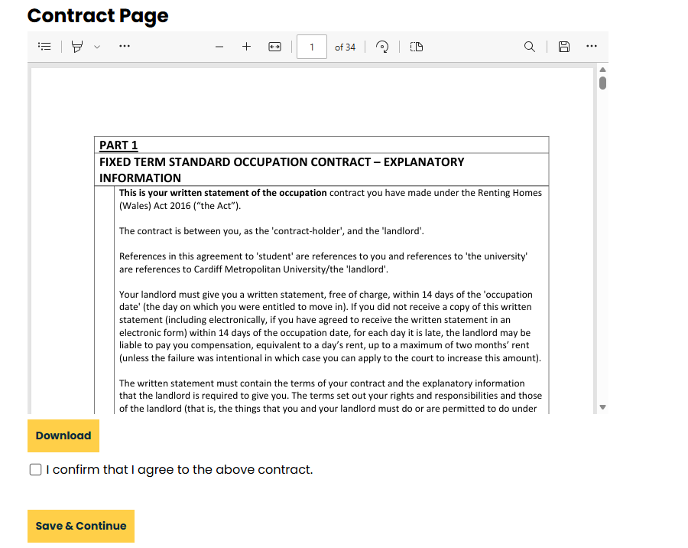

- Pre-payment
Please confirm your country from the drop down menu.
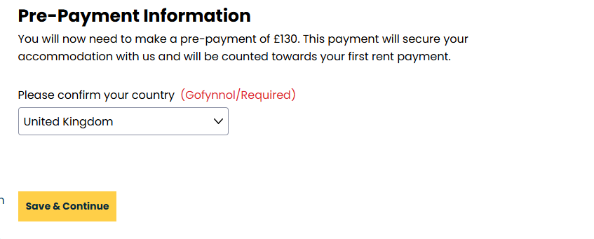
Review the payment amount & select pay now.
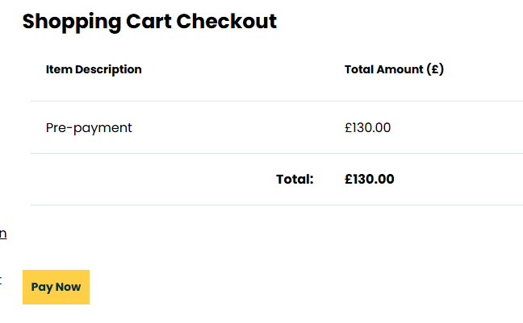
- Enter your card details in the Payment Details screen.
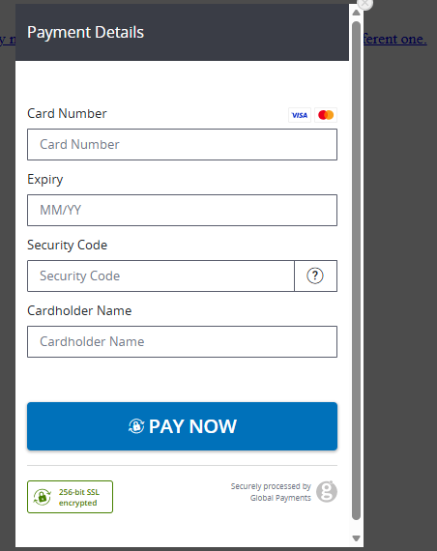
- Your bank may ask you to complete security or authentication information.
- Wait for the portal to return to the Application Summary
- Do not pay twice.
- Do not refresh the page, use the browser back button or open another booking session while the payment is processing.
- If you experience any difficulties with the payment process, please contact the Accommodation team.
  - Email: accomm@cardiffmet.ac.uk
  - Telephone: 029 20 41 6188

- Application Summary and Booking Completion
Your booking is complete when:
- You have accepted the occupation contract
- The £130 pre-payment has been successfully processed
- Your room appears in the Application Summary
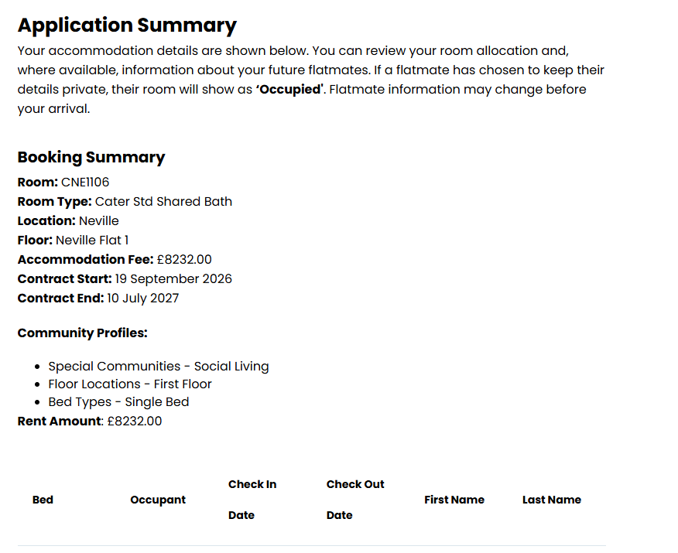
Technical problems?
If the portal does not load, you cannot log in or an error appears:
- Do not open multiple booking sessions
- Take a screenshot of the message
- Record the time the problem occurred
- Contact accomm@cardiffmet.ac.uk and include your student number
You will not be disadvantaged if a verified technical problem prevents you from completing your room selection session. We will review your case and extend or rearrange your session where appropriate.

