

Degree Outcomes Statement



# Introduction

This Degree Outcomes Statement forms an annual part of Cardiff Metropolitan University’s core business. It sets out how the institution maintains academic standards and protects the value of its qualifications. It demonstrates that:

* The Board of Governors have confidence that the arrangements in place protect the value of the University’s qualifications.
* Cardiff Metropolitan University can provide Medr with assurance that the University meets national degree standards.
* The University’s methods of calculating undergraduate degree classifications have been in place since 2014 and sit within a stable policy and regulatory framework.
* The University continues to have a strategic focus on clear and achievable teaching, learning and assessment strategies, intended to equip students with a range of subject-specific knowledge and professional skills.

## **Institutional Degree Classification Profile**

The proportion of Cardiff Metropolitan students achieving a First Class or Upper Second-Class honours degree (referred to as ‘Good Honours’) increased between the 2017/18 to 2020/21 academic years, peaking at 84.5% in 2020/21. It then fell in 2020/21 to 76.7% and fell again by 7.6 percentage points in 2022/23 to 69.1% (Table 1).

The 2022/23 dataset is the first to be only minimally affected by internal Covid-19 safety net features. It is more comparable to the data set for 2018/19, which was the last year of outcomes before Covid-19 related measures were introduced.

Table 1 shows the ‘Good Honours’ profile for Cardiff Metropolitan University for the academic years 2018/19 to 2022/23.

Table 1. Cardiff Metropolitan University Good Honours profile (2018/19 – 2022/23).

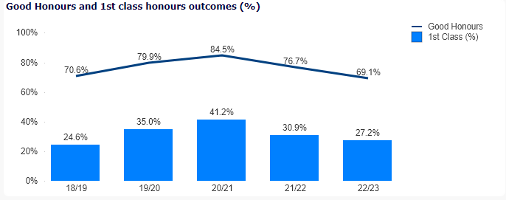

Institutions across the UK implemented various safety net policies during 2019/20 and 2020/21 and this coincided with a sector wide rise in Good Honours outcomes. This rise has been followed by a subsequent decrease in the sector average. From 82% in 2020/21, it fell to 79% in 2021/22 to 78% in 2022/23. There was an overall decrease in the sector in the percentage of First Class honours degrees from 32% in 2021/22 to 30% in 2022/23. Upper Second Class honours degrees slightly increased from 47% in 2021/22 to 48% in 2022/23 [(HESA (2024).This percentage was in line with pre-Covid-19 levels. Meanwhile, First Class Honours (30%) were still above the levels achieved pre-Covid-19 (28%).](https://www.hesa.ac.uk/data-and-analysis/students/outcomes" \l "classifications)

## **Final year of exceptional mitigation due to the Covid-19 pandemic**

In common with much of the Higher Education sector, Cardiff Metropolitan University introduced a range of measures to support student wellbeing and academic achievement during the Covid-19 pandemic. However, students graduating from a three year honours programme in the 2022/23 academic year would only have been taught and assessed at Level 4 under these measures. As Cardiff Metropolitan University’s degree classification algorithms do not include Level 4 marks, these measures would not have impacted outcomes latterly achieved at Levels 5 and 6. Instead, these were assessed under the University’s standard [academic regulations](https://www.cardiffmet.ac.uk/registry/academichandbook/Documents/AH1_04_01.docx). Only individual students who had been trailing a module or modules which had been assessed under the University’s previous exceptional mitigation due to the Covid-19 pandemic would have outcomes covered by the University’s safety net policy (as set out in previous Degree Outcomes Statements).

The classification trends shown in Table 2 indicate that the University’s profile of First and Upper Second Class honours degrees increased between 2018/19 and 2020/21. This coincided with a sector wide rise in ‘Good Honours’ outcomes. After a fall in 2021/22 of the percentage of First-Class honours degrees, these still remained higher than in the pre-Covid-19 years of 2017/18 and 2018/19.

Meanwhile, the decline in the proportion of Upper Second Class and Third-class classifications had come to an end in 2021/22 but still remained below pre-Covid levels. For 2022/23 the combined total for these was 30.8% which is comparable with the last pre-Covid total in 2018/19 which was 29.4%

## **Marking and Assessment Boycott (MAB)**

In common with many Universities during the 2022/23 academic year, Cardiff Metropolitan University was subject to a Marking and Assessment Boycott (MAB). This commenced on the 20th of April 2023 and ended on the 6th of September 2023. The University responded through implementing a [Significant Disruption Policy](https://www.cardiffmet.ac.uk/about/policyhub/Documents/Significant-Disruption-Policy-Academic-Board-190523-Final.pdf). This included mitigations for scenarios where a student due to be awarded might not receive a full profile of marks. However, Cardiff Metropolitan University was able to ensure that no student had missing marks and all who were eligible to graduate did so.

Table 2. Trends in classifications between 2018/19 and 2022/23.

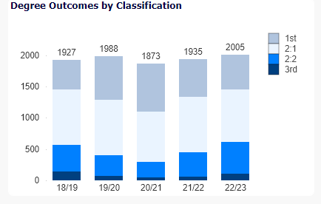

In terms of overall degree outcomes, Table 3 shows in more detail that the percentage of First Class awards fell in 2022/23 to 27.2% but still remained above pre-Covid-19 levels (24.6%). However, the 2022/23 figure is below the sector average of 30%. The percentage of Upper Second Class awards was 41.9%. This has fallen to below pre-Covid levels (46%). It is also below the sector average in 2022/23 (48%). The percentage of Lower Seconds (25.5%) and Third Class (5.3%) degrees increased in 2022/23. Whilst the percentage of Lower Seconds was higher than in 2018/19 (pre-Covid-19) the percentage of Third Class awards remained lower. In comparison with the sector, the percentage of Lower Seconds was higher than the sector average of 20%, and the percentage of Thirds were higher than the sector average of 3%.

Table 3. Overall Degree Outcome percentages 2018/19 – 2022/23

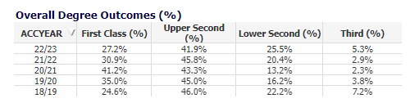

Finally, Table 4 shows that the percentage of ‘Good Honours’ outcomes fell across all student characteristic categories in 2022/23. However, for mature and BME students, the outcomes did remain above pre-Covid-19 levels. In the case of Mature students, in comparison with the final pre-Covid-19 year (2018/19) the ‘Good Honours’ outcomes were 1.4% higher whilst for BME students, the ‘Good Honours’ outcomes were 3.6% higher. Comparing 2022/23 to the final pre-Covid-19 year, the fall in percentage for female students was 0.4%, for male students 3.3% and for young students the decrease was the largest at 8.1%

Table 4. Percentage of Good Honours degrees awarded to First Degree Students by academic year, broken down by student characteristics.

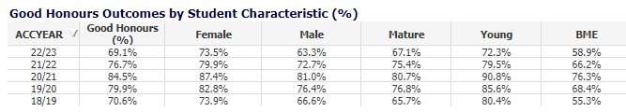

# Assessment and Marking Practices

The University’s assessment and marking practices place a strong emphasis on the constructive alignment of intended learning outcomes, assessment methods and assessment criteria to ensure that assessment is fair, valid, and reliable.

Programmes are approved for delivery following confirmation that the curriculum (including proposed assessment methods) align with the FHEQ/CQFW and any relevant QAA Subject Benchmark Statements or PSRB requirements. Regulations governing marking and moderation are available to staff and students in the Academic Handbook and seek to ensure that marking is fair, consistent, and transparent. The University’s band descriptors steer markers and moderators to the academic standards students are expected to achieve to receive marks in a particular category and map to FHEQ descriptors. The University’s assessment practices are aligned with QAA advice and guidance. Following the recent publication of the revised Quality Code, assessment practices will be re-mapped to the new Principles and Key Practices to ensure continued alignment.

The appropriateness of programme assessment criteria is monitored annually by an External Examiner. In their annual report External Examiners are required to confirm whether standards are appropriate for the award and are aligned to the relevant level of the FHEQ and QAA subject benchmark statements. They are also required to judge whether the standards of awards are comparable to those of other institutions and, where relevant, that they meet PSRB requirements.

External Examiners scrutinise a specified sample of assessed work so that they can make judgements about the standards of student performance and the consistency and fairness of assessment processes. For the 22/23 academic session 99% of External Examiners confirmed that the programmes they considered were aligned with sector benchmarks (including the FHEQ and benchmark statements). The same percentage of External Examiners also confirmed that programme academic standards were comparable across the UK sector, and 98% agreed that student achievement on programmes aligned with other UK HEIs. For programmes delivered with partners, assessment and marking practices are the same as those described above.

# Academic Governance

The University’s Academic Board is responsible for the standards and quality of all provision that leads to the award of credit in its name. The Academic Quality and Standards Committee (AQSC) is empowered by Academic Board to have oversight, on its behalf, of the academic standards of its awards and for the quality of the student learning experience. On an annual basis the University, through the work of its AQSC, assures its regulator Medr that ‘the standards of awards for which we are responsible have been appropriately set and maintained.’ It does so following scrutiny of a suite of reporting on the University’s programme approval and review processes, annual monitoring processes, assessment processes, and arrangements for Examination Boards. This exercise includes scrutiny of External Examiner reporting on whether assessment designs are appropriate, criteria and marking schemes are set at the right level and whether assessment processes are fair reliable and thorough. For programmes delivered with partners the exercise of authority and oversight is the same as that described above.

# Classification Algorithms

There are two available [algorithms](https://www.cardiffmet.ac.uk/registry/academichandbook/Documents/AH1_04_01.docx) for undergraduate honours degrees. However, each individual programme uses only one. The relevant algorithm must be validated and stipulated in each published Programme Specification document. The algorithm will apply consistently to all students on the programme.

Classifications are determined either from:

* the average of the aggregated marks achieved in the best 100 credits at Level 6 (weighted at 0.7) and the next best 100 credits at Level 5 or above (weighted at 0.3); or,
* from the average of the marks achieved in the best 100 credits at Level 6 only.

## **Compensated pass**

Students are required to successfully complete all modules registered against their programme in order to qualify for a final award. However, the Examination Board is empowered to award credits for a ‘compensated pass’. This may be done where the module result is a marginal failure, but the student is deemed to have met the minimum learning outcomes across the module and has a Level average which is above the minimum pass mark.

## **Borderline criteria for uplifts**

If a student’s overall mark falls within the numerical range for an uplift, the Examination Board will confirm if one is to be awarded by referring to the universally applied criteria:

Any student within **1%** of a higher classification is automatically confirmed for an upgrade.

Any student within **2%** of a higher classification an Examination Board is empowered to raise the degree class if they fulfil at least one of three specific upgrade criteria:

* Majority of credits in the higher band (50% or more credits at level 6 in the higher classification).
* Exit Velocity based on a comparison of theLevel 5 and Level 6 average marks. Where the Level 6 average is in the higher classification band, the Examination Board will normally award the higher class of degree.
* Performance in the major final stage project or dissertation.

## **Resit / retrieval limits**

Students can be offered up to two retrieval opportunities, unless prohibited by Programme-specific regulations, or precluded by an Exam Board decision based on their whole academic profile. For example, they have exhausted all attempts for a different module so must be withdrawn. Where reassessment at second or third attempt is necessary, the module is capped at the minimum pass mark. This in line with practice across the sector as outlined in the Universities UK publication ['Understanding Degree Algorithms'](https://www.universitiesuk.ac.uk/policy-and-analysis/reports/Documents/2017/understanding-degree-algorithms.pdf).

# Teaching practices and Learning Resources

The University continues to support student continuation, engagement, and award outcomes, through its Assessment and Feedback Policy, Personal Tutoring programme and professional learning offer provided through its Quality Enhancement Directorate (QED). In response to sector developments and student feedback in recent NSS, SSS and PTES surveys, the University has reviewed its Personal Tutor policy and will be implementing a Personal Academic Tutoring model going forward. This model aims to build on the existing successes of our personal tutor framework, and further extend the support and development of student communities to promote student engagement and learning.

Responding to positive NSS feedback on the value of recorded lectures, the university’s revised Content Capture Policy will see recordings of lecture content routinely provided to students via the Moodle VLE, aiming to support and facilitate improved outcomes for increasingly diverse student cohorts often having responsibilities beyond university.

During the 23/24 session QED continued to roll out its new process in which external examiner reports trigger a targeted learning support offer where a particular challenge has been identified. It is hoped the process will continue to target professional learning support where it can be most impactful.

# Identifying Good Practice and Actions

Good practice in the area of assessment and student outcomes identified through external review, external examiner reporting and programme enhancement planning include:

* an expansion of the Open Campus project has provided a range of work placements that contribute to developing students’ professional skills. The development of the campus based community health hub provides authentic, work-based learning opportunities, enabling students to contribute and make a difference to their communities.
* The University has implemented MetStats, which provides Personal Tutors with an overview of student engagement. The system utilizes information drawn from attendance and the use of VLE, Lecture Capture and Microsoft Teams to provide an average engagement score and an opportunity to check in early with students to offer support.
* External examiners now report on whether programmes produce graduates with digital skills comparable to similar programmes offered by other HEIs and are appropriate for their likely career. The first set of data showed a 95% positive response rate.
* Minimum requirements for Moodle have been reviewed and updated, along with a standardized template for Module Handbooks, which includes details on all assessments, deadlines and links to support.
* Assessment feedback is not restricted to written comments on essays. Feedback may be offered electronically, by audio or video file.

Good practice is disseminated via the University’s Quality Enhancement Directorate through workshops, online videos and guides and its annual Quality Enhancement Conference.

**References**

HESA (2024) *What are HE students’ progression rates and qualifications?* [online]. Cheltenham: HESA. Available from https://www.hesa.ac.uk/data-and-analysis/students/outcomes#classifications [Accessed 30 September 2024].