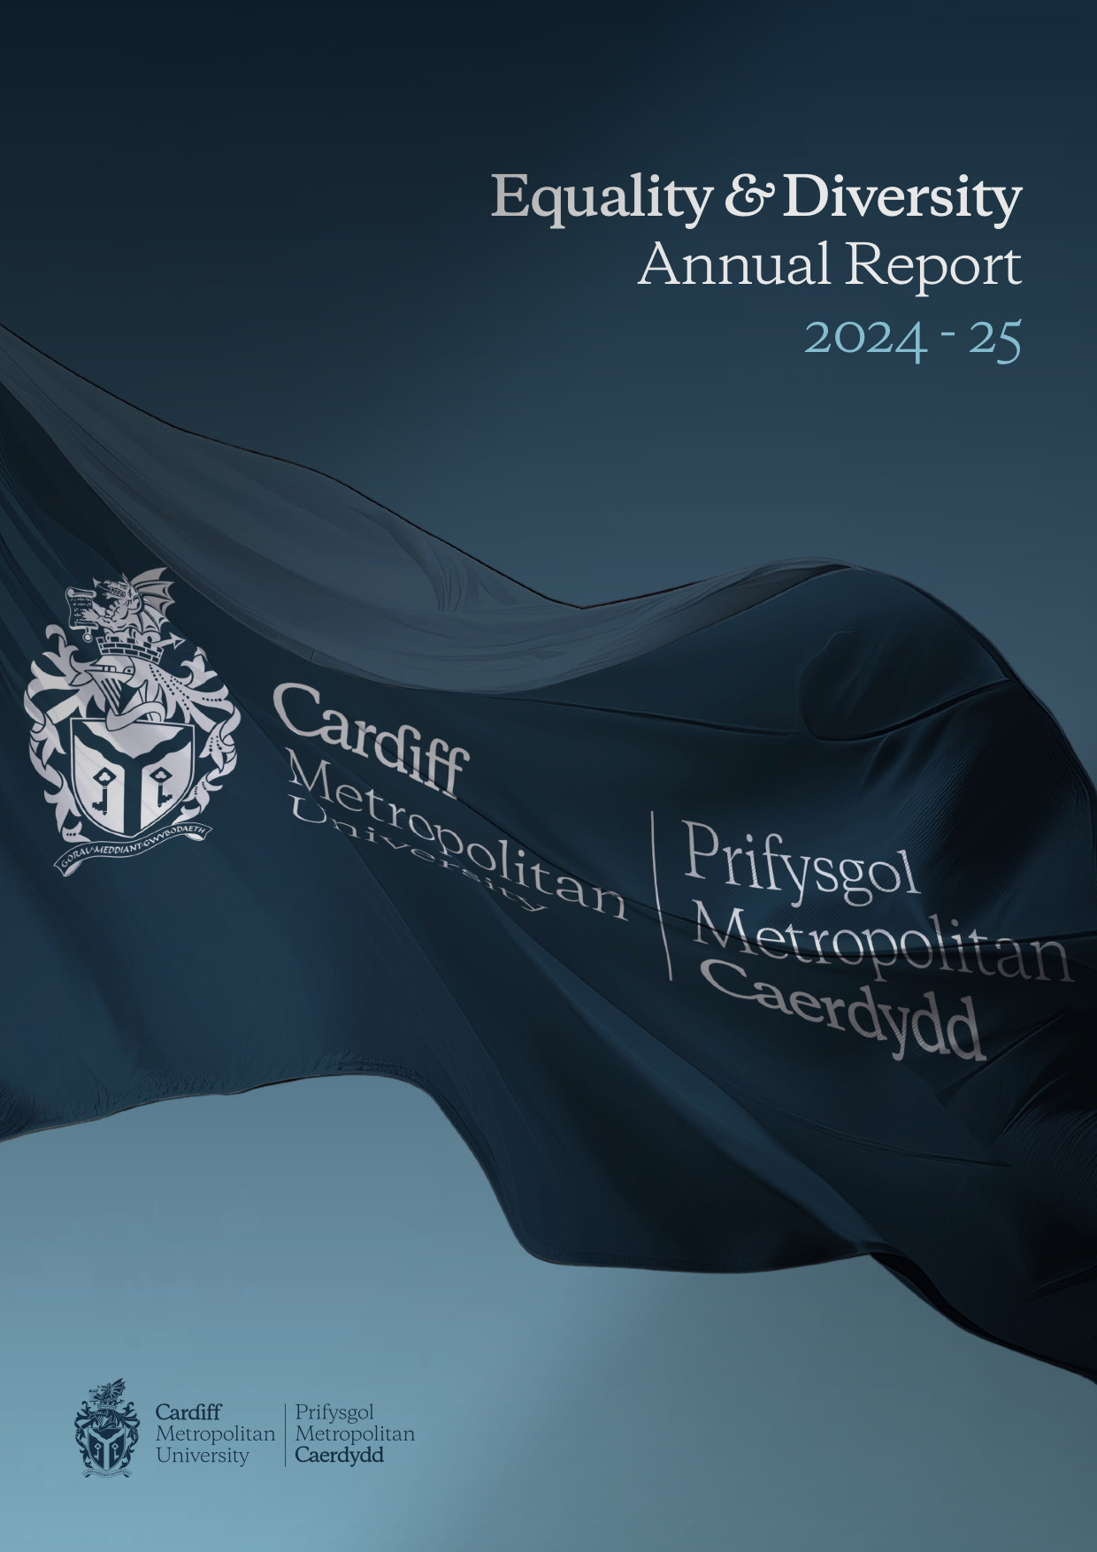

Introduction

The University places a great emphasis and value on Equality, Diversity and Inclusion (EDI) and we are committed to promoting and implementing best practice in EDI to provide a positive working and learning environment for our community.

We wish to ensure that Cardiff Met considers all aspects of equality, diversity and inclusion, ensuring that our policies and practices meet our statutory duties to support equality, diversity and inclusion, while also utilising sector best practice.

At Cardiff Met, we recognise the importance of the Welsh Language and are committed to ensuring that the Welsh and English languages are treated on a basis of equality when conducting our business in Wales. We aim to provide a culture where Welsh speaking staff, students and the public feel comfortable and confident in engaging with the University through the medium of Welsh.

Under the Specific Duties for Wales of the Equality Act 2010 Cardiff Met is required to produce a Strategic Equality Plan outlining equality objectives and to publish an annual monitoring report by the 31st March each year. The following report provides an overview of Cardiff Met’s equality data for the academic year 2024/25 by position.

EDI Governance at Cardiff Met

Board of Governors
The Board of Governors is made up of both external and internal members, with a lay majority; they have responsibility for the educational character and mission of our university, as well as having oversight of its activities.

Key functions of the Board include considering and approving our strategic plan, which sets our university's aims and objectives, and overseeing the financial, physical, and staffing strategies necessary to achieve this plan.

Academic Board
The Academic Board is a Committee of the Board of Governors and is responsible for advising the Vice-Chancellor and the Board of Governors. The Academic Board is both the University’s academic authority and its senior decision-making body for resources which support the University at a strategic level.

University Executive Group
The University Executive Group (UEG) membership consists of the senior leadership team of the University and assists the Vice-Chancellor.

Equality, Diversity and Inclusion Committee
The Equality, Diversity and Inclusion Committee’s aim is to promote and advance equality, diversity and inclusion across the University. The committee provides assurance to Academic Board on the execution of this responsibility and has oversight of the University's Strategic Equality Plan. The committee brings together key stakeholders from across the University to monitor progress in meeting the Equality Act 2010 general duty and other relevant equality legislation, ensuring the delivery of strategic targets and objectives.

Staff Profile 'Snapshot' 2024-25
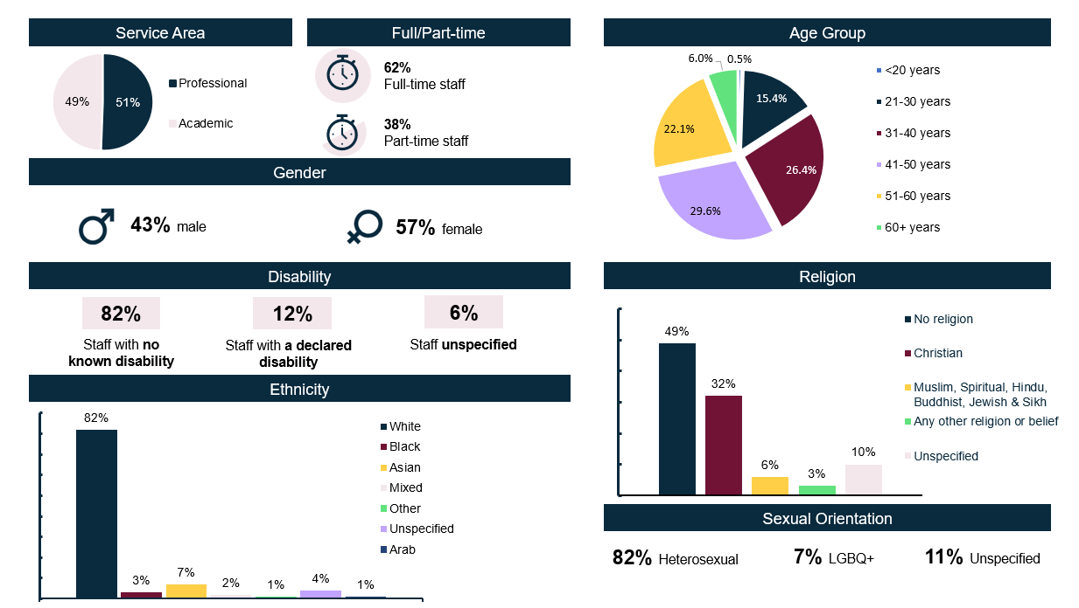

Student Profile 'Snapshot' 2024-25
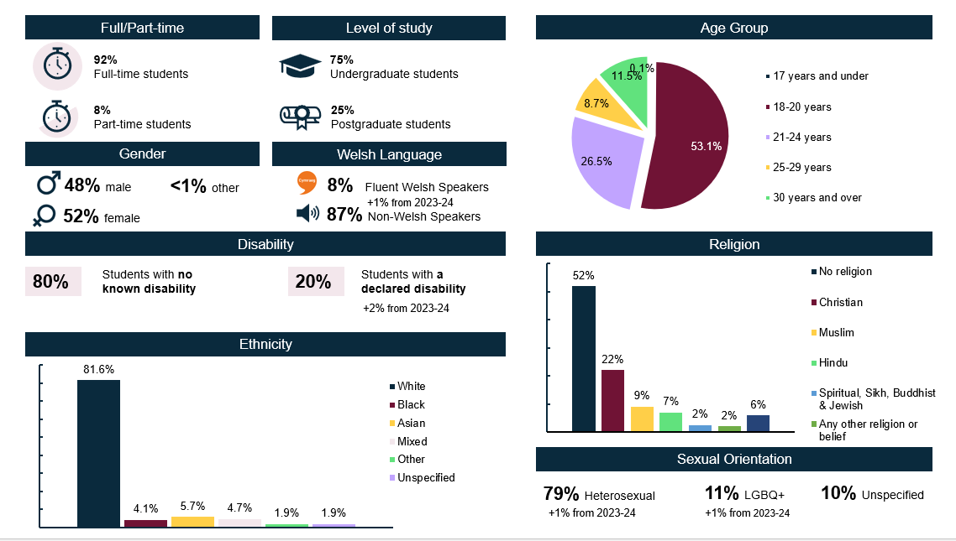

Sex Data 2024-25
Outer: Academic
Inner: Professional
Table 1: Sex of staff by function
 | Academic | Professional | Total
Male | 459 (46.9%) | 399 (39.9%) | 858 (43%)
Female | 519 (53.1%) | 602 (60.1%) | 1121 (57%)
Total | 978 | 1001 | 1979

Table 2: Sex of staff by grade
Grade* | Male | Female | Total
1A/1B | - | - | -
2A/2B | 42 (5%) | 58 (5%) | 100
3A/3B | 33 (4%) | 84 (7%) | 117
4A/4B | 79 (9%) | 139 (12%) | 218
5A/5B | 48 (6%) | 119 (11%) | 167
6A/6B | 101 (12%) | 120 (11%) | 221
7A/7B | 247 (29%) | 273 (24%) | 520
8A/8B | 155 (18%) | 210 (19%) | 365
9A/9B | 70 (8%) | 82 (7%) | 152
Above grade 9 | 83 (10%) | 36 (%) | 119
Total | 858 | 1121 | 1979

Table 3: Sex of staff by working pattern
 | Full-time | Part-time | Total
Male | 574 (47%) | 284 (38%) | 858
Female | 656 (53%) | 465 (62%) | 1121
Total | 1230 | 749 | 1979

Table 4: Sex of staff by contract type
 | Fixed-term | Permanent | Total
Male | 160 (48%) | 698 (42%) | 858
Female | 176 (52%) | 945 (58%) | 1121
Total | 336 | 1643 | 1979

Table 5: Sex of staff by leavers
Male | 90 (42%)
Female | 125 (58%)
Total | 215

Table 6: Sex of staff by Access to training
Male | 490
Female | 748
Total | 1238

Ethnicity Data 2024-25

Table 7: Ethnicity of staff by function
 | Academic | Professional | Total
White | 748 (76%) | 883 (88%) | 1631 (80%)
RM | 179 (18%) | 81 (8%) | 260 (13%)
Unspecified | 51 (5%) | 37 (4%) | 88 (4%)
Total | 978 | 1001 | 1979
Outer: Academic
Inner: Professional
Table 8: Ethnicity of staff by function (Breakdown)
 | Academic | Professional | Total
Arab | 14 (1%) | 4 (<1%) | 18 (1%)
Asian | 97 (10%) | 33 (3%) | 130 (7%)
Black | 30 (3%) | 20 (2%) | 50 (3%)
Mixed | 25 (3%) | 18 (2%) | 43 (2%)
Other | 13 (1%) | 6 (1%) | 19 (1%)
Unspecified | 51 (5%) | 37 (4%) | 88 (4%)
White | 748 (77%) | 883 (88%) | 1631 (82%)
Total | 978 | 1001 | 1979

Table 9: Ethnicity of staff by sex
 | Male | Female | Total
Arab | 10 (1%) | 8 (1%) | 18 (1%)
Asian | 67 (8%) | 63 (6%) | 130 (7%)
Black | 30 (4%) | 20 (2%) | 50 (3%)
Mixed | 10 (1%) | 33 (3%) | 43 (2%)
Other | 9 (1%) | 10 (1%) | 19 (1%)
Unspecified | 40 (5%) | 48 (4%) | 88 (4%)
White | 692 (81%) | 939 (84%) | 1632 (81%)
Total | 858 | 1121 | 1979

Table 10: Ethnicity of staff by leavers
White | 174 (81%)
RM | 33 (15%)
Unspecified | 8 (4%)
Total | 215

Table 11: Ethnicity of staff by Access to training
Arab | 12
Asian | 97
Black | 30
Mixed | 27
Other | 9
Unspecified | 24
White | 1040
Total | 1239

Disability Data 2024-25

Table 12: Disability of staff by function
 | Academic | Professional | Total
Mental health condition | 25 (3%) | 36 (4%) | 61 (3%)
Specific learning difference | 55 (6%) | 38 (4%) | 93 (5%)
Other disability | 44 (4%) | 42 (4%) | 86 (4%)
No known disability | 799 (82%) | 824 (82%) | 1623 (82%)
Unspecified | 55 (6%) | 61 (6%) | 116 (6%)
Total | 978 | 1001 | 1979

Table 13: Staff disability profile
Disability | 240 (12%)
No Disability | 1623 (82%)
Unspecified | 116 (6%)
Total | 1979

Table 14: Disability of staff by leavers
Disability | 30 (14%)
No Disability | 165 (77%)
Unspecified | 20 (9%)
Total | 215

Table 15: Disability of staff by Access to training
Disability | 100
No Disability | 1030
Unspecified | 109
Total | 1239

Sexual Orientation Data 2024-25

Table 16: Sexual Orientation of staff by function
 | Academic | Professional | Total
Bisexual | 12 (1%) | 28 (3%) | 40 (2%)
Gay or lesbian | 42 (4%) | 36 (3%) | 78 (4%)
Heterosexual | 803 (82%) | 828 (83%) | 1631 (82%)
Other | 4 (1%) | 9 (1%) | 13 (1%)
Unspecified | 117 (12%) | 100 (10%) | 217 (11%)
Total | 978 | 1001 | 1979

Table 17: Sexual Orientation of staff by leavers
Bisexual | 17 (8%)
Gay or lesbian | 10 (5%)
Heterosexual | 168 (78%)
Other | <5 (<1%)
Unspecified | 19 (9%)
Total | 215

Table 18: Sexual Orientation of staff by Access to training
Bisexual | 34
Gay or lesbian | 46
Heterosexual | 1026
Other | 11
Unspecified | 122
Total | 1239

Age Data 2024-25

Table 19: Age of staff by function
 | Academic | Professional | Total
<20 years | - | 10 (1%) | 10 (1%)
21 to 30 years | 95 (10%) | 209 (21%) | 304 (15%)
31 to 40 years | 241 (25%) | 281 (28%) | 522 (26%)
41 to 50 years | 331 (34%) | 255 (25%) | 586 (30%)
51 to 60 years | 237 (24%) | 201 (20%) | 438 (22%)
60+ years | 74 (8%) | 45 (4%) | 119 (6%)
Total | 978 | 1001 | 1979

Table 20: Age of staff by leavers
Under 21 | 5 (2%)
21 to 30 years | 45 (21%)
31 to 40 years | 43 (20%)
41 to 50 years | 45 (21%)
51 to 60 years | 54 (25%)
60+ years | 23 (11%)
Total | 215

Table 21: Age of staff by Access to training
Under 21 | 5
21 to 30 years | 191
31 to 40 years | 331
41 to 50 years | 350
51 to 60 years | 280
60+ years | 82
Total | 1239

Religion and Belief Data 2024-25

Table 22: Religion and Belief of staff by function
 | Academic | Professional | Total
Any other religion or belief | 28 (3%) | 31 (3%) | 59 (3%)
Buddhist | 12 (1%) | <5 (<1%) | 15 (1%)
Christian | 314 (32%) | 310 (31%) | 624 (32%)
Hindu | 19 (2%) | 9 (1%) | 28 (1%)
Jewish | <5 (<1%) | <5 (<1%) | 6 (<1%)
Muslim | 62 (6%) | 14 (1%) | 76 (4%)
No religion | 430 (44%) | 534 (53%) | 964 (49%)
Sikh | <5 (<1%) | <5 (<1%) | <5 (<1%)
Unspecified | 106 (11%) | 97 (10%) | 203 (10%)
Total | 978 | 1001 | 1979
Table 24: Religion and Belief of staff by Access to training
Any other religion or belief | 17
Buddhist | 6
Christian | 380
Hindu | 21
Jewish | 5
Muslim | 56
No religion | 622
Not Available | 5
Prefer not to say | 104
Sikh | <5
Spiritual | 20
Total | 1239

Table 23: Religion and Belief of staff by leavers
Any other religion or belief | 12 (4%)
Buddhist | <5 (1%)
Christian | 69 (32%)
Hindu | <5 (1%)
Jewish | <5 (<1%)
Muslim | 9 (4%)
No religion | 96 (45%)
Unspecified | 23 (11%)
Total | 215

Marriage & Civil Partnerships Data 2024-25

Table 25: Marital status of staff by function
 | Academic | Professional | Total
Co-habiting | 23 (2%) | 44 (4%) | 67 (3%)
Divorced/formerly in a civil partnership | 10 (1%) | 15 (1%) | 25 (1%)
Married/civil partnership | 546 (56%) | 416 (42%) | 962 (49%)
Never married/registered in a civil partnership | 288 (29%) | 444 (44%) | 732 (37%)
Separated | <5 (<1%) | 7 (1%) | 10 (1%)
Unspecified | 106 (11%) | 74 (7%) | 180 (9%)
Widowed/surviving partner from civil partnership | <5 (<1%) | <5 (<1%) | <5 (<1%)
Total | 978 | 1001 | 1979
Table 27: Marital status of staff by Access to training
Co-habiting | 48
Divorced/formerly in a civil partnership | 18
Married/civil partnership | 579
Never married/registered in a civil partnership | 485
Separated | 99
Unspecified | 9
Widowed/surviving partner from civil partnership | <5
Total | 1239

Table 26: Marital status of staff by leavers
Co-habiting | <5 (2%)
Divorced/formerly in a civil partnership | <5 (1%)
Married/civil partnership | 97 (45%)
Never married/registered in a civil partnership | 90 (42%)
Separated | <5 (1%)
Unspecified | 17 (8%)
Widowed/surviving partner from civil partnership | <5 (1%)
Total | 215

Pregnancy & Maternity Data 2024-25

Maternity Leave
57 members of staff took maternity leave during the current report period.

Paternity Leave
<5 member of staff took Paternity Leave during the current reporting period.

Parental Leave
<5 member of staff took Parental Leave during the current reporting period.

Adoption Leave
No member of staff took Adoption Leave during the current reporting period.

Shared Parental Leave
No members of staff took Shared Parental Leave during the current reporting period.

Training
59 members of staff on leave undertook training during the reporting period.

Gender Reassignment Data 2024-25

Table 27: Gender Reassignment staff overview
Gender identity same as sex registered at birth | 1655 (84%)
Gender identity different to sex registered at birth | 19 (1%)
Unspecified | 305 (15%)
Total | 1979

Table 28: Gender Reassignment of staff by leavers
Gender identity same as sex registered at birth | 182 (85%)
Gender identity different to sex registered at birth | <5 (1%)
Unspecified | 30 (14%)
Total | 215

Table 29: Gender Reassignment of staff by Access to training
Gender identity same as sex registered at birth | 896
Gender identity different to sex registered at birth | 48
Unspecified | 295
Total | 1239

Staff Recruitment Data 2024-25

Recruitment activity such as the use of head hunters, agencies etc is not counted within the tables below.

Table 30: Progression through recruitment stages
 | Ethnicity |  |  | Sex |  | Disability |  | Sexual Orientation
 | White | RM | Unspecified | Male | Female | No Disability | Disability | LGBQ+ | Heterosexual
Applications | 1806 (51%) | 1668 (47%) | 83 (2%) | 1874 (53%) | 1585 (45%) | 3107 (87%) | 263 (7%) | 363 (11%) | 2890 (89%)
Interviews | 557 (65%) | 291 (34%) | 13 (2%) | 424 (49%) | 404 (47%) | 738 (86%) | 66 (8%) | 82 (11%) | 695 (89%)
Appointed | 335 (70%) | 140 (29%) | 7 (1%) | 229 (48%) | 230 (48%) | 417 (87%) | 27 (6%) | 38 (9%) | 395 (91%)

Table 31: Progression through recruitment stages – Gender Reassignment
 | Gender identity same as sex registered at birth | Gender identity different to sex registered at birth | Unspecified
Applications | 3266 (92%) | 42 (1%) | 249 (7%)
Interviews | 768 (89%) | <5 (1%) | 88 (10%)
Appointed | 436 (90%) | <5 (1%) | 44 (9%)

Table 32: Progression through recruitment stages – Religion and Belief
 | Any other religion | Buddhist | Christian | Hindu | Jewish | Muslim | No Religion | Pagan | Sikh | Spiritual | Unspecified
Applications | 37 (1%) | 66 (2%) | 882 (25%) | 352 (10%) | 11 (<1%) | 446 (13%) | 1444 (41%) | 8 (<1%) | 12 (<1%) | <5 (<1%) | 296 (8%)
Interviews | 10 (1%) | 11 (1%) | 206 (24%) | 43 (43%) | <5 (<1%) | 71 (8%) | 424 (49%) | <5 (<1%) | <5 (<1%) | <5 (<1%) | 90 (10%)
Appointed | <5 (<1%) | <5 (1%) | 125 (26%) | 14 (3%) | <5 (<1%) | 35 (7%) | 256 (53%) | - | - | - | 46 (10%)

Table 33: Progression through recruitment stages – Sexual Orientation
 | Bisexual | Gay | Heterosexual | Lesbian | Other | Unspecified
Applications | 206 (6%) | 68 (2%) | 2890 (81%) | 45 (1%) | 44 (1%) | 307 (9%)
Interviews | 46 (5%) | 12 (1%) | 695 (81%) | 14 (2%) | 10 (1%) | 84 (10%)
Appointed | 27 (6%) | <5 (1%) | 395 (83%) | <5 (1%) | <5 (1%) | 44 (9%)

Table 34: Progression through recruitment stages – Age*
 | <21 | 21-30 | 31-40 | 41-50 | 51-60 | 60+ | Unspecified
Applications | 98 (3%) | 963 (27%) | 385 (11%) | 204 (6%) | 83 (2%) | 20 (1%) | 1804 (51%)
Interviews | 33 (4%) | 169 (20%) | 82 (10%) | 65 (8%) | 22 (3%) | <5 (1%) | 485 (56%)
Appointed | 25 (5%) | 38 (8%) | 38 (8%) | 21 (4%) | 9 (2%) | <5 (1%) | 312 (65%)
*High volume of ‘Unspecified’ due to the implementation of new Hire system. This was corrected mid-way through the academic year.

Grievances and Disciplinaries 2024-25

Only formal grievances are recorded within People Services as a full and fair procedure in line with the ACAS Code must be followed for any formal grievance raised. The procedure followed will be taken into account if the case reaches an employment tribunal.

In comparison to 2023/2024 in which four grievances were received, in 2024/25 one formal grievance was raised in relation to allegations of bullying and harassment. The allegations were not related to a protected characteristic. Following investigation, allegations were partially upheld and an informal resolution was agreed.

People Services continue to monitor all cases and assess for any wider EDI issues.

Due to maintaining data confidentiality, we are unable to provide any details on the individuals who raised the grievances, or the specifics of the grievances raised. This is in line with GDPR requirements and Statistical Disclosure best practice.

Appendices

Appendix 1 – Compliance Information

Appendix 2 – Strategic Equality Plan 2024-25 Progress

Equality, Diversity and Inclusion Team

 | Martin Smith  Equality & Diversity Officer  mrsmith@cardiffmet.ac.uk
Alysean Banks
EDI Project Coordinator
abanks@cardiffmet.ac.uk

General Enquiries: equality@cardiffmet.ac.uk
Website: Cardiff Metropolitan University - Study in Cardiff


`

