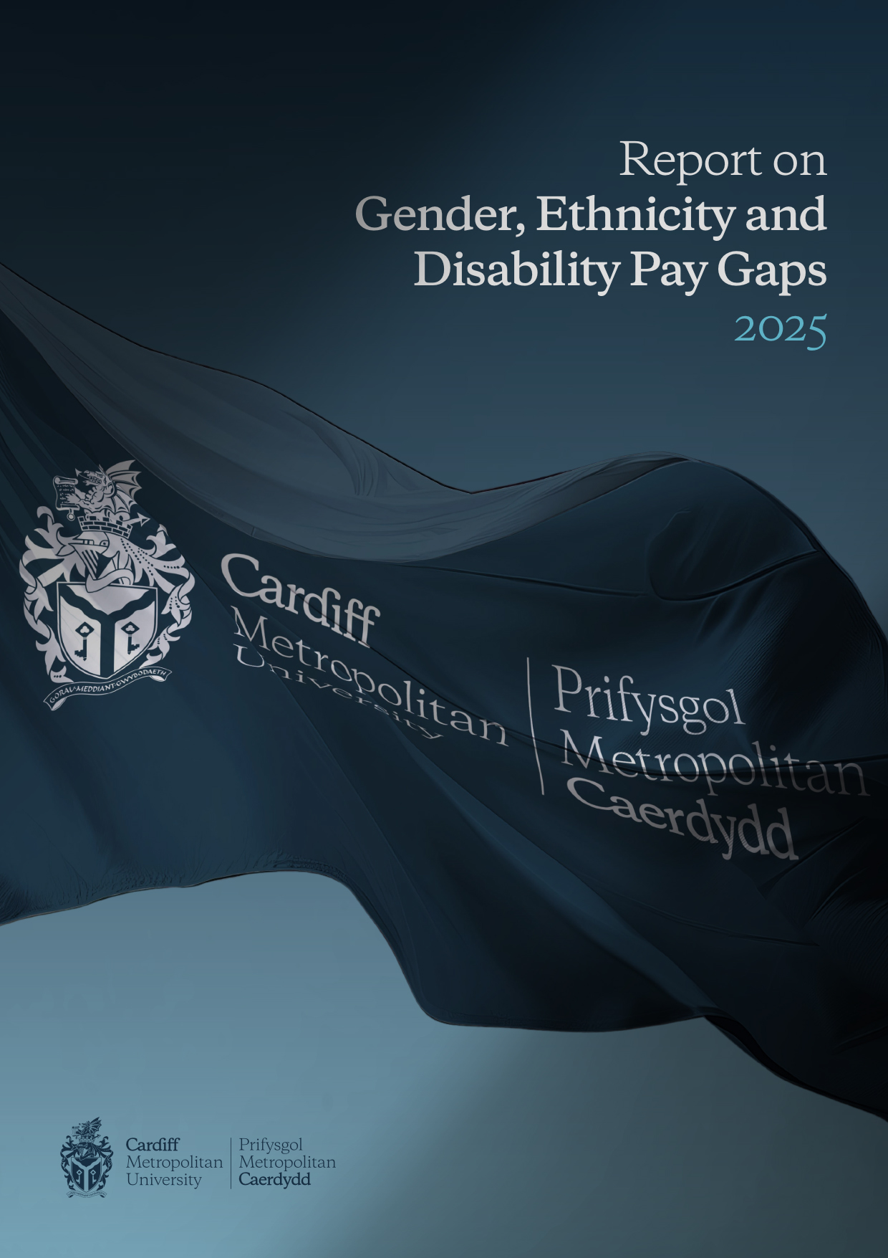

This document is also available in Welsh / Mae’r ddogfen hon hefyd ar gael yn Gymraeg

Welcome

This report contains the findings from Cardiff Metropolitan University’s examination of gender, ethnicity and disability pay gap disparities within its workforce as of 31 March 2025. It aligns with the University’s strategic objectives, as outlined in the Strategy 2030. The document details both the measures already undertaken to address these pay gaps and the planned initiatives for future improvement.
In a year in which the University has successfully achieved it’s Race Equality Charter Bronze Award and following our attainment of the Athena Swan Silver Award in 2024, a continuing range of networks, schemes and initiatives have been established to specifically support underrepresented groups within the University, ensuring that every individual receives the necessary resources to advance in their careers and reach their full potential.
The publication of our Report on Gender, Ethnicity and Disability Pay Gaps 2025 is a vital part of our ongoing commitment to inclusivity. We are committed to placing EDI at the forefront of the design and delivery of our university functions, as ever, with the ultimate goal of eliminating all pay disparities across the institution.

Professor Rachael Langford
President and Vice-Chancellor

Introduction

As part of statutory requirements under the Equality Act 2010, we report on our annual analysis of the gender pay gap at Cardiff Metropolitan University

In addition, for the fourth consecutive year we are reporting the results of the University’s Ethnicity Pay Gap and Disability Pay Gap analysis and for the third time considering intersectionality data.

We prepare this report as part of our equality, diversity, and inclusion commitment so that we understand and monitor our position and identify actions to take, regardless of whether it is a statutory requirement.

The Higher Education landscape is changing across England and Wales and experiencing unprecedented levels of financial challenge. Since March 2024, we have prioritised efforts to develop a financial recovery programme that reduces our costs but does so with an eye to new ways of working aligned to delivering on our strategic objectives. This has included undertaking two voluntary severance schemes in May and December 2024 alongside other actions, including vacancy control.

A comparison of our staff profile reported in the 2024 and 2025 pay gap reports shows that despite a reduction in the size of the workforce, our demographic profile by sex and ethnicity remains the same and the number of staff who have declared whether or not they have a disability has improved.

Our demographic data:

The data below provides a breakdown of staff demographics by sex, ethnicity and disability as at March 2025.

Table 1
Sex | Staff (March 2025) |  | Census 2021 Benchmark
Sex | N | % | %
Male | 774 | 43 | 49
Female | 1032 | 57 | 51

Table 2
Ethnicity | Staff (March 2025) |  | Census 2021 Benchmark
Ethnicity | N | % | %
White | 1510 | 83.6 | 82
Racially Minoritised (RM) | 241 | 13.3 | 18
Unknown / Not declared | 55 | 3.1 | -

Table 3
Disability | Staff (March 2025) |  | Census 2021 Benchmark
Disability | N | % | %
No Disability | 1444 | 80 | 82
Disability | 214 | 12 | 18
Unknown / Not declared | 148 | 8 | -

Definitions

What is Equal Pay?

Equal pay looks at the pay differences between men and women who carry out the same jobs, similar jobs or work of equal value. Cardiff Met supports the principle of equal pay for work of equal value and its systems, practices and policies are based on these principles.

What is the Pay Gap?

The gender pay gap is the percentage difference in the average hourly rate of pay of male and female employees. We have published our numbers in line with the gender pay gap reporting guidelines.

The ethnicity pay gap is the percentage difference in the average hourly rate of pay of white and black, Asian and minority ethnic employees. We calculate our ethnicity pay gap using the same methodology set out in the government regulations for calculating our gender pay gap

The disability pay gap is the percentage difference in the average hourly rate of pay of employees with a disability and those who do not have a disability. We calculate our disability pay gap using the same methodology set out in the government regulations for calculating our gender pay gap

Mean and Median

The mean and the median are measures of central tendency within data sets, used as industry standard to analyse pay gaps.

Mean- the mean (average) involves adding together the pay of staff and then dividing by the total number of staff.

Median – the median is the middle value of all hourly rates when ranked. That is the amount paid to staff in the middle of the list, if staff are listed in order of pay or bonus. We look at the median as it’s less affected by numbers at the top end of the pay range.

Data included in this report
Salary and workforce information for all staff paid via our payroll as of 31 March 2025.

The calculations follow current legislative requirements, and we confirm the data reported is accurate.

Gender Pay Gap

Gender Representation within Cardiff Metropolitan University (March 2025)

On 31 March 2025, the University employed 1806 staff as defined by the Gender Pay Gap reporting guidelines*, of which 57% are Female and 43% are Male.

Cardiff Metropolitan Gender Pay Gap 2025
The gender pay gap shows the difference in the average pay between men and women in the workforce. A gender pay gap is created, for example, when more men than women are employed in senior roles or more women than men are employed in lower paid roles.

Mean Gender Pay Gap
The mean pay gap is the difference between the average hourly earnings of men and women.
Table 4
 | 31/03/2021 | 31/03/2022 | 31/03/2023 | 31/03/2024 | 31/03/2025
Mean Pay Gap (%) | 11.23 | 11.31 | 9.98 | 7.78 | 7.04
- Our mean gender pay gap is 7.04% in favour of males.
- The mean gender pay gap has decreased by 0.74% since 2024

There is a combination of reasons for the slight decrease in the mean percentage:
56.8% of new starters in the top middle quartile and 58% of the lower middle quartile were female, with a mean of £16.28 compared to the male new starters of the same quartiles which had a mean of £15.94.
Although female staff make up 57% of the leavers the mean of male leavers is higher at £21.84 compared to the female leavers mean of £18.95. An average difference of £2.89 in favour of females.
This in turn moves the average hourly rate closer to the male average rate thereby reducing the percentage difference from the previous year.
A greater proportion of higher salaried males left the University between snapshot dates.

Median Gender Pay Gap

The median pay gap is the difference between the midpoints in the ranges of hourly earnings of men and women.
Table 5
 | 31/03/2021 | 31/03/2022 | 31/03/2023 | 31/03/2024 | 31/03/2025
Median Pay Gap (%) | 8.47 | 8.42 | 6.87 | 11.04 | 3.26
- Our median gender pay gap is 3.26%
- The median gender pay gap has decreased by 7.78% since 2024

The change in the median pay is largely influenced by transitions in the staff population, encompassing organisational restructuring and leavers through our voluntary severance programmes. Among the 110 male leavers, the median pay was £19.21, while for the 146 female leavers, it was £15.33—resulting in a median difference of £3.88. Notably, the most significant variation appeared in the top quartile, where female leavers had a median of £31.27 compared to £35.66 for males. In contrast, the median pay for both male and female starters was consistent at £14.49, reflecting a balanced entry point for new staff.

Between 2024 and 2025, the overall staff population decreased by 136, reflecting the University’s strategy to optimise its resource and manage pay costs effectively. This included a planned reduction in core staff and a smaller cohort of Associate Tutors and Casual staff. In 2025, there were196 staff on casual contracts and 65 Associate Tutors—15 fewer than the previous year. Of the 196 casual staff, 77 (39.3%) are male and 119 (60.7%) are female, highlighting the continued diversity within the workforce.

The above is reflected in the quartile data in figures 3 and 4. The number of males has decreased by 4.3% from the previous collection date however the female staff count shows an 8.9% decrease on the previous population. A clear indication of the change is highlighted in the bottom two quartiles where the male headcount decreased by 5, whereas the female headcount in the bottom two quartiles decreased by 64. Female representation has increased in the upper middle quartile, affecting the median positively.
Between April 2024 and March 2025, we have recruited 139 core staff, 101 male and 68 female.

The above changes in the workforce coupled with the deferral of the 2024 pay award mean that analysis is more restricted when compared with previous years.

Figure 1: Headcount by gender – March 2025
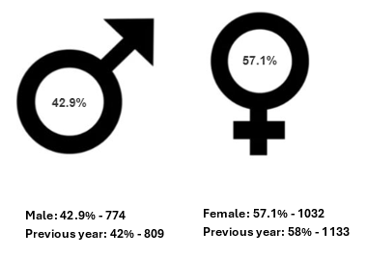

Figure 2: Mean and Median hourly rates and pay gap percentage
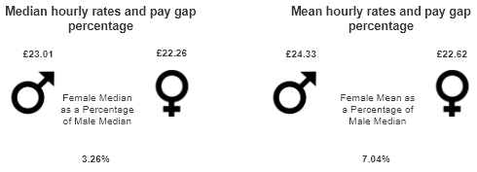

Cardiff Metropolitan University Gender Bonus Gap 2025

Table 6
Bonus Pay Gap | 31/03/2021 | 31/03/2022 | 31/03/2023 | 31/03/2024 | 31/03/2025
Percentage of Men Receiving Bonus Pay | 0.73 | 0.35 | 0 | 0 | 0
Percentage of Women Receiving Bonus Pay | 0.84 | 0.16 | 0 | 0 | 0
- 0% of women were awarded a bonus.
- 0% of men were awarded a bonus.

- The mean bonus gap is 0%.
- The median bonus gap is 0%.

There has been a decrease in the bonus pay gap since March 2021. For many years we operated a contractual bonus scheme for a very small section of our workforce which has impacted on the gender bonus gap. This scheme no longer exists which has positively impacted on the gender bonus gap and for the third consecutive year this is now 0%.

Pay by Quartile – Gender

The tables below show hourly pay by quartile for the University. It shows that there is a higher proportion of women in all quartiles compared to men. However, the proportion of women in the lower middle and lower quartiles is higher than the number of men and this is driving our gender pay gap.

At Cardiff Met we operate an incremental progression pay model where employees progress each year through the pay range until they reach the maximum pay point for their grade. This does mean that individuals may move between quartiles without any contractual change.

Figure 3: Headcount by quartile - 2024
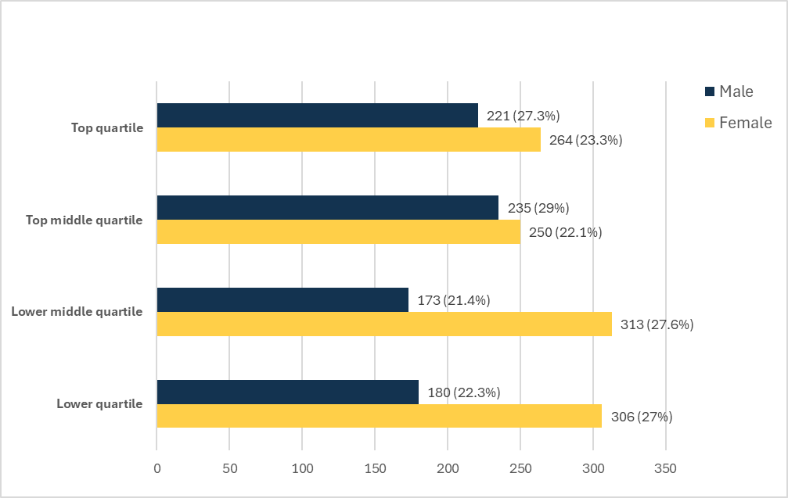
Figure 4: Headcount by quartile - 2025
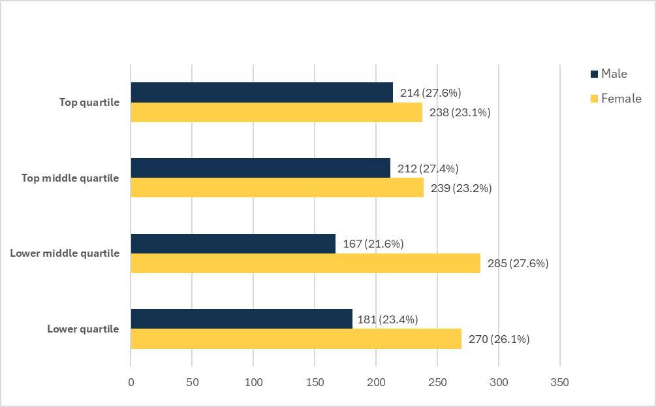
Table 7: Percentage of men and women in each hourly pay quarter
Percentage of men and women in each hourly pay quarter | 31/03/2021 | 31/03/2022 | 31/03/2023 | 31/03/2024 | 31/03/2025
Percentage of Men in Top Quartile | 51.52 | 50.90 | 48.06 | 45.57 | 47.35
Percentage of Women in Top Quartile | 48.48 | 49.10 | 51.94 | 54.43 | 52.65
Percentage of Men in Upper Middle Quartile | 44.42 | 44.50 | 49.35 | 48.45 | 47.01
Percentage of Women in Upper Middle Quartile | 55.58 | 55.50 | 50.65 | 51.55 | 52.99
Percentage of Men in Lower Middle Quartile | 36.61 | 39.90 | 40.41 | 35.6 | 36.95
Percentage of Women in Lower Middle Quartile | 63.39 | 60.10 | 59.59 | 64.4 | 63.05
Percentage of Men in Lower Quartile | 35.01 | 30.40 | 31.01 | 37.04 | 40.13
Percentage of Women in Lower Quartile | 64.99 | 69.60 | 68.99 | 62.96 | 59.87

Ethnicity Pay Gap

We calculate the ethnicity pay gap in the same way as we calculate the gender pay gap and we use the same data collection point of 31st March 2025. This is the fourth consecutive year of publishing our findings.

Our ethnicity data may be influenced by a number of staff who have chosen not to voluntarily disclose this information. The University will continue to explore ways of encouraging staff to disclose this information going forward.

In previous iterations of our reports, we have used the term ‘BAME’. To reflect a broader shift in how people talk about race, identity, and inequality and to align with our work on the Advance HE Race Equality Charter, we have adopted the term Racially Minoritised (RM).

Ethnicity Representation within Cardiff Metropolitan University (March 2025)

The following data below is based on the proportion of staff who declared their ethnicity (96.9%).

Figure 5: Headcount by Ethnicity – March 2025
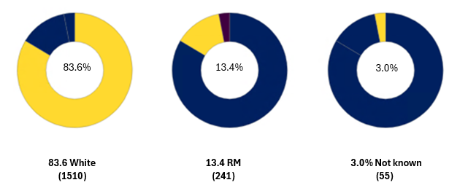

Cardiff Metropolitan Ethnicity Pay Gap 2025

The ethnicity pay gap shows the difference in the average pay between RM and white staff. An ethnicity pay gap is created, for example, when more white staff are employed in senior roles or a greater number of RM staff than white staff are employed in lower paid jobs.

Mean Ethnicity Pay Gap
The mean pay gap is the difference between the average hourly earnings of RM staff and white staff.

Table 8
 | 31/03/2022 | 31/03/2023 | 31/03/2024 | 31/03/2025
Mean Pay Gap (%) | -3.31 | -1.23 | 2.77 | 1.51
- Our mean ethnicity gap is 1.51% in favour of white staff, which is a shift from having been in favour of RM staff in 2023.
While the percentage of RM staff has grown slightly in the 2 middle quartiles and decreased in the top and lower quartile there are less RM staff in this year’s population. The decrease in the mean pay gap in favour of White staff is attributable to this decrease in the white population in all the quartiles.

The RM population decreased by 0.8%, the white population decreased by 8.3% and the Unknown population increased by 5.8%.

Median Ethnicity Pay Gap
The ethnicity median pay gap is the difference between the midpoints in the ranges of hourly earnings of Black, Asian and Minority Ethnic staff and white staff.

Table 9
 | 31/03/2022 | 31/03/2023 | 31/03/2024 | 31/03/2025
Median Pay Gap (%) | -15.85 | -5.5 | -3.01 | -8.49
- Our median ethnicity gap is -8.4% in favour of RM staff, an increase in the last year.
This is due to a decrease in the population between 2024 and 2025 and a reduction in head count in white staff across all quartiles. As shown in figures 6 and 7, the overall headcount in RM staff has decreased by 2. The reason for the increase in the median pay gap in favour of RM staff is due to 87% (169) of leavers being white staff compared to 13% (34) of leavers being RM. The percentage of RM staff increased in the top 3 quartiles. The top quartile is 11.73% up from 11.1%, top middle quartile is 20.8% up from 18.1% and the top lower quartile is 7.8% up from 6.4%. Only in the lower quartile did the percentage decrease to 13.8% from 14.9%.

Cardiff Metropolitan University Ethnicity Bonus Gap 2025

The ethnicity bonus gap continues to be 0% as no bonuses are paid.

Ethnicity - Pay by quartile
Figure 6: Headcount by quartile – 2024
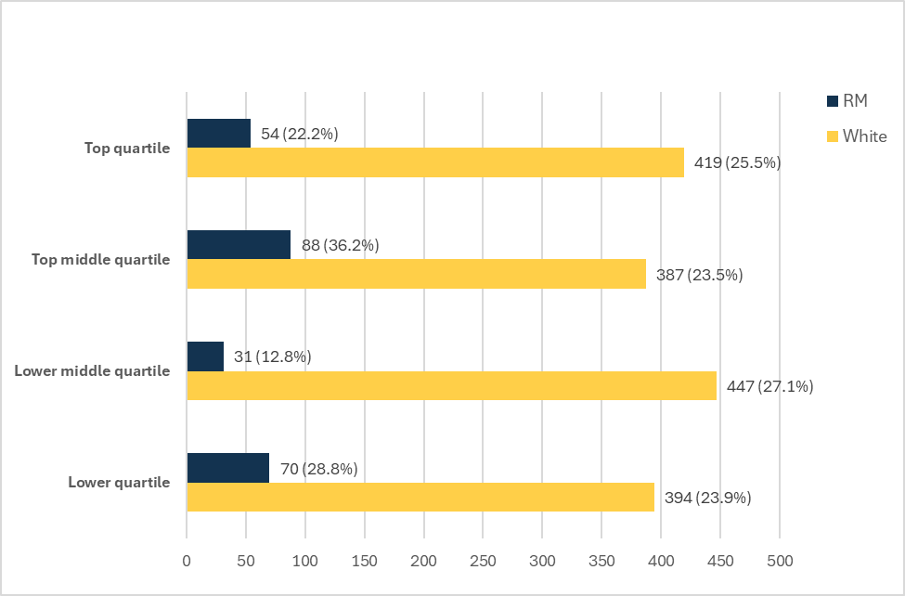

Figure 7: Headcount by quartile – 2025
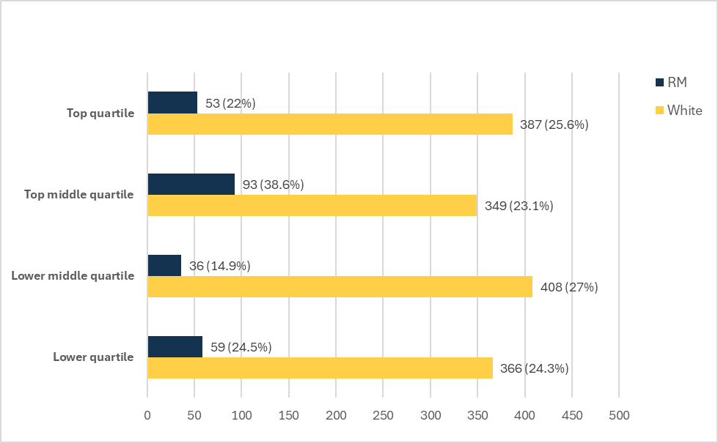

Table 10: Percentage of Racially Minoritised and White staff in each pay quarter

Percentage of Racially Minoritised ethnicity staff and white ethnicity staff in each hourly pay quarter | 31/03/2022 | 31/03/2023 | 31/03/2024 | 31/03/2025
Percentage of Racially Minoritised ethnicity in Top Quartile | 8.84 | 9.3 | 11.11 | 11.73
Percentage of white ethnicity in Top Quartile | 87.50 | 88.11 | 86.21 | 85.62
Percentage of Racially Minoritised ethnicity in Upper Middle Quartile | 15.45 | 20.67 | 18.11 | 20.80
Percentage of white ethnicity in Upper Middle Quartile | 82.12 | 77.52 | 79.63 | 77.21
Percentage of Racially Minoritised ethnicity in Lower Middle Quartile | 6.71 | 8.29 | 6.39 | 7.76
Percentage of white ethnicity in Lower Middle Quartile | 91.46 | 90.67 | 92.16 | 90.47
Percentage of Racially Minoritised ethnicity in Lower Quartile | 7.60 | 9.56 | 14.43 | 13.08
Percentage of white ethnicity in Lower Quartile | 89.06 | 87.34 | 81.24 | 81.15

Disability Pay Gap
We calculate disability pay gap in the same way as we calculate gender pay gap and we use the same data collection point of 31st March 2025. This is the fourth consecutive year of publishing our findings.

Our disability data may be influenced by a number of staff who have chosen not to voluntarily disclose this information. The University will continue to explore ways of encouraging staff to disclose this information going forward.

For the purposes of reporting our disability pay gap we make comparisons between staff who have declared whether or not they have a disability.

Disability Representation within Cardiff Metropolitan University (March 2025)

The following data below is based on the proportion of staff who declared whether they consider themselves to have a disability (91.8%).

Figure 8: Headcount by disability declaration – March 2025
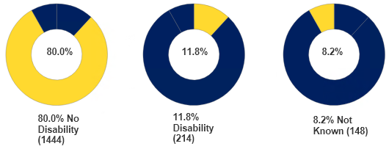

Mean Disability Pay Gap

The mean pay gap is the difference between the average hourly earnings of staff with a declared disability and staff with no known disability.

Table 11
 | 31/03/2022 | 31/03/2023 | 31/03/2024 | 31/03/2025
Mean Pay Gap (%) | 6.49 | 5.8 | 7.63 | 1.66
- Our mean disability pay gap is 1.66% in favour of those with no declared disability. This has decreased by 5.97% since 2024.

Disability - Median Pay Gap

The disability median pay gap is the difference between the midpoints in the ranges of hourly earnings of staff with no known disability and staff with a declared disability.

Table 12
 | 31/03/2022 | 31/03/2023 | 31/03/2024 | 31/03/2025
Median Pay Gap (%) | 8.43 | 2.82 | 8.34 | 1.50
- Our median disability pay gap is 1.50% in favour of those with no declared disability, which has decreased by 6.84% since 2025. This is due to 12.5% (32) of leavers had a self-certified disability compared to 182 staff leavers with no disability recorded. This contrast is highlighted in Fig 9 and 10 where the non-disability populations have reduced by greater numbers across all quartiles than self-certified disability staff, thus reducing both the mean and median of the characteristic.
Figure 9: Headcount by quartile – 2024
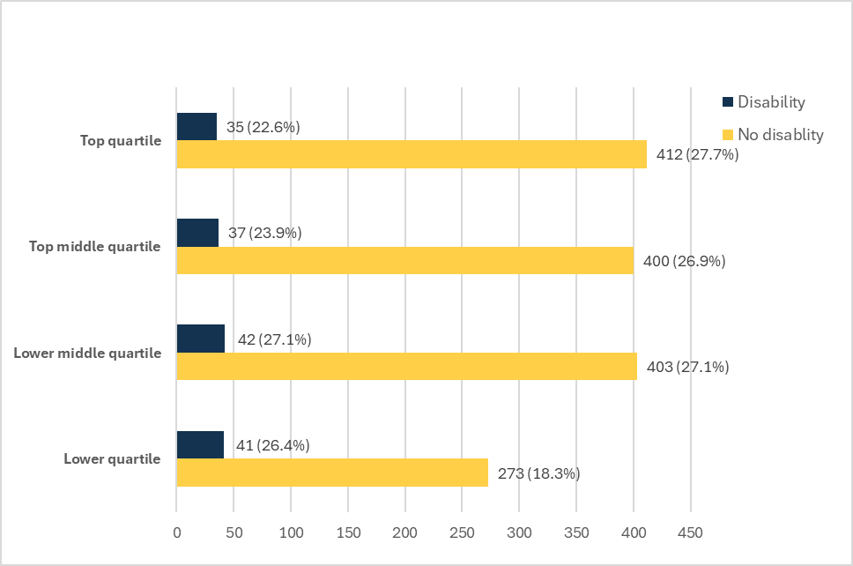
Figure 10: Headcount by quartile – 2025
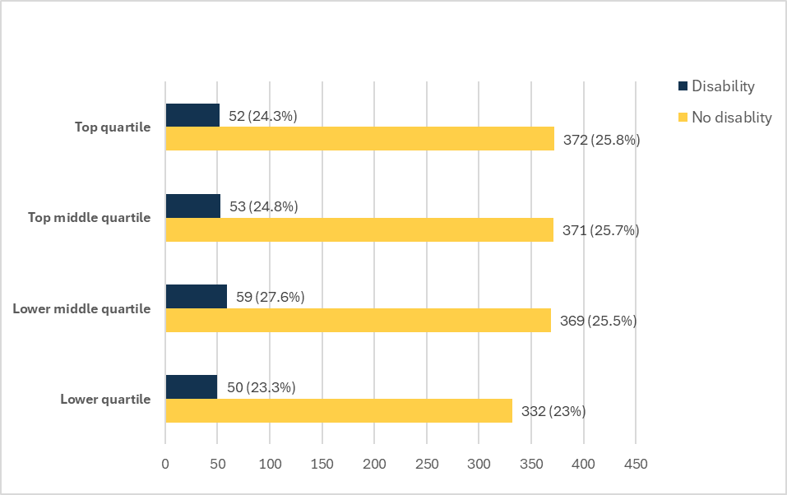
Cardiff Metropolitan University Disability bonus gap 2025

The disability bonus gap continues to be 0% as no bonuses are paid.

Pay by Quartile

The table below shows the hourly pay by quartile for the University based on staff with a disability and with no known disability. It shows that there is a higher proportion of staff with no known disability in all quartiles. There is a higher proportion of staff with a declared disability in the lower quartiles than in the top/upper middle quartiles.

Table 13: Percentage of staff with a disability and with no disability in each pay quarter

Percentage of staff with a disability and with no disability in each hourly pay quarter | 31/03/2022 | 31/03/2023 | 31/03/2024 | 31/03/2025
Percentage with a declared disability in Top Quartile | 5.49 | 5.68 | 7.21 | 11.50
Percentage with no known disability top Quartile | 87.80 | 87.08 | 84.94 | 82.30
Percentage with a declared disability in Upper Middle Quartile | 3.94 | 5.43 | 7.62 | 11.73
Percentage with no known disability in Upper Middle Quartile | 86.06 | 83.72 | 82.47 | 82.30
Percentage with a declared disability in Lower Middle Quartile | 6.10 | 6.99 | 8.64 | 13.08
Percentage with no known disability in Lower Middle Quartile | 86.28 | 83.68 | 82.92 | 81.60
Percentage with a declared disability in Lower Quartile | 6.69 | 6.46 | 8.43 | 11.09
Percentage with no known disability in Lower Quartile | 82.37 | 78.04 | 56.17 | 73.61

Intersectionality Data

The University is also presenting intersectional pay gap analysis by gender and ethnicity and also gender and disability. This data is published with the recognition that we continue to face challenges and need to go further in our analysis and understanding of how to address these gaps.

Figure 11: Gender By Disability and Average Hourly Rate (Mean)
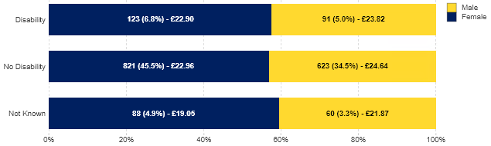

Males have a higher average hourly rate of pay in comparison to their female counterparts in all categories.

Figure 12: Gender By Ethnicity and Average Hourly Rate (Mean)
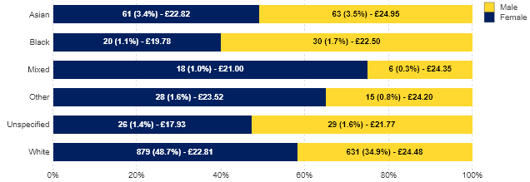
Males have a higher average hourly rate of pay than females across all ethnicity groups.

Addressing our identified gaps

Our actions have been considered and approved by the University’s EDI Committee.

As outlined within our Strategic Equality Plan 2024-28, we are committed to placing EDI at the forefront of the design and delivery of our university functions. We continue to evidence this through:
- Our review of inclusive People policies, including generous annual leave, special leave and shared parental leave provisions.
- Being an accredited Real Living Wage employer.
- Our commitment to addressing issues relating to underrepresentation in Higher Education through Advance HE’s recognised charter marks.
- The launch of our new University website, ensuring better digital accessibility for all.
- Embedding inclusion and diversity content into our Manage@Met Leadership development programme.
- Ensuring all recruitment panels are diverse and contain members of more than one gender.
- Taking positive action and encouraging applicants from diverse and underrepresented groups to apply for positions.
- Where we use independent search agencies, such as for executive positions or shortage occupation roles, suppliers are set clear expectations about the importance of applicant diversity.
- Proactively engaging with senior leaders to encourage applications from racially minoritised staff when staff development opportunities are promoted.
- Continued implementation of our successful Women to Reader and Professor scheme.
- The establishment of the Women Professors Network, to provide senior female academics with a confidential space to discuss challenges and an opportunity to engage in active diversification to support women and those from ethnic minorities to Professorships.
- Supported the launch of Welsh Ethnic Minority Professors Initiative (WEMPI) and its associated activities.
- The launch of the first Wales Advance HE Diversifying Senior Leadership programme for racially minoritised staff (grade 6 and above) in collaboration with Cardiff University and University Wales Trinity St David’s.
- Diversifying the membership of our Research Degrees Committee, engaging representatives from relevant staff networks.
- Enhancing the Performance & Development Review (P&DR) process, adding new guidance asking reviewers to be consciously curious to find out about reviewees’ lived experiences, the impact of these and any additional support they may need.
- Our university-wide mentoring network.

Over the next year, we will work with key stakeholders across the University, including our staff networks to:

- Take proactive steps to encourage disclosure of ethnicity and disability.
- Conduct an internal review of pay gap data, splitting by Academic and Professional Services roles.
- Conduct a review of starting salaries, monitoring offers made to new staff to prevent gaps arising at the point of hire.
- Launch of a similar scheme to the Women to Reader and Professor Scheme, aimed at supporting RM staff progression.
- Diversifying the pool of mentors within our university-wide mentoring network.

