Sustainability Targets & Carbon Management Focus
Cardiff Metropolitan University March 2026

This document is also available in Welsh / Mae’r ddogfen hon hefyd ar gael yn Gymraeg.

Introduction
Strategy 2030 - The University will achieve its goal of becoming Net Zero Carbon for Scope 1 and Scope 2 emissions by 2030; and in parallel will progress the reduction of its Scope 3 emissions by 30% by 2030 with the aim of achieving Net Zero Carbon for Scope 3 emissions by 2040.
Carbon Management Plan 2024 – 2030 – Our Carbon Management Plan sets out our carbon baseline, targets, action and ambition to achieve Net Zero Carbon. They will be achieved by robust leadership and governance, analysis and planning, and crucially, full engagement from key collaborators and organisational stakeholders. Together, we will act with purpose, delivering impact with compassion to address the complexities and challenges we face as an organisation to achieve our Net Zero goal.
ISO 14001 Environmental Management System - The University activities have an impact on the environment and we are committed to continual improvement of our Environmental Management System (EMS) and to exceed the requirements of ISO 14001. Publication and reporting of smart objectives and priorities to deliver EMS, Sustainability Strategy and Carbon Management Plan with Sustainability themed policies. Progress is reported to the Climate Action Working Group.
Sustainability Development Goals SDG’s - All Sustainability targets and carbon management
activities, policies and strategies are mapped alongside the SDG’s. Research is mapped against the relevant sdg sustainable development goal, giving profile, research unit and research output.

Carbon Emission

About Carbon Emissions
Cardiff Metropolitan University is committed to measuring, reporting, and reducing its carbon footprint across all aspects of its operations. Our Carbon Management Plan 2024 – 2030, outlines strategic approaches to achieving carbon reductions. This includes direct emissions (Scope 1 and 2) and indirect emissions (Scope 3), such as waste, water, travel, and procurement. Our targets align the University with the Welsh Government’s ambition for the public sector in Wales to achieve Net Zero by 2030. Scope 1 & 2 net zero by 2030 in carbon management plan and reduce scope 3 by 30% in 2030.

SDG – numbers 7, 11, 12, 13, 15

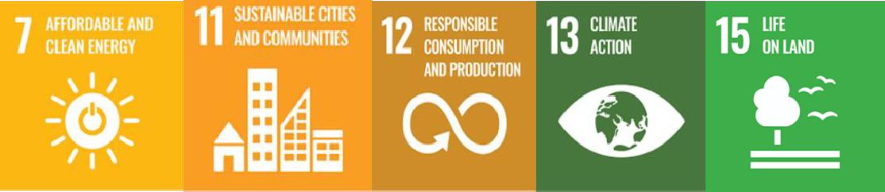

Baseline Impact

Baseline Year | Narrative | Value | Source / HESA field
2005 | Emissions from all scope 1 and 2 sources | 7,025 tCO2e | E12E2005
2021/2022 | Total scope 1 and 2 carbon emissions (kg CO2e) | 2,758,151.242  kg CO2e | E12CET
2021/2022 | Residential scope 1 and 2  carbon emissions total (kg CO2e) | 794,222 kg CO2e | E12CERT
2021/2022 | Non-residential scope 1 and 2 carbon emissions  total (kg CO2e) | 1,959,650 kg CO2e | E12CENRT
2021/2022 | Emissions from all scope 3 sources | 7,039 tCO2e | (CMP)
2021/2022 | Benchmarking - Overall score in P&P green league – rank universities in Carbon reduction from HESA data  21/22 | Joint 50th in league | People and Planet league 2023 ranking of Universities –  Carbon Reduction

SMART Targets
    - Achieve net zero carbon emissions for Scope 1 & 2 by 2030 (CMP) baseline as above from 21/22

    - Achieve 30% carbon emission reduction for Scope 3 by 2045 (CMP) baseline as above from 21/22
    - Total carbon emissions attributed to residential accommodation (both in-house and externally provided accommodation) to be reported via HESA return annually fields E12CERT and E12CENRT
    - Improve the sectional standing in the People and Planet Green League when benchmarking Carbon Reduction against other UK Universities from joint 50th in 2023 league with 21/22 HESA data.

Electricity & Gas Consumption

About Energy & Gas Consumption:
Scope 1 and 2 representing estate and fleet are within immediate operational control for the University and represent an opportunity for shorter term action. We aim to build on the strong energy performance we have achieved so far with a range of measures aimed at accelerating our decarbonisation activities wherever possible as we work towards a net zero carbon. Through our carbon management plan we have set a corporate commitment to deliver scope 1 &2 net zero by 2030.

SDG – numbers 7, 11, 12, 13, 15

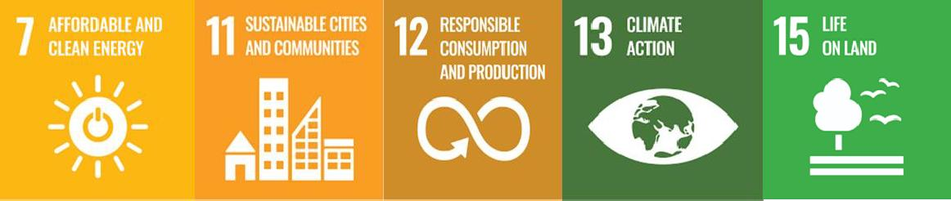

Baseline Impact

Baseline Year | Narrative | Value | Source / HESA field
2021/2022 | Emissions from  Scope 1 Gas (Fossil Fuels) | 1,700 tCO2e | (CMP) E12CENGAS
2021/2022 | Emissions from Scope 2 Electricity  (Fossil Fuels) | 1,005 tCO2e | (CMP) E12CEGE
2021/2022 | Benchmarking - Overall score in P&P green league – rank universities in Carbon reduction from HESA data  21/22 | Joint 57th in league | People and Planet league 2023 ranking of Universities – Energy Sources

SMART Targets
  - Reduce energy consumption Gas against 2021/2022 baseline to achieve net zero carbon emissions by 2030 - 1,700 tCO2e (CMP)
  - Reduce energy consumption Electricity against 2021/2022 baseline to achieve net zero carbon emissions by 2030 - 1,005 tCO2e (CMP)

  - Improve the sectional standing in the People and Planet Green League when benchmarking Energy Sources against other UK Universities from joint 57th in 2023 league with 21/22 HESA data.

Priorities:
    - Publish reviewed Thermal Comfort Policy

Emissions & Effluents

About emissions and effluents
Our current work is co-ordinated through the Environmental Management System (EMS) which ensures that the university addresses its significant environmental impacts whilst at the same time meeting the requirements of environmental legislation especially on emissions and effluents. The implementation of the EMS has identified the relevant environmental legislation affecting the university and ensured that we meet these requirements.

SDG – numbers 6, 11, 12, 13

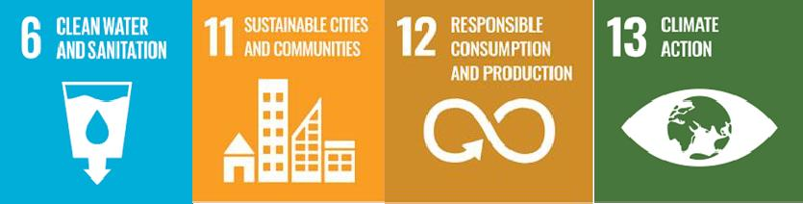

Baseline Impact

Baseline Year | Narrative | Source / HESA field
2021/2022 | Compliant with legislation and best practice for emissions and  effluents | (CMP)

SMART Targets
  - Maintain compliance with Legislation /Best Practice, Drainage Discharge, Emissions to Air, Drainage, Air Conditioning, Lev’s and Fume Cupboards, Water Treatment / Control of Legionella.
  - Research best ways of recording of Compliance with Legislation and Best Practice for Drainage Discharge; Emissions to Air; Drainage; Air Conditioning; Lev’s and Fume Cupboards and Water Treatment / Control of Legionella.
  - Produce and maintain campus drainage plans to minimise risk of pollution.
  - Legislative compliance audits are completed by internal auditors every year as part of the EMS, checking via internal staff & student audits and ensuring compliance through our legislation update service.

Sustainable Procurement

About Sustainable Procurement
Analysing the breakdown of Scope 3 emissions has identified the highest area of impact to be the procurement of goods and services. Targeting the largest category contributing to Scope 3 emissions, purchased goods and services, requires a programme to gather more accurate data from suppliers on the impact of their products and services. (Extract from CMP)

SDG – number 12
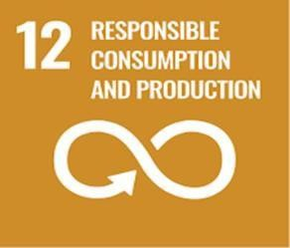

Baseline Impact

Baseline Year | Narrative | Value | Source / HESA field
2021/2022 | Emissions from procurement (supply chain) | 17196.70 (tCO2e) | (CMP) E3SCBS E3SCPP E3SCMP E3SCMFCG E3SCFC E3SCCON E3SCICT E3SCWW E3SCMPI  E3SCOTH E3SCUNC

SMART Targets
  - Reduce Scope 3 emissions from procurement by 30% by 2030 (CMP)
  - Ensure all major suppliers meet Cardiff Met’s sustainability criteria by 2030 (CMP)
  - Procurement (supply chain) Baseline 17196.70 21/22, Target – Reduction of 5% in carbon emissions (tCO2e) associated with purchased goods and services by 2030.

Priorities:
    - Review procurement themed policies with changes in legislation

Water Management

About Water Management
Cardiff Met aims to reduce water consumption and improve efficiency to lessen environmental impact. (Extract from CMP)

SDG – number 6
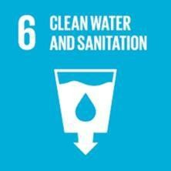

Baseline Impact

Baseline Year | Narrative | Value | Source / HESA field
2021/2022 | Total scope 3 carbon emissions  from water supply | 10.979 | E3CEWST
2021/2022 | Total scope 3 carbon emissions from waste water  treatment | 19.040 | E3CEWWTT
2021/2022 | Benchmarking - Overall score in P&P green league – rank universities in Water Reduction from HESA data  21/22 | Joint 41st in league | People and Planet league 2023 ranking of Universities – Water Reduction

SMART Targets
  - Achieve a 30% reduction of total emissions from water supply by 2030 (CMP)
  - Wastewater Treatment E3CEWWTT Baseline 19.040 21/22, Target 10% reduction in (t CO2e) by 2030
  - Water Supply (incl. residential) E3CEWST Baseline 10.979 21/22, Target 10% reduction in (t CO2e) by 2030
  - Improve the sectional standing in the People and Planet Green League when benchmarking Water Reduction against other UK Universities from joint 41st in 2023 league with 21/22 HESA data.

Priorities:
    - Publish Water Management Policy

Waste Management

About Waste Management
Reducing waste and improving recycling rates are key to Cardiff Met’s sustainability efforts. Waste generated on site and how it’s managed has been part of our EMS targets for many years, working towards the Welsh Government targets of 70% of all waste being recycled by 2025 and zero waste by 2050.

SDG – number 11, 12, 13
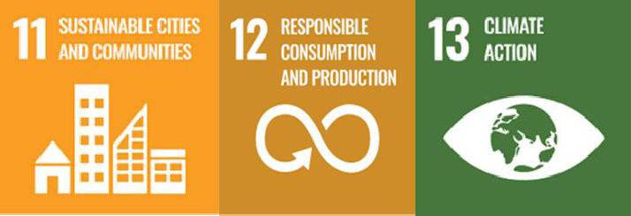

Baseline Impact

Baseline Year | Narrative | Value | Source / HESA field
2021/2022 | Total scope 3 carbon emissions  from waste | 13.150 (t CO2e) | E3CEWT
2021/2022 | Total scope 3 carbon emissions  residential waste | 4.350 (t CO2e) | E3RCEW
2012/2022 | Total scope 3 carbon emissions  non-residential waste | 8.800 (t CO2e) | E3NRCEW
2021/2022 | Benchmarking - Overall score in P&P green league – rank universities in Waste & Recycling from HESA data  21/22 | Joint 39th in league | People and Planet league 2023 ranking of Universities – Waste & Recycling

SMART Targets
  - Waste (inc. Construction & residential) Baseline 21/22, Target Zero waste to landfill and recycle 70% of waste, 5% reduction (t CO2e)
  - Reduce total waste to achieve Welsh Government targets of 70% of all waste recycled by 2025 and zero waste by 2050 (CMP)

  - Improve the sectional standing in the People and Planet Green League when benchmarking Waste & Recycling against other UK Universities from joint 39th in 2023 league with 21/22 HESA data.

Priorities:
    - Publish reviewed Waste Management Policy

Travel and Transport

About Travel and Transport
The University aspires to encourage modal shift away from car usage to active travel, providing a range of accessible, affordable, convenient sustainable travel options connecting students, staff, contractors and visitors to the University’s campuses and the wider city. Cardiff Met promotes sustainable travel options to reduce emissions from commuting and business travel.

SDG – numbers 3 and 11
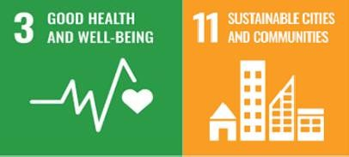

Baseline Impact

Baseline Year | Narrative | Value | Source / HESA field
2021/2022 | Total emissions from business travel, commuting and homeworking | 2,888,682 | Welsh Govt Annual Report
2021/2022 | Emissions from business travel | 24,712 | Welsh Govt Annual Report
2021/2022 | Business Travel – staff & students | 62.7 tCO2e | CMP
2021/2022 | Staff Commuting | 463.57 tCO2e | CMP
2021/2022 | Student Commuting | 1532.40 tCO2e | CMP
2018/2019 | Student travel from home to University (outside scope for Welsh Govt report) | 4.438 | CMP

SMART Targets
  - Business Travel – staff & students 62.17 Target Reduction of 5% reduction in carbon emissions
  - Reduce staff single car occupancy car journeys to Cardiff Met and the dependency on vehicles to support its activities by 5%
  - Student commuting - Baseline 1532.40 21/22, Target Reduction of 5% in carbon emissions tCO2e
  - Student travel from home to University (outside of scope for Welsh Govt reporting) – Baseline
4.438 2018/19, Target Reduction of 5% in carbon emissions tCO2e
  - Reduce total commuting emissions by 30% tCO2e by 2030 based Welsh Government Annual Reporting 2021/2022 baseline
  - Reduce business travel related emissions by 30% by 2030 based on Welsh Government Annual Reporting 2021/2022 baseline

Priorities:
    - Publish Travel Plan
    - Complete bi-annual travel survey of staff and students to inform modal percentage split

Sustainable Food

About Sustainable food
Catering & Hospitality Services recognises its responsibility to carry out its procurement activities in an environmentally and socially responsible manner, whilst also encouraging healthy and sustainable food production and consumption. (Extract from Sustainable Food webpage)

SDG – numbers 1, 2,3, 6, 11, 12, 14
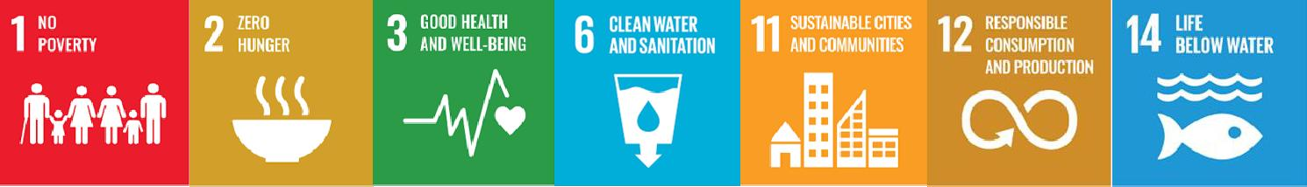

Baseline Impact

Baseline Year | Narrative | Value | Source / HESA field
2019 | Sustainable Restaurant Association (SRA) submission bi-annually | 2019 - 3* 78%  2022 - 3* 80%  2024 - 3* 88% | SRA reports
2021/2022 | Fairtrade Award submission | 2022 Fairtrade University status 2024 Fairtrade University status | EEFAIREX

SMART Targets
  - Improve scoring of 2021/2022 baseline scoring of 80% Sustainable Restaurant Association each bi-annual submission
  - Achieve zero plastic use by 2030
  - Submit Fairtrade application to maintain accreditation in 2026.
  - Increase the number of reusables sold by 10% in 2025
  - Create baseline of Food waste during production, in outlet from consumers and end of service
  - Reduce food waste baseline figure by 10% in 2026.

Priorities:
    - Publish reviewed Sustainable Food Policy
    - Publish reviewed Sustainable Seafood Policy
    - Publish reviewed Fairtrade Policy
    - Explore the feasibility and introduction of a fully plant-based outlet with the help of Business in Action students Real world project March 2025
    - Plastic use audit for all outlets
    - Create a feasibility study with students to remove single use coffee cups from each outlet April 2025
    - Introduce menu Co2 for awareness
    - Review 2024 SRA feedback and create a plan for next submission

    - Engage with CSSHS (Nutrition and Dietetics) Real World project to support development of new product (food) development at university catering outlets. (CMP)
    - Enhance involvement with the Sustainable Food City initiative (CMP)
    - Work with Students’ Union on cost-of-living options

Green Infrastructure & Biodiversity

About Green Infrastructure & Biodiversity
We’ve made a start to improve biodiversity on site with the introduction of our own apiaries. We organise regular litter picks as a Keep Wales Tidy Hub and have been planting trees across campuses. However, we recognise we need to do more both to manage our land to enhance the opportunity for carbon sequestration, biodiversity and increase our resilience to flooding and high temperatures. (Extract from CMP)

SDG – number 15
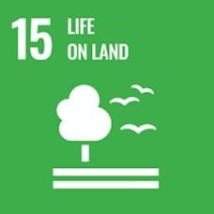

Baseline Impact

Baseline Year | Narrative | Source / HESA field
2018/20 | Cardiff Met Biodiversity Action Plan | Gavin Jones Ltd.
2022 | Cardiff Met external areas | Estates and Gavin Jones Ltd.
2023/2024 | Ecological survey conducted in March 2024 | Thomson Environmental  Consultants

SMART Targets
  - Implement the costed Biodiversity Management Plan in 2025 to ensure clear accountability and track progress towards campus biodiversity enhancement.
  - Achieve “Nature Friendly Grounds” status by 2028.
  - Complete a baseline biodiversity assessment across both campuses by March 2027.
  - By March 2027, establish at least 150 native trees and shrubs in Queenswood Woodland, achieving a minimum 80% survival rate through ongoing maintenance, invasive species control, and protection measures.
  - By July 2027, reduce Laurel and Holly coverage in priority restoration zones by 50% and install at least 10 biodiversity enhancement features (e.g. bird boxes, deadwood habitats, wildflower areas) to improve habitat quality for wildlife and pollinators.

Construction and Refurbishment

About construction and refurbishment
Cardiff Metropolitan University aims to prioritise sustainable design, construction practices, and reusing materials that minimise environmental impacts for new developments, refurbishments, and maintenance on the estate. (Extract from webpage)

SDG – numbers 9, 11, 12 and 15
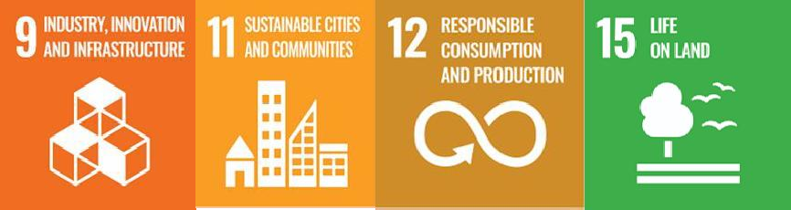

SMART Targets
  - By July 2030, all new build and major refurbishment projects with external works will achieve a minimum 10% biodiversity net gain, measured using a recognized biodiversity metric.
  - By July 2028, all construction and refurbishment projects will achieve at least 90% diversion of construction waste from landfill and reduce total construction waste intensity by 20% from the 2025 baseline.
  - By July 2028, refurbishment projects involving washroom or building services upgrades will achieve at least a 15% reduction in water consumption (litres/m²) compared to pre-refurbishment baseline.

Priorities:
    - Publish Sustainable Construction & Refurbishment Policy

Sustainability Engagement & Community Involvement

About Sustainability Engagement & Community Involvement
The University recognises environmental awareness as a key aspect to reaching Net Zero Goals and to maintain our Environmental Management System ISO14001, particularly in respect of the large number and annual transition of students, staff, visitors and contractors on site, presenting a challenging mixture of backgrounds, cultures and interests. Different methods are used in order to create various opportunities for engagement. We measure sustainability engagement through number of events organised yearly, attendance number, student internships, volunteering and auditor trainers, social and digital analytics and awards submissions.
The University is committed to the public good and understands that in order become a truly sustainable city we must also engage with the wider community and contribute to the general wellbeing of our communities. Most of our events such as Repair Cafes, Litter Picks and Community Days, Green Week are open to wider community.

SDG – numbers 4, 11, 12 and 13
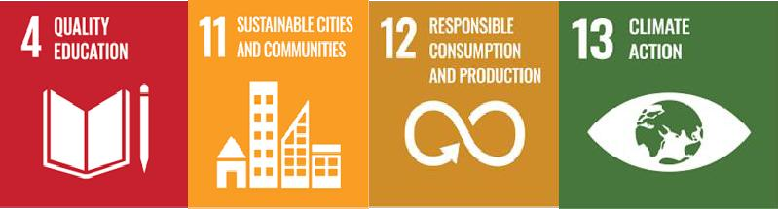

Baseline Impact

Baseline Year | Narrative | Value | Source / HESA field
2009 | Environmental management system existence | 2009 | EEMSE
2021/2022 | Environmental management system external verification | Y | EEMSEXV
2012/2022 | Environmental management system external verification coverage | Y | EEMSEXVC
2021/2022 | Number of ISO 14001 non-conformities during external audit  annual assessment | 0 | Sustainability Engagement Progress  Report
2021/2022 | Number of community sustainability projects and events delivered | 52 | Sustainability  Engagement Progress Report
2022 | Fairtrade accreditation | Y | EEFAIREX
2022 | SRA submission |  | Sustainability Engagement Progress  Report

2021/2022 | Student volunteers completing their EMS training as internal auditors of the EMS and completion of internal  audits on campus |  | Sustainability Engagement Progress Report
2021/2022 | Successful award submissions |  | Sustainability  Engagement Progress Report
2008 | Position in the People and Planet Green League | 2021 - 5th in UK, 1st in Wales 2022 - 1st in UK, 1st in Wales  2023 - 6th in UK, 1st in Wales  2024 - 12th in  UK, 1st in Wales | People and Planet Green League

SMART Targets
11.110% yearly increase in the number and variety of yearly sustainability projects and events delivered in baseline year 2021/2022
  - Achieve zero non-conformities at the yearly external audit for ISO14001
  - Maintain top 10 position in the annual People & Planet Green League
  - Achieve and maintain current high scoring on Fairtrade status and SRA Award
  - Continue to deliver our benchmark events Repair Cafe, Litter Pick and Community Day that invite the community on to Campus
  - Increase the number of free repairs by 10% in 2025 compared to baseline year – include figures of past performance

Priorities:
    - Publish reviewed Sustainability Strategy
    - Publish reviewed Sustainability Engagement Strategy
    - Publish reviewed Environment and Sustainability Policy
    - Publish reviewed Fairtrade Policy

Students’ Union

About community involvement
Cardiff Met works in partnership with the Students' Union with promotion and awareness of sustainability issues, with staff, students, visitors, stakeholders and the local community as part of the Sustainability Strategy and Sustainability Engagement Strategy. The Students' Union is an Aspect Owner and part of the University Environmental Management System (ISO 14001) with responsibility for Community and Student initiatives and play a key role in coordination of the Fairtrade Award.

SDG – numbers 4, 12 and 13


Baseline Impact

Baseline Year | Narrative | Value | Source / HESA field
2021/2022 | Fairtrade accreditation | Y | EEFAIREX

SMART Targets
  - In collaboration with the Students’ Union, achieve Fairtrade Award accreditation by 2028 through coordinated actions on procurement, engagement, and awareness activities.
  - By July 2026, design and implement a tiered points-based reward system for societies to incentivise engagement, participation, and sustainability-focused activities.

  - By July 2027, establish at least one new student society, providing clear guidance, support, and approval processes to enable successful setup and ongoing activity.

Learning and Teaching / Research

About learning and teaching
Cardiff Metropolitan University is an ambitious and progressive institution, a leading modern university with a distinctive profile for teaching, learning, research and innovation. Our students and staff work alongside our partners to lead the way in making a positive difference to Wales and the wider world, contributing to a fairer and greener economy that benefits all (Strategy 2030).
We will deliver an outstanding student experience, widening access and inclusion by extending learning opportunities beyond our traditional undergraduate and postgraduate offers through short courses, degree apprenticeships and micro-credentials, including through the medium of Welsh and via transnational education. We will design our learning and teaching experiences, including learning spaces, to develop a sense of belonging that supports learners to reach their academic potential and maximise their graduate outcomes

SDG – numbers 4 and 11
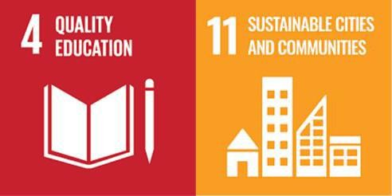

SMART Targets
  - Align the curriculum with the SDGs and sustainable themed teaching and legislation
  - Train staff and students in carbon literacy by 2027
  - Continue to map SDG’s for Research
  - Increase Real world projects for Carbon net zero delivery

Priorities:
    - Review the sustainability e-module for all staff
    - Develop an engaging standard sustainability training for student induction
    - Explore funding options for staff training or sustainability and climate emergency
    - Promote collaboration between courses and sustainability department to co-create and deliver educational projects and real-world projects

SMART Targets and Objectives summary

Number | Area | SMART TARGET
1.1.1 | Carbon Emissions | Achieve net zero carbon emissions for Scope 1 & 2 by 2030 (CMP) baseline as above from 21/22
1.1.2 | Carbon Emissions | Achieve 30% carbon emission reduction for Scope 3 by 2045 (CMP) baseline as above from 21/22
1.1.3 | Carbon Emissions | Total carbon emissions attributed to residential accommodation (both in-house and externally provided accommodation) to be  reported via HESA return annually fields E12CERT and E12CENRT
1.1.4 | Carbon Emissions | Improve the sectional standing in the People and Planet Green  League when benchmarking Carbon Reduction against other UK Universities from joint 50th in 2023 league with 21/22 HESA data.
2.1 | Electricity & Gas Consumption | Reduce energy consumption Gas against 2021/2022 baseline to achieve net zero carbon emissions by 2030 - 1,700 tCO2e (CMP)
2.2 | Electricity & Gas Consumption | Reduce energy consumption Electricity against 2021/2022 baseline to achieve net zero carbon emissions by 2030 - 1,005 tCO2e (CMP)
2.3 | Electricity & Gas Consumption | Improve the sectional standing in the People and Planet Green  League when benchmarking Energy Sources against other UK Universities from joint 57th in 2023 league with 21/22 HESA data.
3.1 | Emissions & Effluents | Maintain compliance with Legislation /Best Practice, Drainage Discharge, Emissions to Air, Drainage, Air Conditioning, Lev’s and  Fume Cupboards, Water Treatment / Control of Legionella.
3.2 | Emissions & Effluents | Research best ways of recording of Compliance with Legislation and Best Practice for Drainage Discharge; Emissions to Air; Drainage; Air Conditioning; Lev’s and Fume Cupboards and Water  Treatment / Control of Legionella.
3.3 | Emissions & Effluents | Produce and maintain campus drainage plans to minimise risk of pollution.
3.4 | Emissions & Effluents | Legislative compliance audits are completed by internal auditors every year as part of the EMS, checking via internal staff & student  audits and ensuring compliance through our legislation update service.
4.1 | Sustainable Procurement | Reduce Scope 3 emissions from procurement by 30% by 2030 (CMP)
4.2 | Sustainable Procurement | Ensure all major suppliers meet Cardiff Met’s sustainability criteria by 2030 (CMP)
4.3 | Sustainable Procurement | Procurement (supply chain) Baseline 17196.70 21/22, Target – Reduction of 5% in carbon emissions (tCO2e) associated with  purchased goods and services by 2030.
5.1 | Water Management | Achieve a 30% reduction of total emissions from water supply by 2030 (CMP)
5.2 | Water Management | Wastewater Treatment E3CEWWTT Baseline 19.040 21/22, Target 10% reduction in (t CO2e) by 2030
5.3 | Water Management | Water Supply (incl. residential) E3CEWST Baseline 10.979 21/22, Target 10% reduction in (t CO2e) by 2030

5.4 | Water Management | Improve the sectional standing in the People and Planet Green League when benchmarking Water Reduction against other UK  Universities from joint 41st in 2023 league with 21/22 HESA data.
6.1 | Waste Management | Waste (inc. Construction & residential) Baseline 21/22, Target Zero waste to landfill and recycle 70% of waste, 5% reduction (t CO2e)
6.2 | Waste Management | Reduce total waste to achieve Welsh Government targets of 70% of all waste recycled by 2025 and zero waste by 2050 (CMP)
6.3 | Waste Management | Improve the sectional standing in the People and Planet Green League when benchmarking Waste & Recycling against other UK  Universities from joint 39th in 2023 league with 21/22 HESA data.
7.1 | Travel & Transport | Business Travel – staff & students 62.17 Target Reduction of 5% reduction in carbon emissions
7.2 | Travel & Transport | Reduce staff single car occupancy car journeys to Cardiff Met and the dependency on vehicles to support its activities by 5%
7.3 | Travel & Transport | Student commuting - Baseline 1532.40 21/22, Target Reduction of 5% in carbon emissions tCO2e
7.4 | Travel & Transport | Student travel from home to University (outside of scope for Welsh Govt reporting) – Baseline 4.438 2018/19, Target Reduction of 5% in  carbon emissions tCO2e
7.5 | Travel & Transport | Reduce total commuting emissions by 30% tCO2e by 2030 based Welsh Government Annual Reporting 2021/2022 baseline
7.6 | Travel & Transport | Reduce business travel related emissions by 30% by 2030 based on Welsh Government Annual Reporting 2021/2022 baseline
8.1 | Sustainable Food | Improve scoring of 2021/2022 baseline scoring of 80% Sustainable Restaurant Association each bi-annual submission
8.2 | Sustainable Food | Achieve zero plastic use by 2030
8.3 | Sustainable Food | Submit Fairtrade application to maintain accreditation in 2026.
8.4 | Sustainable Food | Increase the number of reusables sold by 10% in 2025
8.5 | Sustainable Food | Create baseline of Food waste during production, in outlet from consumers and end of service
8.6 | Sustainable Food | Reduce food waste baseline figure by 10% in 2026.
9.1 | Green Infrastructure &  Biodiversity | Implement the costed biodiversity plan in 2025 to ensure accountability and tracks our progress toward enhancing campus  biodiversity (CMP)
10.1 | Construction & Refurbishment | A sustainable construction assessment will be completed for refurbishments to consider all potential carbon impacts.
11.1 | Sustainability Engagement &  Community Involvement | 10% yearly increase in the number and variety of yearly sustainability projects and events delivered in baseline year 2021/2022
11.2 | Sustainability Engagement & | Achieve zero non-conformities at the yearly external audit for ISO14001

 | Community Involvement
11.3 | Sustainability Engagement & Community  Involvement | Maintain top 10 position in the annual People & Planet Green League
11.4 | Sustainability Engagement & Community  Involvement | Achieve and maintain current high scoring on Fairtrade status and SRA Award
11.5 | Sustainability Engagement &  Community Involvement | Continue to deliver our benchmark events Repair Cafe, Litter Pick and Community Day that invite the community on to Campus
11.6 | Sustainability Engagement &  Community Involvement | Increase the number of free repairs by 10% in 2025 compared to baseline year – include figures of past performance
12.1 | Students’ Union | Work in collaboration with SU to coordinate and achieve Fairtrade Award in 2025.
13.1 | Learning and  Teaching / Research | Align the curriculum with the SDGs and sustainable themed teaching and legislation
13.2 | Learning and Teaching /  Research | Train staff and students in carbon literacy by 2027
13.3 | Learning and  Teaching / Research | Continue to map SDG’s for Research
13.4 | Learning and Teaching /  Research | Increase Real world projects for Carbon net zero delivery

