

Resolution Policy

COVERSHEET

Key Details

|  |  |
| --- | --- |
| ***POLICY TITLE*** | *Resolution Policy* |
| ***DATE APPROVED*** | *July 2025* |
| ***APPROVING BODY*** | *Academic Board* |
| ***VERSION*** | *1* |
| ***PREVIOUS REVIEW DATES*** |  |
| ***NEXT REVIEW DATE*** | *June 2028* |
| ***OUTCOME OF EQUALITY IMPACT ASSESSMENT*** | *\* No major change* |
| ***RELATED POLICIES / PROCEDURES / GUIDANCE*** | The Resolution Policy is supported by the Code of Conduct, Formal Grievance Procedure, Disciplinary Procedure, Equality Diversity and Inclusion Policy, Data Protection Policy - Staff Privacy Notice, Complaints Policy and CMU Dignity and Respect at Study and Work Statement. |
| ***IMPLEMENTATION DATE*** | *October 2025* |
| ***POLICY OWNER (JOB TITLE)*** | *Chief People Officer* |
| ***UNIT / SERVICE*** | *People Services* |
| ***CONTACT EMAIL*** | *LWilliams3@cardiffmet.ac.uk* |

Version Control

|  |  |  |
| --- | --- | --- |
| ***VERSION*** | ***DATE*** | ***REASON FOR CHANGE*** |
| *1.0* | *March 2025* | *First version* |

Policy Hub

For further information on policies:

1. You can go to the Secretariat pages on InSite at <https://outlookuwicac.sharepoint.com/sites/Secretariat>;
2. You can go to the Policy Hub at [cardiffmet.ac.uk/about/policyhub](https://www.cardiffmet.ac.uk/about/policyhub); or
3. Contact [policies@cardiffmet.ac.uk](mailto:policies@cardiffmet.ac.uk).

**Mae'r ddogfen hon hefyd ar gael yn Gymraeg** / This document is also available in Welsh.

Contents

1 Introduction 3

2 Forms of Informal Resolution 4

3 Principles 5

4 Roles and Responsibilities 6

5 Formal Resolution 7

6 Welsh Language Standards 7

7 Related policies 7

8 Review and Approval 7

# Introduction

## **Purpose**

### A restorative workplace culture is based upon clarity of communication and workplace connections. Our Resolution Policy replaces the traditional Grievance Policy and is accompanied with formal Grievance and Disciplinary Procedures all of which are designed to work collaboratively with colleagues to offer a timely, fair, supportive, and proactive approach to resolving workplace concerns.

### Wherever possible the focus is on finding solutions that are beneficial to all involved, through a future focused approach that is used to realign organisational ways of working and secure constructive and lasting outcomes. This approach increases the use of informal / early resolution and enables professional disagreement and debate to form part of an innovative and inclusive culture, whilst preventing disagreements to become entrenched.

### Identifying concerns or conflict at work may vary in severity. Focusing on constructive resolution, helps to create and sustain a positive working environment where all can thrive, an aim of our University’s Strategy.

### The policy and procedures are compliant with employment legislation and are non-contractual.

## **Scope**

### The Resolution Policy and associated procedures applies to all employees of the University, including those on fixed term and casual contracts.

### The University will use informal approaches where appropriate to manage and support resolution for matters arising that would typically be raised as grievances or a matter relating to dignity at work; supported by formal procedures.

### The University’s Articles of Government defines the specific arrangements that apply only to the holders of senior posts. These are set out in the Procedure for Senior Post Holders.

### Matters that are excluded from being dealt with under this Policy and its associated procedures are:

#### Protected Disclosure Concerns (raised under the Public Interest Disclosure Act 1998). Protected Disclosure Concerns should be raised under the [University’s Whistleblowing Policy and Procedure.](https://www.cardiffmet.ac.uk/about/policyhub/Documents/whistleblowing-policy.docx)

#### Concerns over which the University has no control, for example HMRC rules and Health and Safety legislation.

#### Matters that are; under investigation with the University’s Complaints Policy or allegations of criminal matters that may be under investigation by the Police or are subject to collective bargaining.

#### Where there is evidence that a grievance is deliberately vexatious. Examples of a deliberately vexatious grievance are:

#### Intentionally false or malicious allegations.

#### Intent to cause unnecessary harm or as a form of bullying against a colleague or manager.

#### Frivolous in nature and unmerited.

#### Where the aim is to waste time and resources or delay the progress of other processes.

# Forms of Informal Resolution

## The first and most important step in resolving a concern or a conflict at work, is to have a prompt, informal conversation to try to find a constructive outcome that is amenable to both parties. Where individuals are unable to resolve concerns in this way, they should discuss with their Line Manager for advice, or with their senior manager where appropriate i.e. if the conflict situation involves their direct manager.

## The journey to restoration may involve:

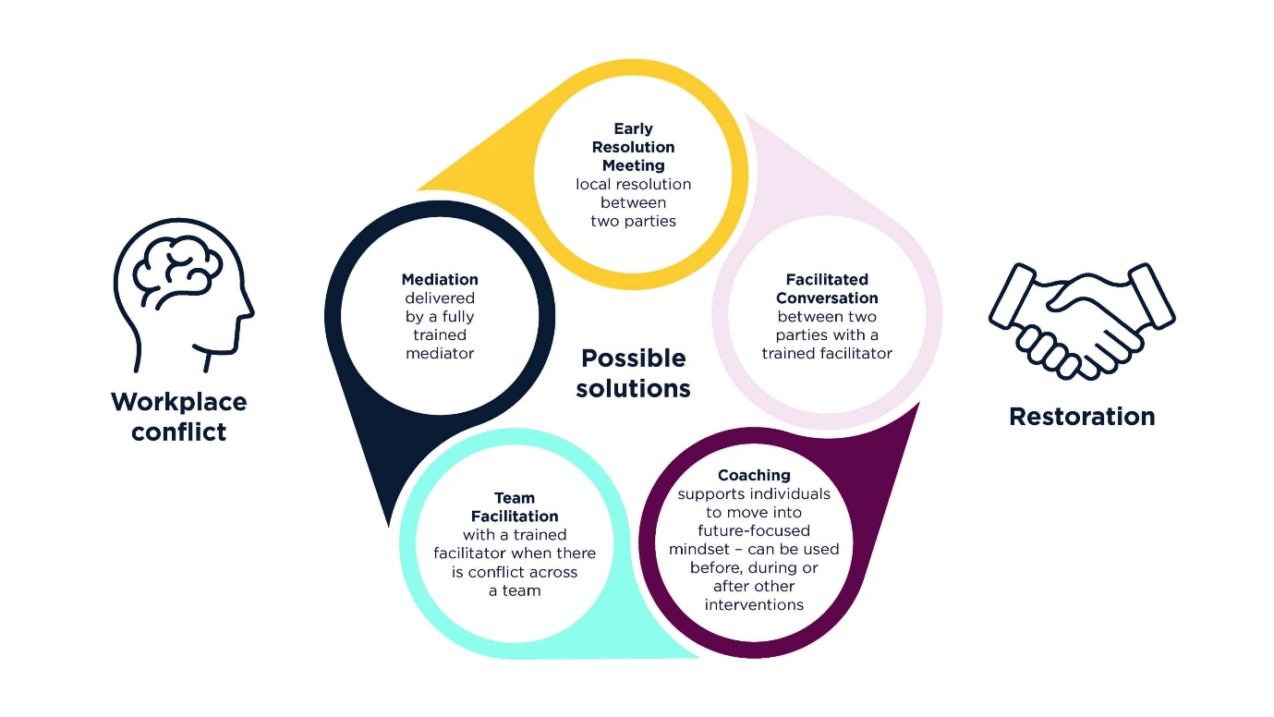

## The outcomes may include:

### A verbal resolution/agreement.

### An agreed action plan between the parties which sets out the nature of the agreement and agreed timescales.

### A written variation or contractual change.

## This will enable most concerns to be resolved locally and without the need for further intervention of the resolution process.

## If that approach is not successful, another intervention could be suggested such as an early resolution meeting, which means attempting local resolution again (i.e. engaging in a conversation without the need for a third party).

## Whilst facilitated conversations and mediation remain voluntary, they are proven to be highly effective. The University is committed to exhausting such interventions prior to moving to the formal grievance procedure and expects all employees to give this serious consideration and not rule them out unless in extenuating circumstances.

## The Resolution Hub provides further information and support to employees and managers, to help resolve workplace conflict at the earliest opportunity and enable sensitive conversations, to achieve positive and lasting outcomes.

# Principles

## The approach that will be applied to the Resolution Policy and formal procedures creates principles that are based upon fairness and psychological safety, so that it feels safe to take interpersonal risks in a team or group setting, knowing that your contributions and opinions will be valued and demonstrate:

### A commitment to ensuring all employees are treated with dignity and respect, promoting a high level of trust through mindful use of language and learning-oriented conversations.

### Interventions are early and as close to source as possible - a resolution that is secured by the people involved, is more likely to be mutually acceptable and to endure over the longer term than one which is imposed by another party.

### Support and resources to assist managers and employees to resolve issues informally. Staff engagement cannot be achieved if anyone feels excluded.

### Promotion of equality, valuing diversity and inclusion through a positive approach to workplace conflict and eliminating discrimination.

### An accessible process and level of support so that everyone can resolve any concerns they have, making adjustments, wherever appropriate.

### Promotion of positive language to encourage a culture of early resolution to change ways of working.

### Encouragement for employees to be open and honest when a mistake is made, and for managers to take that into account when reaching a decision about next steps.

### Confidence that by raising a concern in good faith it will not impact negatively on themselves or their career.

### An employee can use Welsh or English as their language of choice throughout the process.

### Maintaining confidentiality throughout, including once the process has concluded.

# Roles and Responsibilities

## To support a culture of constructive resolution, our leaders, managers, recognised trade union representatives, employees, and People Services are expected to work together to:

### Resolve concerns informally and as close to source wherever possible.

### Ensure that actions are aligned to the University’s core ways of working.

## **Employee Responsibilities**

### Concerns should be raised at the earliest possible opportunity so that positions do not become entrenched, and situations do not escalate. Employees are expected to attempt to have a conversation with each other to resolve any differences they encounter in the workplace and to raise concerns directly with their line manager where they are not able to directly resolve themselves or where the concern is about a contractual matter.

## **Trade Union Responsibilities**

### Trade union representatives are expected to support and work with employees and the University; to engage in conversation to resolve differences in the workplace. Trade Unions should also raise any matters arising with People Services colleagues to promote early resolution.

## **Manager Responsibilities**

### The role of the manager is central in resolving conflicts and concerns in the workplace, both at informal and formal stages. Managers are expected to create and sustain a positive working environment where employees feel able to come to them directly with their concerns and where issues can be resolved quickly, cooperatively, and amicably – this is called informal resolution. Therefore, all managers must:

#### Encourage and engage in respectful conversations.

#### Set out clearly their expectations.

#### Actively seek out opportunities to resolve concerns before they escalate.

#### Engage actively and fully in facilitation and mediation processes, when required.

# Formal Resolution

## In cases where informal resolution has been exhausted or where it is not appropriate, an employee may raise a grievance following the Formal Grievance Procedure.

# Welsh Language Standards

## The University is fully committed to meeting the Welsh language standards set under the powers provided in the Welsh Language (Wales) Measure 2011 and to ensuring that the Welsh language has equal status, in treating the Welsh language no less favourably than the English language.

## The University has considered what effects this policy has on opportunities to use the Welsh language and any correspondence in relation to this policy will be provided in Welsh, should the staff member have chosen to receive any correspondence in relation to their employment, in Welsh.

# Related policies

## Employees must continue to act in accordance with the practices of the University and our [workplace policies](https://www.cardiffmet.ac.uk/about/policies/). This Policy should be read in conjunction with other Cardiff Metropolitan University policies and procedures including:

### Code of Conduct

### Formal Grievance Procedure & Disciplinary Procedure

### Equality Diversity and Inclusion Policy

### Data Protection Policy - Staff Privacy Notice

### Complaints Policy

### Dignity and Respect at Study and Work Statement.

# Review and Approval

### To ensure it is relevant and effective, this policy will be reviewed annually to ensure it complies with the relevant statutory provisions for formal procedures.

### People Services will proactively advise, support, and monitor the application of the Resolution Policy and formal Grievance and Disciplinary procedures, and will provide oversight, governance, and accountability where there is a change in employment legislation or case law or good practice; and engage in continuous monitoring and evaluation of the process in terms of its usage, the outcomes it achieves, and benefits delivered.

### A formal review will be undertaken every three years in line with the policy cycle or where there is a change in the University’s requirements. The policy will be approved by the University’s Academic Board.