Bedrooms for Graduation 2022
En-suite Single Bedrooms £32.00 per night (room only)
Bed & Breakfast £38.50 per night
Free return transport from Cyncoed Campus to Wales Millennium Centre on graduation days

Free transport

Did you stay in student halls during your first year? Then here’s your chance to re-create those memories with your friends and family while visiting Cardiff for your graduation.
En-suite single bedrooms are available at our Cyncoed Campus. Just 5 miles from Cardiff City Centre, with a bus stop on site and ample car parking available.
Book a bed & breakfast rate and get a full cooked or continental breakfast served each day in the on-campus dining room.
For Further information
Book here (quote code GRAD22)

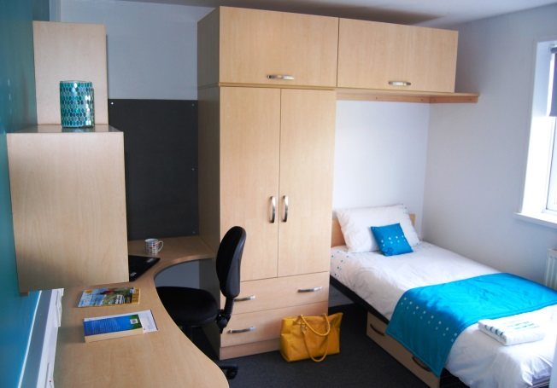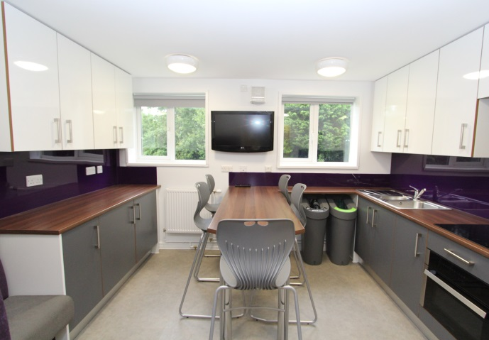

Further Information:
- Rates includes VAT.
- Payment is non-refundable.
- All rooms are provided with bed linen and a towel and have use of a shared kitchen with TV and seating area.
- There are no cooking utensils or crockery supplied in the kitchens.
- There is a launderette available on site with washing machines and dryers that are operated via the Circuit app.
- Pay and Display Car parking is available on campus @ £2.00 per day Monday to Friday, 50p evenings and weekends.
- Pay & Display machines take card only, or you can pay using the Saba Parking App
- Address is: Cyncoed Campus, Cyncoed Road, Cardiff, CF23 6XD
- Travel information can be found here

Roath Park and Lake; 5 minute walk

