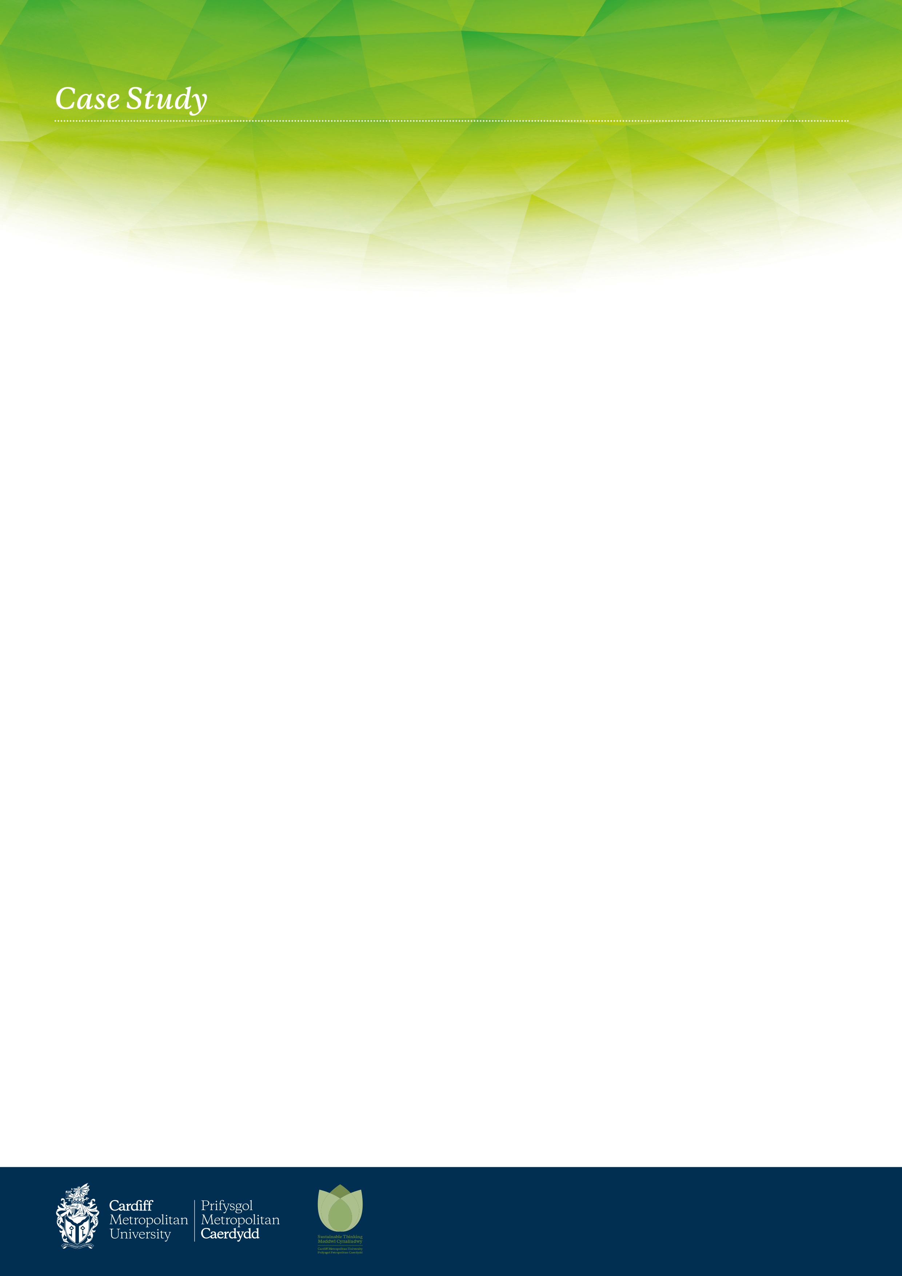

Outcomes The Real World Project encouraged students to consider the role they and their discipline can play in prompting and influencing meaningful sustainability data collection. By developing and promoting real world solutions to genuine problems that had the potential for implementation and thus achieve a lasting impact, it was clear that the vast majority of students became invested in their project outputs and accordingly developed a strong sense of ownership and value in their accuracy of data collection and recording – evidence of effective experiential learning.

# Learning Outcomes - I thoroughly enjoyed the process of carbon accounting. After receiving a big pile of data, we had to work together to ensure we used the right strategies by using excel and other features. Whilst doing the work placement I gained a range of skills, including management, teamwork and problem-solving skills. I also enjoyed learning more about excel and the many features which can make working with a lot data so much easier. **Willem Vos - BA (Hons) Business and Management (Entrepreneurship)**

Work Placements Feb 2022 – April 2022

Carbon Accounting for Travel Data – setting the baseline data for carbon neutral planning.

# Key Points

* This Real World project allowed students to apply for one of six different themed work placement teams based with the Sustainability Engagement Manager.
* Work placements equates to 15 working days.
* Issues of sustainability are positioned with constraints and difficulties that the students would need to overcome, illustrating to the students the context within which sustainability has to practice.
* The need for scrutiny, in addition to economic and environmental considerations, when providing generalised sustainability advice within the context of Cardiff Met sites was explored.
* Travel data to be collected, calculated and provision of a full audit trail.

# Who?

The Real World work placement opportunity for BA Business and Management / Banking & Finance / Accounting & finance / Business Economics / Economics / International Economics & Finance students on Work Placement Module at Level 5.

The projects were designed for students on the Sustainability, Marketing and Finance pathways, with the opportunity to conduct research, analyse the issues identified and provide realistic solutions with the potential to directly influence sustainability initiatives on Campus. This group were tasked with the collection, sorting, conversion and audit trail of data for the HESA/EMR data return for 2020/21 to a deadline of April 2022.

# Why?

Cardiff Metropolitan University recognises the importance of the role it has to play in environmental management of its estate and in promoting principles of sustainability across all activities, including teaching and research. The University manages and controls its environmental risks in a sustainable manner by complying with relevant legislation and adopting where appropriate best practice. Cardiff Metropolitan recognises a wide definition of sustainability, based on engaging in development that meet the needs of the present, without compromising the ability of future generations to meet their own needs. The University is continuously looking at how it can improve sustainability and reduce its carbon footprint, the placement gave student groups the opportunity to work collaboratively (virtual / online) on a range of projects within the sustainability field in relation to surroundings they were familiar with. Data capture for Travel has proved difficult in locating in previous years, this work placement group requiring the information assisted the locating and reviewing for future years.

# How?

After applying for a position in their chosen subject, four students completed research on internal data collation and reporting to an external deadline of April 2022. Due to Covid-19 the work placement was completed on Microsoft Teams, with weekly / regular meetings demonstrating ideas and progress on tasks allocated. The final element of the placement was to present group findings with an oral presentation and short report.

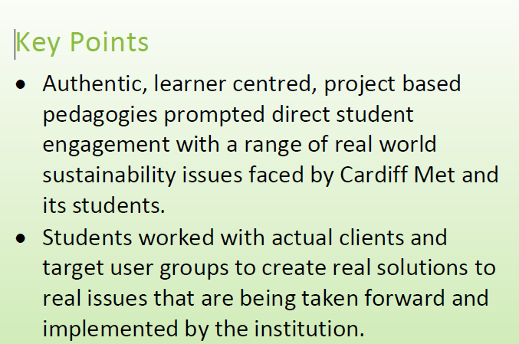

*February 2021 – May 2021*