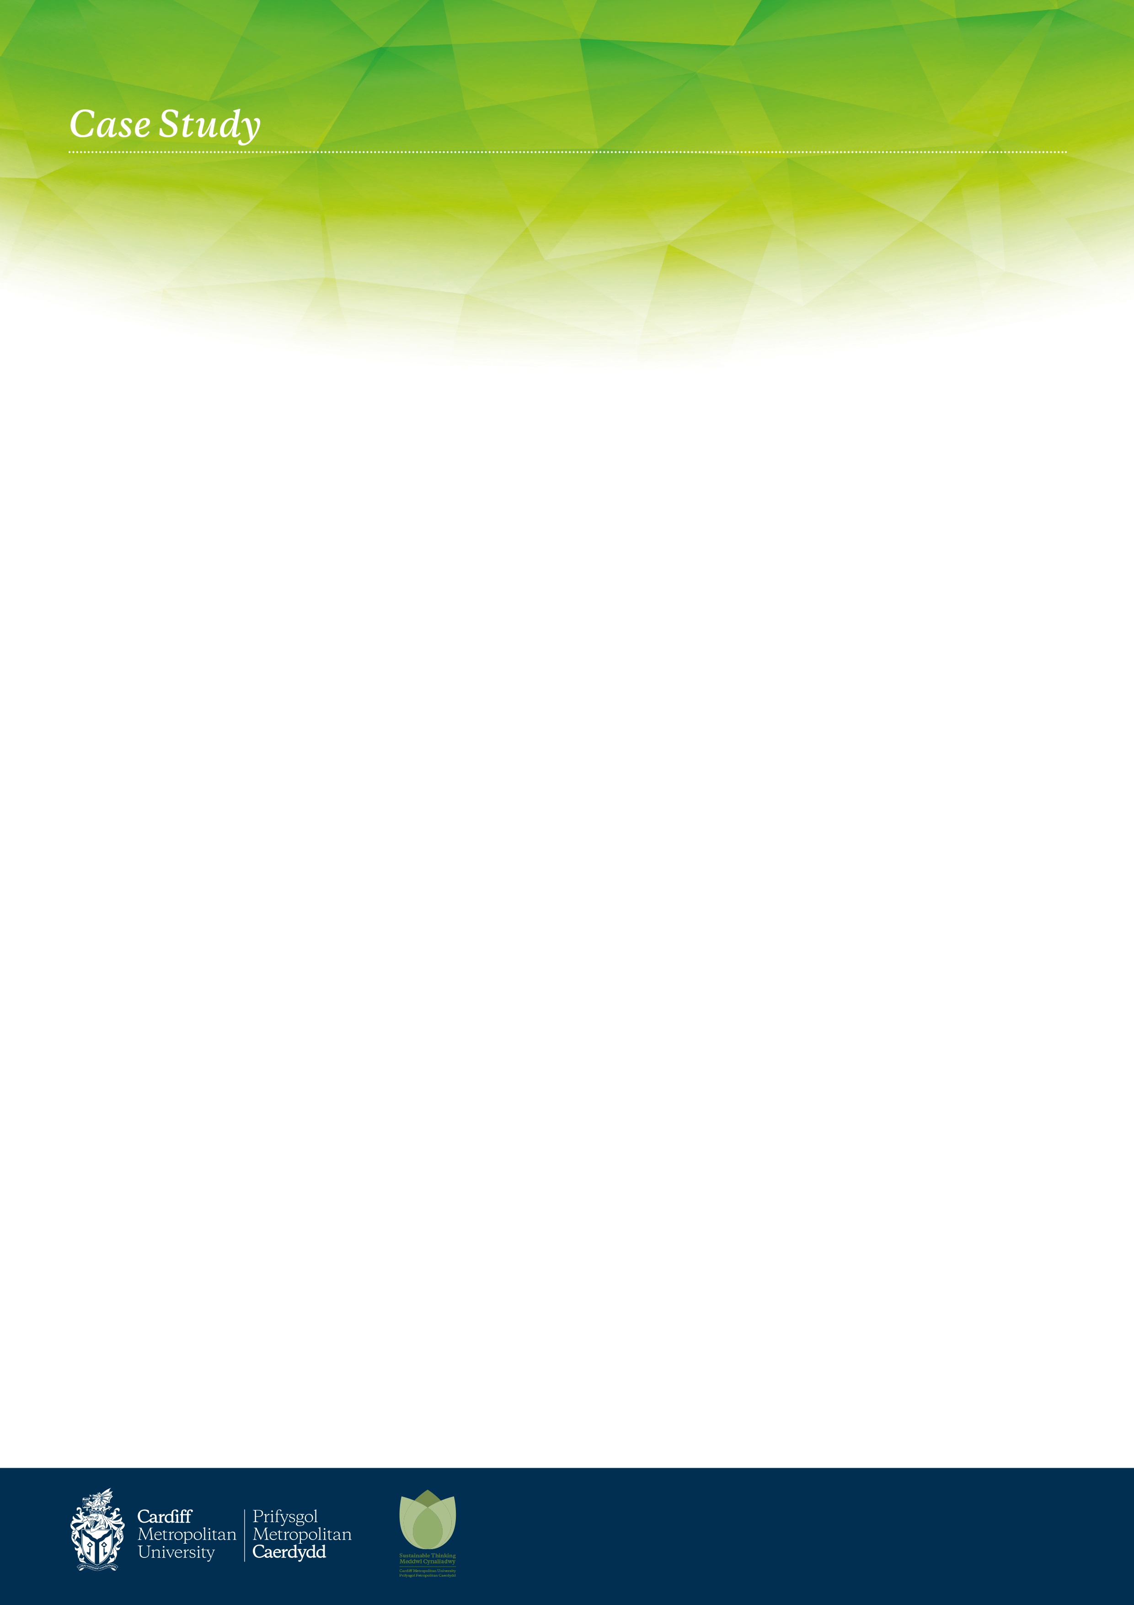

Outcomes

The Real World Project encouraged students to consider the role they and their discipline can play in prompting and influencing meaningful sustainability data collection. By developing and promoting real world solutions to genuine problems that had the potential for implementation and thus achieve a lasting impact, it was clear that the vast majority of students became invested in their project outputs and accordingly developed a strong sense of ownership and value in their accuracy of data collection and recording – evidence of effective experiential learning.

Work Placements Feb 2022 – April 2022

Open Days.

# Key Points

* This Real World project allowed students to apply for one of six different themed work placement teams based with the Sustainability Engagement Manager.
* Work placements equates to 15 working days.
* Issues of sustainability are positioned with constraints and difficulties that the students would need to overcome, illustrating to the students the context within which sustainability has to practice.
* The need for scrutiny, in addition to economic and environmental considerations, when providing generalised sustainability advice within the context of Cardiff Met sites was explored.
* Tasked with how can they could raise awareness of sustainability activities on Campus to visitors at Open Days.

# Who?

The Real World work placement opportunity for BA Business and Management / Banking & Finance / Accounting & finance / Business Economics / Economics / International Economics & Finance students on Work Placement Module at Level 5.

The projects were designed for students on the Sustainability, Marketing and Finance pathways, with the opportunity to conduct research, analyse the issues identified and provide realistic solutions with the potential to directly influence sustainability initiatives on Campus. This group were tasked with the planning, delivery and engagement of Fairtrade events on Campus and online during Feb/ March 2022 and creation of a Fairtrade survey and analysis of results.

# Why?

Cardiff Metropolitan University recognises the importance of the role it has to play in environmental management of its estate and in promoting principles of sustainability across all activities, including teaching and research. The University manages and controls its environmental risks in a sustainable manner by complying with relevant legislation and adopting where appropriate best practice. Cardiff Metropolitan recognises a wide definition of sustainability, based on engaging in development that meet the needs of the present, without compromising the ability of future generations to meet their own needs. The University is continuously looking at how it can improve sustainability and reduce its carbon footprint, the placement gave student groups the opportunity to work collaboratively (virtual / online) on a range of projects within the sustainability field in relation to surroundings they were familiar with.

# How?

After applying for a position in their chosen subject, six students created a slideshow of images that could be displayed on tv screens around the Campus during Open Days. The work placement was completed on Microsoft Teams, with weekly / regular meetings demonstrating ideas and progress on tasks allocated and on Campus for image collection. The final element of the placement was to present their slideshow.

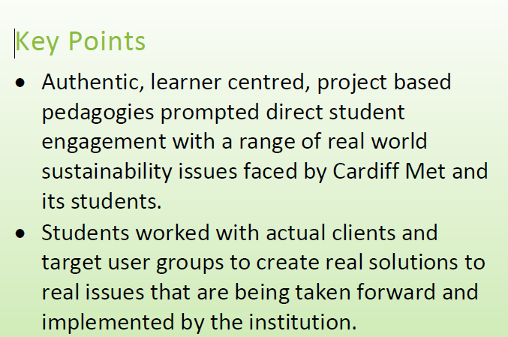

*February 2021 – May 2021*