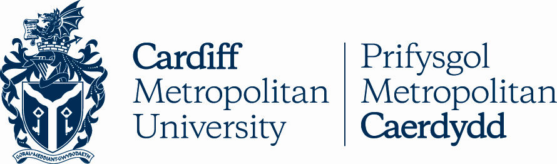

12.2

REGULATIONS FOR POSTHUMOUS AWARDS

Key Details
POLICY TITLE | Regulations for Posthumous Awards
DATE APPROVED | 01 May 2008
APPROVING BODY | Academic Board via AQSC
VERSION | 3
PREVIOUS REVIEW DATES | Sep 2008, Mar 2017, Mar 2022
NEXT REVIEW DATE | 2025
OUTCOME OF EQUALITY IMPACT ASSESSMENT
RELATED POLICIES / PROCEDURES / GUIDANCE | Academic Handbook Ah1_12 (cardiffmet.ac.uk)
IMPLEMENTATION DATE | 01 May 2008
POLICY OWNER (JOB TITLE) | Director of Registry Services
UNIT / SERVICE | Registry Services
CONTACT EMAIL | regulations@cardiffmet.ac.uk

Version Control
VERSION | DATE | REASON FOR CHANGE

Regulations for Posthumous Awards

These regulations only apply in the instance where a student has passed away whilst enrolled on a programme at Cardiff Metropolitan University but has not been entered into an award for that programme.

Where the Examination Board or Research Degrees Group recommends a posthumous award, these regulations then supersede the credit requirements for Undergraduate and Postgraduate Taught awards as set out in Section 10 of the Academic Handbook.

The student will be granted the full award on which they were registered but it will be unclassified or undifferentiated.

The making of a posthumous award is not to be confused with the awarding of a student posthumously, where a student passes away after completing all required assessments for the award but has not been awarded.

The process for awarding a student posthumously, would not be distinguished in any way from any other Cardiff Metropolitan University award.

Procedures for Approval of Posthumous Awards

These procedures will apply where a deceased student has not completed all the required assessment (Undergraduate and Postgraduate Taught programmes) or research (Doctoral Research programmes) but is registered at the University at the time of death. In these cases, the student will be granted an unclassified or undifferentiated posthumous award.

In order to ensure the student’s academic profile is correct, if there are any work / modules / credits completed that have not been ratified these will still be presented at the next scheduled Examination Board or Research Degrees Group. Unless this results in the student then meeting all the requirements for their award, they will receive the unclassified or undifferentiated posthumous award.

The Examination Board shall confirm that a Posthumous Award is to be granted and instruct the school to notify the Special Cases Committee. The Research Degrees Group shall confirm that a Posthumous Award is to be granted and will notify the Special Cases Committee. Notifications will be made using the Special Cases Request Form - Volume 1, Section 05.3.

If it is not permissible to make an award due to accrediting / professional body requirements or similar constraints, an Examination Board or the Research Degrees Group may recommend an alternative award.

The Special Cases Committee will note the Posthumous Award, confirming this in writing to the student’s family, the relevant School and Registry Services.

Registry Services shall award the student and invite the student’s family to graduation. The certificate shall be issued in accordance with; 04.8 Assessment Marks, Certificates and Final Transcripts.

Cardiff Metropolitan University awards issued under regulations for Posthumous Awards will include the wording; "has been admitted to the posthumous degree of" on the certificate. Any posthumous award made will be ‘unclassified’ and will not carry accreditation nor confer eligibility to register with a professional body.

Reporting and Monitoring

The Special Cases Committee shall submit an annual report to the Academic Quality and Standards Committee on all awards made under this regulation.

