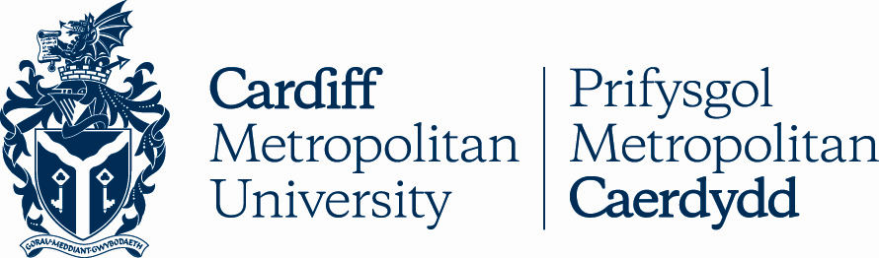

14.1

DESIGNATED DEGREES AND AWARDS OF CARDIFF METROPOLITAN UNIVERSITY

Key Details
POLICY TITLE | Designated Degrees and Awards of Cardiff Metropolitan University
DATE APPROVED | 11 Nov 2011
APPROVING BODY | Academic Board via AQSC
VERSION | 7
PREVIOUS REVIEW DATES | Oct 2012, Feb 2013, Oct 2013, Dec 2016, Jul 2019, Nov 2019, Jan 2023, Apr 2023
NEXT REVIEW DATE | N/A
OUTCOME OF EQUALITY IMPACT ASSESSMENT
RELATED POLICIES / PROCEDURES / GUIDANCE | Academic Handbook Ah1_14 (cardiffmet.ac.uk)
IMPLEMENTATION DATE | 14 Aug 2007
POLICY OWNER (JOB TITLE) | Director of Registry Services
UNIT / SERVICE | Registry Services
CONTACT EMAIL | regulations@cardiffmet.ac.uk

Version Control
VERSION | DATE | REASON FOR CHANGE

Designated Degrees and Other Awards of Cardiff Metropolitan University

The following sets out the definitive list of those degrees and other awards that have been designated by the Academic Board of the University.

- These were first approved by the University’s Academic Board at its meeting on 11 November 2011.

- Proposals for the establishment of any new degrees of Cardiff Metropolitan University must be submitted in accordance with the “Procedure for Establishment of New Cardiff Metropolitan University Awards”.

Once any new degrees have been established, they will be added to the attached list together with the date of establishment.

- The Qualification Level is shown alongside each category of degree or other award.

Cardiff Metropolitan University Degrees
Definitive List of Degrees Designated as the University’s Degrees
(English and Welsh titles as they appear on Degree Certificates)

The Degrees of Cardiff Metropolitan University shall be designated as follows:

Foundation Degrees (Level 5)

Post-nominal Letters | English | Welsh
FdA | Foundation Degree in Arts | Gradd Sylfaen yn y Celfyddydau
FdSc | Foundation Degree in Science | Gradd Sylfaen mewn Gwyddoniaeth

Bachelor’s Degrees (Level 6)

Post-nominal Letters | English | Welsh
BA | Bachelor of Arts | Baglor yn y Celfyddydau
BSc | Bachelor of Science | Baglor mewn Gwyddoniaeth
BScEcon | Bachelor of Economic and Social Studies | Baglor mewn Astudiaethau Economaid a Chymdeithasol
BEng | Bachelor of Engineering | Baglor mewn Peirianneg
LLB | Bachelor of Laws | Baglor yn y Gyfraith
BBA | Bachelor of Business Administration | Baglor mewn Gweinyddiaeth Fusnes

Master’s Degrees (Level 7)

Post-nominal Letters | English | Welsh
MA | Master of Arts | Athro yn y Celfyddydau
MSc | Master of Science | Athro mewn Gwyddoniaeth
MBA | Master of Business Administration | Athro mewn Gweinyddiaeth Fusnes
MDes | Master of Design | Athro mewn Dylunio
MEng | Master of Engineering | Athro mewn Peirianneg
MFA | Master of Fine Arts | Athro yn y Celfyddydau Cain
MProf | Master of Professional Practice | Athro mewn Ymarfer Proffesiynol
MRes | Master of Research | Athro mewn Ymchwil
MPhil | Master of Philosophy | Athro mewn Athroniaeth
LLM | Master of Laws | Athro yn y Cyfreithiau
MArch | Master of Architecture | Athro mewn Pensaernïaeth

Doctoral Degrees (Level 8)

Post-nominal Letters | English | Welsh
PhD (by Research) | Doctor of Philosophy | Doethur mewn Athroniaeth
PhD (by Published Works) | Doctor of Philosophy | Doethur mewn Athroniaeth
DBA | Doctor of Business Administration | Doethur mewn Gweinyddiaeth Fusnes
DBMS | Doctor of Biomedical Sciences | Doethur mewn Gwyddorau Biofeddygol
EdD | Doctor of Education | Doethur mewn Addysg
DSBE | Doctor of Sustainable Built Environment | Doethur mewn Amgylchedd Wedi'i Adeiladu'r Gynaliadwy
DForenPsy | Doctor of Forensic Psychology | Doethur mewn Seicoleg Fforensig
DEng | Doctor of Engineering | Doethur mewn Peirianneg
DProf | Doctor of Professional Practice | Doethur mewn Arfer Proffesiynol
DMan | Doctor of Management | Doethur mewn Rheolaeth
DSC | Doctor of Sport Coaching | Doethuriaeth mewn Hyfforddi Chwaraeon

Senior Doctorates

Post-nominal Letters | English | Welsh
DLitt | Doctor of Letters | Doethur mewn Llên
DSc | Doctor of Science | Doethur mewn Gwyddoniaeth
DScEcon | Doctor of Economic and Social Studies | Doethur mewn Astudiaethau Economaid a Chymdeithasol
DDSc | Doctor of Dental Science | Doethur mewn Gwyddioniaeth Ddeintyddol

Honorary Degrees

All of the above Masters and Doctoral Degrees may also be awarded as Honorary Degrees of the University. The Degree Certificate would bear the words “The Honorary Degree of …” before the name of the degree, or the words “honoris causa” after the name of the degree.

In addition, the following shall be designated as an Honorary Degree of Cardiff Metropolitan University, especially for situations where the subject areas of the above Doctoral Degrees would not be appropriate:

Post-nominal Letters | English | Welsh
DUniv | Doctor of The University | Doethur er Anrhydedd y Brifysgol

Other Cardiff Metropolitan University Awards
Definitive List of Other Awards designated as the University’s Awards

The Non-degree Awards to be conferred by Cardiff Metropolitan University shall be designated as follows:

Award Title | Abbrev | Qualification Level
Foundation Certificate | - | Level 3
Certificate of Higher Education | CertHE | Level 4
Diploma of Higher Education | DipHE | Level 5
Higher Diploma | HDip | Level 5
Graduate Certificate | GradCert | Level 6
Graduate Diploma | GradDip | Level 6
Postgraduate Certificate | PgCert | Level 7
Postgraduate Diploma | PgDip | Level 7
Postgraduate Certificate in Education* | PGCE | Level 7
Professional Graduate Certificate in Education** | PGCE | Level 6
Professional Certificate in Education | CertEd | Level 4
*PGCE (with QTS, Qualified Teacher Status)
**PGCE (PcET, Post-compulsory Education & Training)

A full list of all Cardiff Metropolitan University programmes (validated by Cardiff Metropolitan University) leading to these degrees and other awards is published on the web at:
https://cis.cardiffmet.ac.uk/onlinecurriculummatrix/

