Policy on Research Misconduct
  - POLICY COVERSHEET

Key Details
POLICY TITLE | Policy on Research Misconduct
DATE APPROVED | 15 December 2021
APPROVING BODY | Research & Innovation Committee
VERSION | 4
PREVIOUS REVIEW DATES | September 2016  December 2018
NEXT REVIEW DATE | December 2024
OUTCOME OF EQUALITY IMPACT ASSESSMENT | No major change
RELATED POLICIES / PROCEDURES / GUIDANCE | For staff:  Staff Disciplinary Policy  Whistleblowing Policy and Procedure  Research Ethics Procedures  For students:  Student Disciplinary Procedure  Examination Regulations  Student Unfair Practice Procedure  Research Ethics Procedures
IMPLEMENTATION DATE | January 2022
POLICY OWNER (JOB TITLE) | REF & Policy Manager
UNIT / SERVICE | Research & Innovation Services
CONTACT EMAIL | kajefferies@cardiffmet.ac.uk

Version Control
VERSION | DATE | REASON FOR CHANGE
1.0 | February 2008 | First version
2.0 | September 2016 | Second version
3.0 | December 2018 | Third version

Contents
Key Details 1
Version Control 1
1 Introduction 3
2 Procedure in the case of suspected research misconduct 4
3 Timescales 7
4 Roles and Responsibilities 7
5 Related Policies and Procedures 7
6 Review and Approval 7
Annex 1 8
Annex 2 8

Introduction

Purpose

Cardiff Met is committed to maintaining the highest standards of professional conduct in all research activities and is committed to ensuring that all research is carried out with the utmost rigour and integrity.

Whilst research misconduct is uncommon, it does pose a potential threat to maintaining rigour and integrity, this policy therefore aims to ensure that any allegation of research misconduct is dealt with fairly and in a timely manner.

Scope

This policy applies to all individuals who are engaged in research at Cardiff Metropolitan University. This includes all staff and postgraduate and undergraduate students as well as other individuals who conduct research on Cardiff Met premises.

This policy is concerned with the investigative process to be undertaken when an allegation of research misconduct is made rather than any subsequent disciplinary procedures which may be invoked. The precise nature of those procedures (if invoked) will be determined by the nature of the misconduct in question.

This policy focuses on misconduct in the context of research activity. This being the case, it complements, rather than replaces, other Cardiff Met policies and procedures, in particular:
For staff:
Staff Disciplinary Policy
Whistleblowing Policy and Procedure
Research Ethics Procedures
For students:
Student Disciplinary Procedure
Examination Regulations
Student Unfair Practice Procedure
Research Ethics Procedures

Definitions

The institution endorses the definition of research misconduct provided and formally adopted by UKRI in its Policy and Guidelines on Governance of Good Research Conduct. This being the case, research misconduct will include, whether deliberate, reckless or negligent, fabrication, falsification, plagiarism, misrepresentation, breach of duty of care and improper dealing with allegations of misconduct. Full details of the RCUK definitions can be found at Annex 2.

The institution is also mindful of UKRI’s Preventing harm (safeguarding) in research and innovation policy and will investigate any allegation made in relation to the issues covered by that policy, using the procedure laid out below.

1.3.3 Fraud or other misuse of research funds or research equipment may be dealt with under Cardiff Met’s financial regulations.
1.3.4 Anyone who may be unclear on what might constitute research misconduct, either in general or in relation to a specific incident, may seek advice from Research & Innovation Services.

Procedure in the case of suspected research misconduct

Cardiff Met will investigate allegations of research misconduct fully and expeditiously whilst also ensuring that researchers are protected from malicious, mischievous or frivolous allegations.

Allegations of research misconduct should be made in writing and be no longer than 1000 words in length. The allegation should normally be directed in the first instance to the Director of Research who will undertake an initial investigation to establish whether a prima facie case of misconduct exists. Any allegation which implicates the DoR should be directed to the PVC (Research) who will nominate an alternative member of staff to undertake the initial investigation. Allegations may be made in either English or Welsh.

Where it is decided that no prima facie case can be established, the complainant will be informed in writing and will have the right to appeal against the decision. Appeals will be referred to the Director of Learning Enhancement who will undertake a second initial investigation. Any allegation which implicates the DLE will be referred to an alternative member of staff, nominated by the PVC (Research). The outcomes of the appeal process will be final.

In the event that a prima facie case is deemed to exist, the case will be referred to the PVC (Research) who may take immediate action via the appropriate disciplinary regulations or, if considered appropriate, may instigate further investigations into the allegation.

If further investigations are necessary, they will be carried out either by the PVC(R) or by an appropriate individual appointed by the PVC(R). This individual will be referred to as the Investigating Officer and will be supported by a member of Research & Innovation Services.

Whilst it is preferable that the Investigating Officer will have expert knowledge of the area of research involved, of paramount importance will be their independence from the complainant and the subject of the complaint. In cases where it is not possible to satisfy both of these provisos, the Investigating Officer may decide to consult an external expert. Similarly, the Investigating Officer may seek legal advice where appropriate. The complainant will be informed in writing who the Investigating Officer is prior to commencement of any formal proceedings and will be given an opportunity to request an alternative on the grounds of conflict of interest.

The individual or individuals against whom the allegation is made shall be informed in writing of the nature of the allegation, of the decision to appoint an Investigating Officer and details of who the Investigating Officer will be. Full details of the investigation process will also be provided. They shall be given the opportunity to request an alternative Investigating Officer on the grounds of conflict of interest.

The Investigating Officer shall require the production of such records as are necessary to enable the investigation to proceed and shall ensure their safekeeping. The Investigating Officer may interview the person or persons accused and the person or persons making the allegation, together with anyone else who may have relevant information. Anyone attending for interview may be accompanied by a friend or representative.

The Investigating Officer shall take all reasonable steps to:
- Preserve the anonymity of the person or persons accused and the person or persons making the allegation, unless this would compromise the investigation.
- Ensure that the investigation is undertaken as expeditiously as possible.
- Ensure that the person or persons accused have full access to the evidence being presented against them prior to being interviewed by the panel.

Once the investigation has been concluded, the investigating officer will prepare a report setting out the evidence received, accounts of any interviews conducted, and conclusions reached. Both the complainant and the person or persons accused shall have an opportunity to comment on the report. The report, together with any comments received, will then be submitted to the PVC(R).

The Investigating Officer may also make recommendations to promote best practice in the conduct of research and any such recommendations will be brought to the attention of the Research & Innovation Committee and Academic Board.

In cases where the person or persons accused is a member of staff or a student at Cardiff Met, on receiving the report, the PVC(R) shall proceed in one of the following ways:
i. In the event that no evidence of misconduct has been found, the complaint shall be dismissed.
ii. In the event that a complaint is upheld but the offence found to be insufficiently serious to warrant formal disciplinary proceedings, the matter may be referred to the Dean of School, or other appropriate individual, for resolution.
iii. If the investigation has uncovered prima facie evidence of serious misconduct, then the matter shall be dealt with under the appropriate disciplinary procedures. Action may be taken in respect of members of staff under the Staff Disciplinary Policy. Action may be taken in respect of students under the Student Disciplinary Procedure, Student Unfair Practice Procedure or Examinations Regulations.

2.14 In cases where the outcome implicates someone who is not subject to Cardiff Met’s disciplinary procedures, the PVC(R) shall bring the report to the attention of any appropriate disciplinary body.

2.15 If the Investigating Officer finds the allegations to have been malicious or mischievous in nature, the PVC(R), will consider whether disciplinary action should be taken against those making the allegation.

2.16 Where the research in question is funded in whole or in part by an external grant, the institution will refer to guidance issued by that funder regarding cases of alleged research misconduct. The PVC(R) will ensure that any such body is provided with appropriate and timely information regarding the instigation and process of an investigation and any referral under disciplinary regulations.

2.17 Where an allegation of misconduct is upheld against an individual who is subject to the regulation of a professional body, the PVC(R) will consider whether it is appropriate to inform the professional body of any finding.

2.18 Where the individual has published research, especially research relating to the misconduct investigation, the PVC(R) will consider whether it is appropriate to inform journal editors or others of any finding.

2.19 In cases where the individual resigns their post during the misconduct investigation, the investigation will continue to its conclusion.

Timescales

Individuals involved in the investigative process shall take all reasonable steps to ensure that the investigation is undertaken as expeditiously as possible.

Of paramount importance is that a full and thorough investigation is undertaken, in order that the integrity of the institution, its staff, students and associates is maintained. However, it is recognised that the welfare of those accused must also be protected and should not be compromised by a protracted process. It is therefore recommended that all incidences of alleged research misconduct are investigated within a 12 working week timeframe, from the date of receipt of the original allegation.

If an investigation is likely to take longer than 12 working weeks, both the complainant and the accused will be informed in writing of the reasons for this and given an indication of when the investigation will conclude.

An indicative timeline for the investigative procedure is appended to this policy.

Roles and Responsibilities

This policy applies to all individuals who are engaged in research at Cardiff Metropolitan University. This includes all staff and postgraduate and undergraduate students as well as other individuals who conduct research on Cardiff Met premises.

The Research & Innovation Committee has strategic ownership of the policy and is responsible for monitoring its use and for reviewing it periodically, in line with the University Schedule for Policy Approval.

Any staff member or student requiring further advice in relation to the policy, or any aspect of perceived research misconduct, should contact the University Director of Research for advice in the first instance.

Related Policies and Procedures

A list of related Cardiff Met policies and procedures is provided in 1.2.3 above.

Review and Approval

This policy will be reviewed by Research & Innovation Committee every three years, in line with the University Schedule for Policy Approval, or more frequently if deemed necessary.

Annex 1

Research Misconduct Procedure and Indicative Timeline

Annex 2

Details of UKRI definitions of unacceptable research conduct taken from the UKRI Policy and Guidelines on Governance of Good Research Conduct

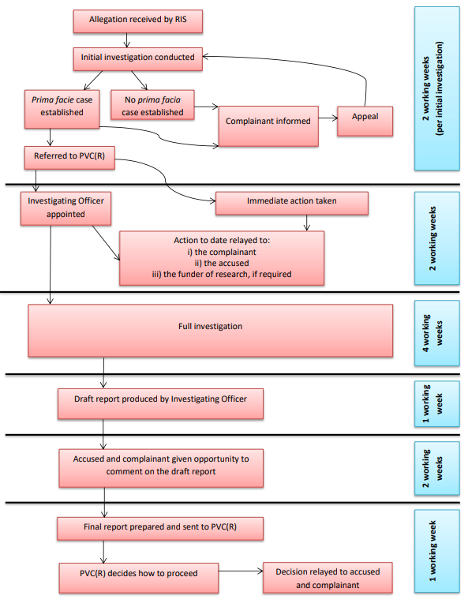

The following is taken from the UKRI Policy and Guidelines on Governance of Good Research Conduct (latest update February 2021)
Unacceptable Research Conduct includes each of the following:
Fabrication, comprising the creation of false data or other aspects of research, including documentation and participant consent.
Falsification, comprising the inappropriate manipulation and/or selection of data, imagery and/or consents.
Plagiarism, comprising the misappropriation or use of others’ ideas, intellectual property or work (written or otherwise), without acknowledgement or permission.
Misrepresentation, including:
- Misrepresentation of data, for example suppression of relevant findings and/or data, or knowingly, recklessly or by gross negligence, presenting a flawed interpretation of data.
- Undisclosed duplication of publication, including undisclosed duplicate submission of manuscripts for publication.
- Misrepresentation of interests, including failure to declare material interests either of the research or of the funders of the research.
- Misrepresentation of qualifications and/or experience, including claiming or implying qualifications or experience which are not held.
- Misrepresentation of involvement, such as inappropriate claims to authorship and/or attribution of work where there has been no significant contribution, or the denial of authorship where an author has made a significant contribution.

Breach of duty of care, whether deliberately, recklessly or by gross negligence, including:
- Disclosing improperly the identity of individuals or groups involved in research without their consent, or other breach of confidentiality.
- Placing any of those involved in research in danger, whether as subjects, participants or associated individuals, without their prior consent, and without appropriate safeguards even with consent; this included reputational danger where that can be anticipated.
- Not taking all reasonable care to ensure that the risks and dangers, the broad objectives and the sponsors of the research are known to participants or their legal representatives, to ensure appropriate informed consent is obtained properly, explicitly and transparently.
- Not observing legal and reasonable ethical requirements or obligations of care for animal subjects, human organs or tissue used in research, or for the protection of the environment.
- Improper conduct in peer review of research proposals or results (including manuscripts submitted for publication); this includes failure to disclose conflicts of interest; inadequate disclosure of clearly limited competence; misappropriation of the content of material; and breach of confidentiality or abuse of material provided in confidence for peer review purposes.

Improper dealing with allegations of misconduct, including:
- Failing to address possible infringements including attempts to cover up misconduct or reprisals against whistle-blowers.
- Failing to deal appropriately with malicious allegations, which should be handled formally as breaches of good conduct.

