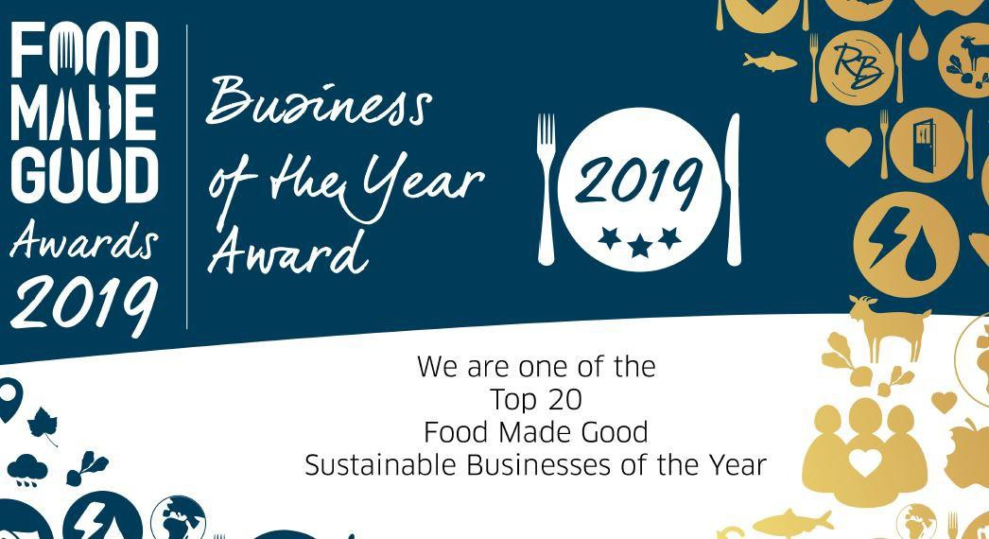

Cardiff Metropolitan University
Commercial Services

Sustainable Food Policy

Approved: Sustainability Committee Date : September 2020
Version 1.4 Next revision: January 2021

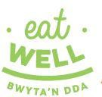
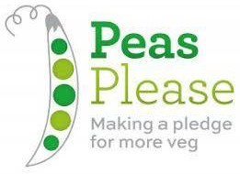
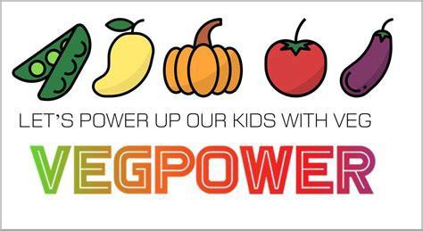
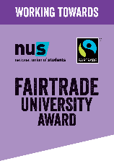

Introduction

The University Catering & Hospitality Service recognises its responsibility to carry out its procurement activities in an environmentally and socially responsible manner, whilst also encouraging healthy and sustainable food production and consumption.

We will encourage suppliers to minimise the negative environmental and social effects associated with their production and supply chain, and ensure, through active encouragement, that local and smaller suppliers are not discriminated against in the procurement process and tender opportunities.

This policy document forms part of the University's overall Environment and Sustainability policy and strategy, and will contribute to the SMART objectives therein. It provides a framework within which the University will increasingly seek to provide healthy, local and sustainable food and commodities to its customers.
This policy will apply to all food and beverages managed and produced by the University's Catering and Hospitality Service.

Sustainable Catering Accreditation

The University is accredited to the Sustainable Restaurant Association ‘Food Made Good’ and has achieved a rating of Three Stars. In 2019, Cardiff Metropolitan was included in the Top 20 sustainable operators for the scheme and it commits to maintaining the high standards in its future food provision.

Objectives

The objectives of this policy are:

Fairtrade

- To support the University to maintain its Fairtrade status, by fully commiting to re-accreditaion through the new Fairtrade University criteria. set out by the Fairtrade foundation. This will be achieved by supporting the University’s Fairtrade Policy and SMART action plan.
- To actively support the Fairtrade fortnight and any nationwide campaigns to help raise awareness
- Identify opportunities to increase our Fairtrade product range and POS information

Waste and Recycling

- The service aims to support the University’s set targets for the reduction of food waste sent to landfill with WRAP
- The service will continue to utilise the University’s waste and recycling channels to minimise the amount of waste sent to landfill.

- Promote food waste segregation and collection across all catering outlets and other kitchen areas throughout the University.
- Continue to recycle all waste oil via a registered contractor for conversion to biodiesel.
- Reduce the amount packaging used in both retail and hospitality services.

Disposables

- We will seek to reduce the use of disposal drinking cups used in the service.
- Review the disposable items used in delivered hospitality and the retail operation to reduce the number of items used.
- Look to reduce the use of non-biodegradable food packaging used in both retail and hospitality services.
- Promote the use of Cardiff Met’s reusable mug and eco to go food box ranges food containers and any other reusable product to reduce the amount of packaging sent to landfill.
- Promote the use of Chilly bottles and free water vending on campus to reduce the amount of plastic used on campus.

Procurement

The majority of our suppliers are nominated and regulated through our membership of TUCO (The University Caterers Organisation), and the HEPCW (Higher Education Purchase Consortium Wales).
Catering & Hospitality will adhere to the aims and objectives set out in their respective sustainability policy and framework agreements.
We will support the work of the (Cardiff) Sustainable Food Cities Network, and seek to increase the number of supply agreements with locally-based companies and place particular emphasis on locally-sourced fresh ingredients.

Vegetarian & Vegan options

We will: -

- Offer a daily selection of hot and cold vegan and vegetarian products at each catering venues on campus
- Make vegan and vegetarian options an integral part of core of the daily menu range.
- Support and champion vegan promotions throughout the year.

Free Range Eggs

We will

- Use eggs purchased will be from a free-range production system and sourced from a local supplier.
- Promote the use of free range eggs

Dairy

We will: -

- Only purchase milk from local Welsh producers/suppliers that is bottled and farmed in Wales.
- Offer healthier milk alternatives in all of the catering venues on campus
- Offer various non-dairy milk substitutes through all of the catering venues on campus.

Meat & Poultry

We will: -

- Ensure all meat purchased are sourced from local butchers, with appropriate accreditation, and full traceability of all meat sourced from suppliers.
- Use poultry that is Red tractor Assured or equivalent as a minimum standard.
- When appropriate and required, certified Halal meat will be used.

Fish

We will;-

- Avoid the use of fish as listed on the Marine Conservation Society’s “fish to avoid list”
- Become a signatory of the Sustainable Fish Cities pledge, and aim to serve only Marine Stewardship Council (MSC) certified fresh fish, and the promotion of fish on the MSC's 'fish to eat' list.

Fruit and Vegetables

We will;-

- Wherever possible our menus will use seasonal produce grown in the UK and locally grown produce when in season.
- Promote seasonal and local produce via an annual promotional calendar. (eg Welcome to Wales Food Week)
- Ensure that fresh fruit is available in all catering units each day
- Run a free fruit promotion throughout the year encouraging both staff and students to eat more healthily.

Water and Beverages

We will;-

- Reduce the use of bottled water for hospitality by incorporation of a water bottling system.
- We will promote the availability of free, chilled water on site for staff and students and the community from the Hydrachill machines. In partnership with Refill by having the hydrachill machines promoted on their app on a map for people to find their closest Refill point within the City. The hydrachill machines locations are also included on the University maps and on the University app.

Health & Wellbeing

We will;-

- Continue to develop its healthy eating range of products 'Eatwell', and ensure that all daily menus include an option from this range.
- Adopt cooking methods that reduce the use of salt, fat, oil and artificial additives and preservatives in its menus.
- In conjunction with the Health & Wellbeing group, the service will actively develop and promote healthy eating on all campuses via its Eatwell food standard.
- Provide menu information that includes nutritional and dietary information so customers are able to identify the healthier choice.
- Support a culture of healthy eating with meal choices reflecting cultural diversity.
- Ensure healthier options will be available and promoted in all corporate hospitality menus.
- Hold promotional events throughout the year in support of the Corporate Health Standard.
- Offer a daily vegan hot main course in the two main food courts on campus.
- Support the Pea’s Please campaign to encourage the consumption of more vegetables in our diet.
- Actively support the Veg Power campaign to raise awareness of vegetables and a healthier diet.

Sustainable Food Projects

We will;-

- Continue to support the University Community garden and student Enactus Orchard project.
- Continue to support the Real World projects with Health Science students for the design and implementation of new menu options.
- Continue to support the delivery of promotional and awareness events based on sustainable food campaigns and projects, e.g. the May 2019 staff and student ‘Dirty Vegan’ chef and author event.

Commitment and Communications

We will;-

- Apply the Sustainable Food Policy across all the University catering outlets and support the delivery through relevant staff training and development.
- Ensure this Policy is fully reflected in all catering tenders and contracts.
- Actively seek to engage with all stakeholders and customers in the continued development of this area of work.
- Will activity communicate and promote all sustainable good practise to both staff and students on campus.

Monitoring and Evaluation

The policy will be monitored and evaluated annually and reports produced containing the following
- Sales mix Analysis of healthy options as percentage of sales.
- Customer feedback from monthly surgeries and promotional events.

Review

The Policy will be reviewed annually by the Catering & Hospitality management team and by the Sustainability Committee.
The University will continually encourage members of the University staff and student community and other relevant stakeholders to engage with the Sustainable Food Policy in focus groups and by posting the policy on the University webpages located under the Sustainability Policies Section with the appropriate contact details.

This document has been created, reviewed and approved by the Sustainability Committee April 2020, comprising of Pro-Vice Chancellor Partnerships and External Engagement, Sustainability Engagement Manager, EMS Aspect Owners, Students’ Union – SU President and SU Part Time Environmental Officer, Trade Unions and School Academic representatives.
The draft was presented to Focus Group consultations of staff and student volunteers, updated and approved on the 3rd September 2020 Sustainability Committee.
If you have any comments or would like to volunteer with Sustainability Strategy / Policy review please contact Sustainability@cardiffmet.ac.uk

