Cardiff Metropolitan University Commercial Services

Sustainable Seafood Policy

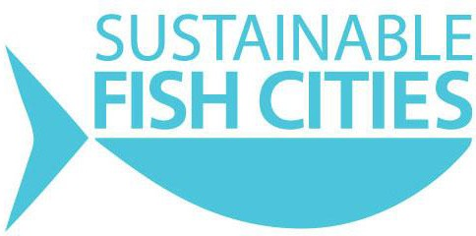
Version 2.2 September 2020 Next revision: January 2021

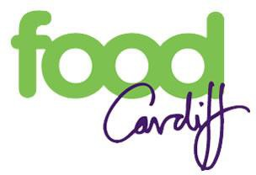
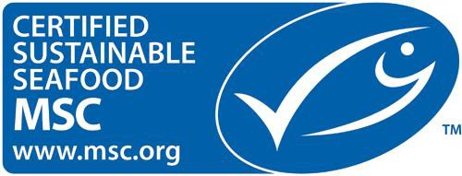

Objectives

This Policy should be read in conjunction with Sustainable Food Policy.

The objectives of this policy are:

Overfishing presents a huge global challenge. Unsustainable fishing practices are leading to the depletion of many fish stocks, which threatens the livelihoods of fishers, the future of our fish supplies, and our marine ecosystems.
Choosing to source sustainable fish allows us as a business to help reverse this trend, to know that we are contributing to the solution, not the problem, and to support sustainable fishing.
Seafood can be a healthy menu choice, and we acknowledge that to continue to serve the variety of seafood that we enjoy today we must have a robust policy to ensure we only serve fish that is demonstrably sustainable.
We are proud to be signatories of the Sustainable Fish City pledge, as part of which we follow the following principles to ensure that we only serve fish which is demonstrated to be sustainable:

Avoid the Worst:

- Will remove all fish that is ‘red rated’ by the Marine Conservation Society (scoring a 5). These are considered by the Marine Conservation Society to be unsustainable, overfished, highly vulnerable or from poorly-managed fisheries or farming systems.
- We do not sell any fish for which we cannot be certain of full traceability – we require evidence from our supplier of the farm or fishery all seafood is sourced from.

Promote the Best:

- Will increase our range of Marine Stewardship Council (MSC) certified fish
- We have increased the proportion of the fish on the menu rated ‘Fish to Eat’ (rated 1 or 2) by the Marine Conservation Society (MCS)
- Our most popular dishes are now all either MSC Certified or rated ‘fish to eat’ by the MCS
We label all fish on the menu by species, and more information can be found in the fish list folder located at each campus.
Our policy is reviewed on an annual basis, and, because the status of fish stocks is always changing, we check the MCS rating of our species at least every 6 months, and ask our suppliers to do the same.

This document has been created, reviewed and approved by the Sustainability Committee April 2020, comprising of Pro-Vice Chancellor Partnerships and External Engagement, Sustainability Engagement Manager, EMS Aspect Owners, Students’ Union – SU President and SU Part Time Environmental Officer, Trade Unions and School Academic representatives.
The draft was presented to Focus Group consultations of staff and student volunteers, updated and approved on the 3rd September 2020 Sustainability Committee.
If you have any comments or would like to volunteer with Sustainability Strategy / Policy review please contact Sustainability@cardiffmet.ac.uk

