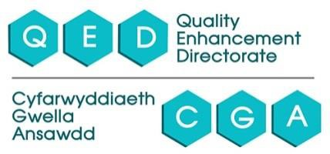

Cardiff Metropolitan University
Policy on the use of Panopto ReView

Ade Clark v5 – amended June 2020

Background and context
The ability to digitally record learning materials, addresses some key strategic themes currently facing modern universities in shaping a flexible learning environment, appropriate to a wide range of learning styles and learner requirements. It is vital if universities are to develop truly inclusive curricula.

Purpose of Panopto ReView
Students’ learning (and hence the student experience) can be enhanced by allowing students to review and reflect on course material. One system at Cardiff Met which enables this to occur at a time and location to suit the students is Panopto ReView. ReView facilitates the recording of content, which can then be distributed electronically to students. The lecturer’s delivery (either audio, or audio and video), along with synchronised learning materials such as PowerPoint or other on-screen content, are captured and then subsequently made available – usually via Moodle, the Virtual Learning Environment (VLE). This allows students to access lectures and other learning content on-demand via PC/laptop, tablet or mobile.

Benefits
Panopto ReView offers students the following key benefits:

    - Students can revisit learning anytime - for revision, and to facilitate repeated viewing of complex content
    - Provides support for students with learning differences, or whose first language is not English
- allowing them to digest content at their own pace
    - Supports 'Flipped' approaches - where core lecture content is delivered via ReView, freeing up contact time for further development & reinforcement
    - ReView facilitates detailed note-taking subsequent to the lecture
    - Offers greater flexibility & a more student-centred approach - students can manage their time most effectively around other commitments

It is for the above benefits that Panopto ReView is provided to staff and students at Cardiff Met. It can be used for both recording lectures, and the independent creation of bespoke electronic content.

Role
There is no intention that recordings should ever be a replacement for face-to-face teaching. In all the circumstances covered by this policy, the recording of teaching is undertaken to supplement student learning and will not replace contact hours. Indeed, if recording is
undertaken as part of a ‘flipped’ approach, then contact time can be optimised. It is understood that if a student misses a lecture, they miss the opportunity for social interaction and a more holistic learning experience. A number of peer-reviewed articles (please see Research section) have examined the relationship between attendance and lecture recording, and evidence suggests that lecture capture is not detrimental to attendance.

Accessibility
Under the Equality Act (2010) Cardiff Met has a legal obligation to provide reasonable adjustments to enable students with any disability to access lecture content. Having access

to recordings is considered to be such a reasonable adjustment. Withdrawal of the Disabled Students’ Allowance (DSA) for Specific Learning Differences (SpLDs) means individual note- takers may not be available from September 2016 for many SpLD students. The recording of teaching sessions using Panopto ReView will in some cases help to support these students. However, the benefits outlined above mean that the majority of students, not only those with a disability, value the availability of recordings – it is viewed by Cardiff Met as an inclusive tool.

Policy
Currently, much recording of teaching activity within the University is undertaken independently by students themselves, using mobile devices or other digital recording equipment. The purpose of this may be to support accessibility and/or to assist the student with their preferred learning style.
Often, recording may take place covertly without the agreement or even the knowledge of those present – either the tutor or fellow students. This fails to deal with the rights and interests of those being recorded, and this policy therefore aims to provide a clear framework to guide staff and students.

This Panopto ReView policy applies to recording for educational purposes, which is taken to mean any purpose related to taught student activity at Cardiff Metropolitan University. Where recordings are to be made publically available outside of normal educational purposes, independent and explicit written consent will need to be obtained from those contributing.

Opt-in and appropriate use
A key element to the approach taken by Cardiff Met towards content capture is that staff opt-in to use it. This is central to the University’s belief that learning materials should only be provided in this form if it is appropriate and harmonious to the student group; the member(s) of staff concerned; and most critically, the content itself. Guidance is provided within this policy, on what types of content are most suited to recording (please see Appendix D).

In order to comply with current legislation, the following points should be considered:

Student consent
Under the Data Protection Act 2018, it is important that all students receive proper notice that a session is being captured, and that they have a right to opt-out or ask for an edit of that recording. This policy is intended to encourage responsible recording - in a transparent and consistent manner.

    - In order to provide students with appropriate notice, signs have been deployed in rooms equipped with Panopto ReView, explaining that learning and teaching activity within that room may be recorded, and outlining students’ rights and data compliance implications (please see appendix A). Welsh medium notices are also being deployed from September 2019.

    - Staff are also encouraged in the training workshops to provide a PowerPoint (or equivalent) slide reinforcing this guidance. Staff can download this slide (please see appendix B) from the Panopto ReView support website, to include in their delivery.
    - If a session is being recorded, students should also be verbally informed prior to capture commencing. Students are therefore empowered to autonomously manage their involvement in the recording.
    - In rooms where webcams have been installed, these are front-facing and fixed angle. This is to facilitate capture of the lecturer. In addition to a webcam, most rooms are also equipped with an omnidirectional microphone to enable improved audio capture. Again though, this is primarily to capture the lecturer’s delivery as they move around the front of the teaching space. Students could therefore be encouraged to locate away from the front portion of the teaching space if they are concerned about being recorded.
    - If students chose to opt-out, they should be invited to participate fully at a time when recording is not taking place, such as at the end of an activity or in a different group.

Any recordings that contain personal data will be kept securely in accordance with the University’s Data Protection Policy, which can be found here:
http://www.cardiffmet.ac.uk/about/structureandgovernance/Pages/Data-Protection---Records-Management.aspx
Personal data includes visual content which could identify individuals, and particular care should be taken if visual capture may identify sensitive personal data about an individual – such as a disability.

Media and copyright
The Panopto ReView software captures on-screen content, so staff must ensure that they do not infringe copyright by capturing any material that they do not have permission to use.
Written permission should be sought, and must be granted where material is included which is the intellectual property, including copyright, of another party. For example, where lectures contain broadcast or published audio/video material such as commercially purchased DVDs, audio downloads, or excerpts from on-demand services such as BBC iPlayer, these parts of the lecture should not be recorded. Because these materials are subject to copyright, any form of copying is prohibited, and therefore capturing would constitute a breach of copyright. YouTube content can be included within a Panopto ReView session, but not via screen capture. It can be integrated via a feature within the Panopto Editor. This allows the embedding of a YouTube video where the original source is not copied, but instead the video is drawn into the playback stream. Further guidance on copyright can be sought through Library and Information Services (online via http://study.cardiffmet.ac.uk/Library/Pages/Copyright.aspx)

The sign-off, and any editing of a recording, is the responsibility of the individual tutor, to ensure academic standards are maintained, and that Cardiff Met policies are adhered to.

Ownership
Both staff and students at Cardiff Met are bound by UK copyright law. This applies to any copyright materials they may use in the course of learning and teaching activity - both online

and in printed form. Under UK copyright law, students are permitted to use lecture recordings for personal study use only. They are not permitted to share or upload recordings to the Internet or Social Media.

Under UK law, an employer owns the copyright of anything that is produced by an employee as part of their work. The University therefore owns the copyright of any staff recordings made as part of their professional role, and all Cardiff Met staff and students are subject to the copyright restrictions placed upon it. These prevent the content being sold or used by way of trade without the express permission of the copyright holder. Images and recordings may not be re-edited, amended or re-used without prior permission from the University.
However, the University does respect the rights of staff and students to be accredited as authors and performers, and therefore staff making recordings do retain Performance Rights. Personal details of those taking part are never made available to third parties.

Further guidance on copyright can be sought through Library and Information Services (online via http://study.cardiffmet.ac.uk/Library/Pages/Copyright.aspx)

Use of recordings
Panopto ReView recordings will generally be made available to students via Moodle, Cardiff Met’s VLE, either as a link to the full Panopto web interface, or as embedded video. Good practice guidance is provided within this policy, on the most effective methods for delivering recorded content to students (please see Appendix D).

The Panopto software can be configured to allow students to download (and therefore keep) recordings, rather than just access them on-demand as streamed content. However, at present staff are directed to disable this option to offset any potential issues relating to copyright and ownership.

Recordings will by default remain available for a minimum of five years – to facilitate the three and four year programmes delivered by the University, and to allow for potential individual resits. However, staff are encouraged to autonomously keep their recorded offering current, and not re-publish recordings that are many years out-of-date. Staff have full control over the availability of their recordings, and are therefore directed to reflect on their recorded output to maintain currency. Providing a previous years’ recording of a specific lecture to current students - in order to ‘flip’ the classroom and thus free-up the timetabled lecture time for further engagement (such as a Question & Answer session) would be encouraged. However, providing recordings that are many years out-of-date, and which do not reflect the live lectures that students have experienced, would be strongly discouraged. Staff are reminded that it is the responsibility of the individual tutor, to ensure that academic standards are maintained, and that Cardiff Met policies are adhered to.

The University will routinely stop using recordings from the date on which any member of staff who made the recording ceases to be employed by Cardiff Met. This respects the Performance Rights of the former member of staff. Exceptions to this can be made upon request from Schools/Departments – and will require written consent from any individual featured in the recording, who is no longer employed by the University. Other exceptions may include where a student who has taken a leave of absence from the University, returns

to complete their studies and would benefit from viewing the recording.
The University will therefore not initially delete recordings, but will instead archive them whilst there are still registered students enrolled on the programme and cohort to which the recording relates. At present, this archiving process is a manual task, requiring a member of staff to make content inaccessible. In the future, if the same protocol is retained, this process may be automated.

Except in cases of alleged gross misconduct, recordings will only be used for educational purposes and will not be used to manage performance or as part of any disciplinary or capability processes. However, lecture capture does offer staff an opportunity for reflection
- if they personally wish to use recordings to reflect on their own teaching practice, communication skills and opportunities for continuing professional development.

3.0 Conclusion
This policy aims to provide a clear framework to guide staff on their use of Panopto ReView. However, in such a rapidly evolving area, where both the technology and accompanying legal and practical implications are changing, this policy also strongly advises that continuous discussion and consultation should take place. A key element of the Panopto ReView project is evaluation – to more fully understand the value that capture can bring to staff practice and the student experience. This holistic approach, assimilating feedback and further discussion, should provide an environment where a comprehensive and contemporary policy will continue to develop.

Research

For a selection of relevant literature on the pedagogical implications of recording, colleagues are directed to the following:

    - Bollmeier, S. G., Wenger P. J., Forinash A. B. (2011) Impact of Online Lecture-capture on Student Outcomes in a Therapeutics Course. American Journal of Pharmaceutical Education. 74: 127
    - Copley, J. (2007). Audio and video podcasts of lectures for campus-based students: production and evaluation of student use. Innovations in education and technology international, 44(4), 387-399
    - Davis, S. J., Connolly, A., & Linfield, E. (2009). Lecture capture: making the most of face to face learning. Engineering Education: Journal of the Higher Education Academy Engineering Subject Centre, 4(2), 4-13
    - Herreid, C., Schiller, N. (2013) Case Studies and the Flipped Classroom. Journal of College Science Teaching. p62-65
    - Karnad, A. (2011) Student use of recorded lectures. A report reviewing recent research into the use of lecture capture in HE, and its impact on teaching methods and attendance, London School of Economics and Political Science.
    - McKinney D, Dyck JL, Luber ES (2009) iTunes University and the classroom: can podcasts replace professors? Computers and Education 52: 617-623
    - Morris NP (2010) Podcasts and mobile assessment enhance student learning experience and academic performance. Bioscience Education, 16.1
    - Owston, R., Lupshenyuk, D., & Wideman, H. (2011). Lecture capture in large undergraduate classes: student perceptions and academic performance. The Internet and Higher Education, 14(4), 262-268
    - Shaw G.P.; Molnar D. (2011) Non-native english language speakers benefit most from the use of lecture capture in medical school. Biochemistry and Molecular Biology Education. 39: 416-420
    - Taplin, R. H., Low, L. H., & Brown, M. A. (2011). Students’ satisfaction and valuation of web-based lecture recording technologies. Australasian Journal of Educational Technology, 27(2), 175-191
    - Traphagan, T., Kucsera, J. V., & Kishi, K. (2010). Impact of class lecture webcasting on attendance and learning. Educational Technology Research and Development, 58(1), 19-37
    - Yudko, E., Hirokawa, R., & Chi, R. (2008). Attitudes, beliefs, and attendance in a hybrid course. Computers & Education, 50(4), 1217-1227

Appendix A
(Wall-mounted notices deployed in ReView-equipped teaching rooms)
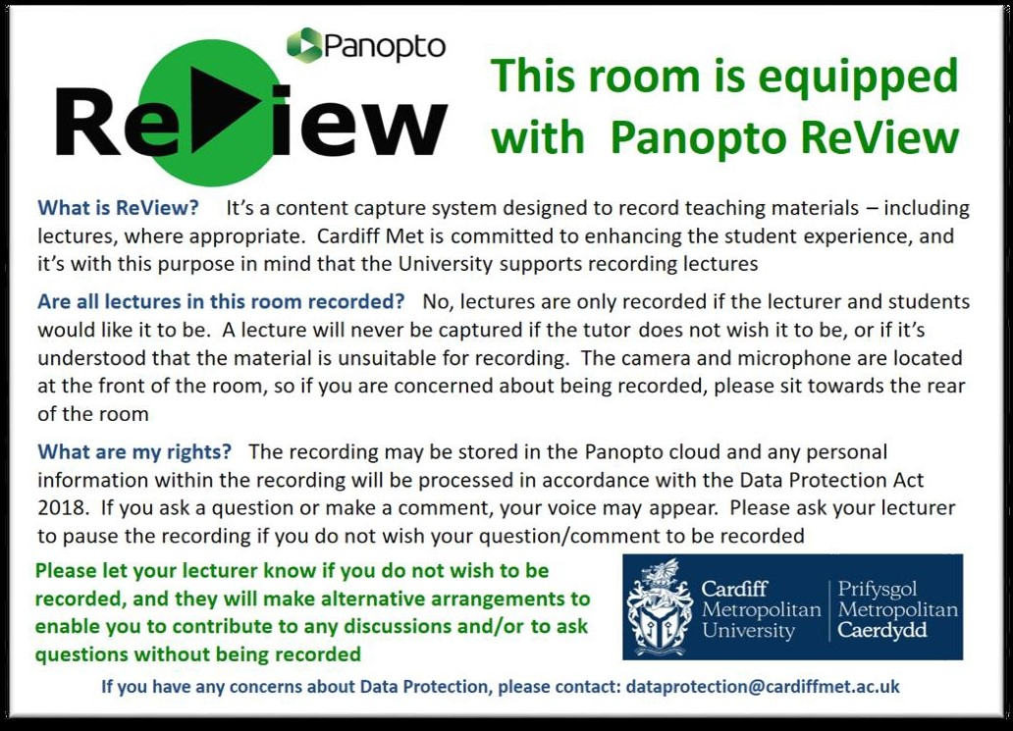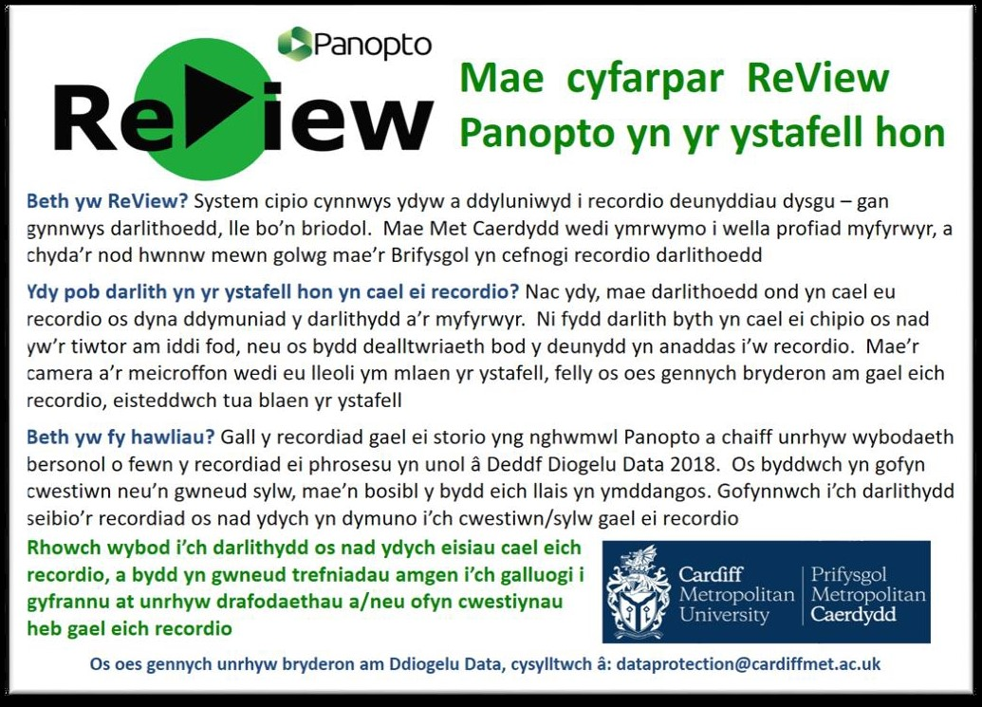

Appendix B
(Staff are advised to add this PowerPoint slide to their presentation to reinforce student guidance)
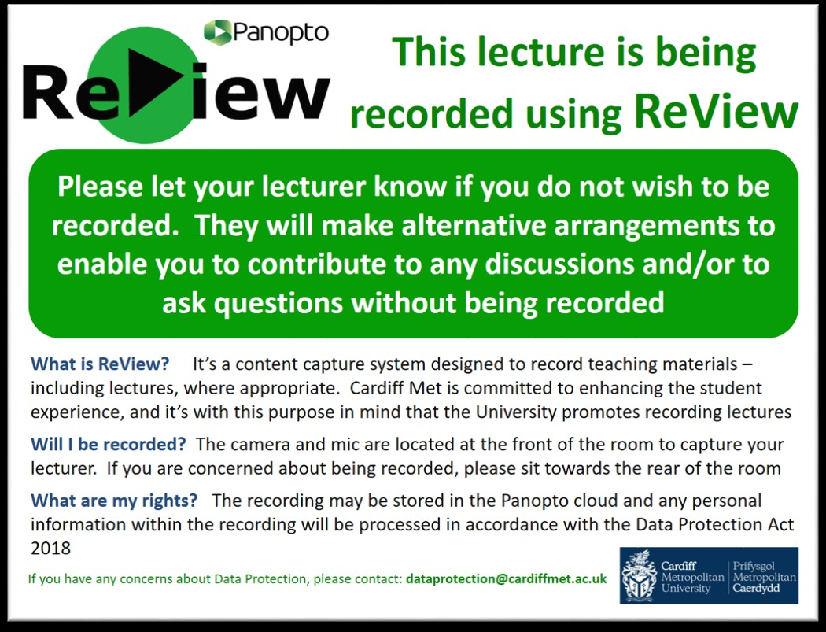

Appendix C
(Support notices placed next to teaching PCs in rooms equipped with Panopto ReView)
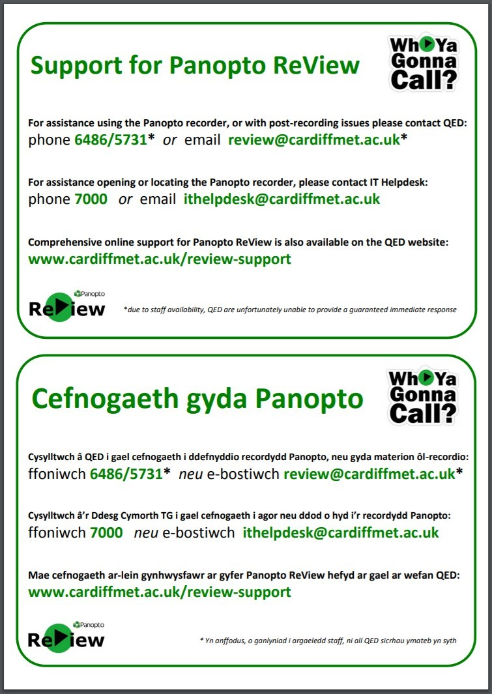

Appendix D

Panopto ReView good practice
The following guidance is offered to staff to support them in using Panopto ReView most effectively.

Provision of facilities, support and training
Cardiff Met has invested in Panopto software, audio & video hardware, and staff support to facilitate the recording of lectures and other electronic content. The University is keen to ensure that these opportunities are maximised and used most effectively - to positively impact the student experience.

Licence
Under the terms of the license that Cardiff Met has purchased from Panopto EMEA, the recording software can be downloaded and installed on any Cardiff Met device. This means that capture can take place wherever and whenever appropriate – maximising the benefits that can be realised.
Cardiff Met’s has purchased a ‘hosted solution’, where a remote server is used to process and store recordings. This minimises impact on local technical support, as maintenance and storage capacity are managed elsewhere. The Panopto license also includes a staff support package – so Cardiff Met staff can draw upon technical support for any issues relating to the uploading, processing and sharing of recordings (for more details on support, please see below)

Facilities
The programme to install Panopto recording software, a wide-angle webcam and omnidirectional microphone into a total of around 90 teaching spaces, began in 2016 and was completed in 2018. This provides Panopto ReView facilities in most Cardiff Met pool teaching spaces, facilitating capture of face-to-face teaching sessions. Staff are able to confirm what teaching spaces have been equipped, by accessing the room list on the Panopto ReView support website here: http://www.cardiffmet.ac.uk/about/ltdu/Pages/Panopto-ReView-support.aspx

Training
Workshops are provided for staff wishing to explore Panopto ReView. These sessions combine an insight into pedagogic aspects of the facility, with practical guidance and advice on how to use the software. The workshops are widely promoted via the InSite staff intranet webpages, and
colleagues can book onto ‘Getting started with Panopto ReView’ via the Organisational Development Learning Pool training pages. Bespoke workshops are also available to for specific user groups, such as Module or Programme teams.

Support
A specialist Learning Developer has been employed to provide support on both the pedagogic and practical use of the system – to facilitate improved proficiency, confidence and creativity in teaching via this medium. In order to produce high quality recordings, lecturers need to be supported in this developing pedagogy – potentially seeing part of their role as an effective on-screen presenter.
Technical support is provided via a three-tier approach, which although fails to provide staff with a single point-of-contact, does deliver a comprehensive approach, within the available resource. The support breaks down as follows:

    - Staff experiencing any difficulties accessing or opening the Panopto recorder software should contact IT Helpdesk, by phoning extension 7000 or emailing ithelpdesk@cardiffmet.ac.uk

    - Staff requiring assistance with logging-on or using the Panopto recorder, should contact QED, via extensions 6486/5731 or emailing review@cardiffmet.ac.uk
    - Staff experiencing post-recording issues should initially contact QED (via extensions 6486/5731 or emailing review@cardiffmet.ac.uk) and the issue will be forwarded to Panopto support via email, on support@panopto.com

Support elements from both IT Helpdesk and Panopto.com (this is included as part of our hosted solution) are provided on a managed approach with call-logging and guaranteed service levels. However due to the small team of just two Learning Developers, support provided by QED is on the basis of availability. This is made explicit to those wishing to use Panopto ReView, both at the time of account creation, and also during training workshops. This is also reinforced by the bilingual support notices placed next to teaching PCs, in rooms where Panopto ReView is available (please see Appendix C). Any email sent to the review@cardiffmet.ac.uk email address will also receive an initial automatic reply, informing the sender that a full response will be forthcoming as soon as possible.
At present, this model of support is proving sufficient, but it is acknowledged that this may in future not meet staff needs and is thus an area for further exploration and potential investment. In an attempt to provide staff with adequate guidance and technical advice at the time required, comprehensive on-line support materials have been developed.

A Panopto ReView support site has been created at: http://www.cardiffmet.ac.uk/about/ltdu/Pages/Panopto- ReView-support.aspx, with a short URL re-direct at www.cardiffmet.ac.uk/review-support to allow easier access for staff. Guidance is provided in the form of PDF how-to guides which can be easily viewed on any device, or printed out for reference. These take a step-by-step approach, with pictorial support such as screen-shots, to support staff through different processes. FAQs, handy reminders, and useful resources are also provided to promote autonomy and independence by staff in their use of the system.

The recording approach

The type of session
Certain forms of learning content are better suited to being recorded via Panopto ReView. Reasons for this may include because they contain particularly difficult or dense content, or because students wish to revisit the material many times. In this latter instance, Panopto ReView can be used to assist staff in offsetting multiple student enquiries, by providing information in flexible form.
Sessions which may work particularly well include:

    - Induction content
    - Whole-group assignment feedback
    - Didactic lecture content (which can be recorded to facilitate ‘flipping’ the classroom)
    - Revision sessions
    - Exemplars and case studies

Conversely some sessions are less appropriate for recording, such as:

    - Interactive sessions (effective audio/video capture can problematical, and students may be less willing to participate if recorded)
    - Sessions where confidentiality or ethical considerations may be an issue

Staff are encouraged to reflect upon what content yields greatest value from being recorded, and identify where it will most positively impact the student experience.

Making recordings
Staff should also be aware that it is often beneficial to provide smaller ‘bite-size’ recordings (e.g. 15- 20 minutes duration) rather than delivering a whole 45-60 minute lecture. Most content can be subdivided into smaller elements, and this approach benefits students’ use of recordings

In some situations, it may be more appropriate to simply record audio and screen capture, rather than using the webcam to capture visual content. This could placate concerns from both staff and students about being captured, and thus facilitate recording of sessions where it would otherwise have been precluded. The procedure to switch off the webcam is very simple, and can easily be actioned from the recorder software. Recording audio-only can also provide a practical solution for staff who through choice or necessity, struggle to remain in-shot at the front of the teaching space.

The microphones that have been installed in teaching rooms, feature an omnidirectional pick-up pattern which enables audio capture within approximately 3m of the mic. Therefore, by opting for audio-only, staff are able to move around more, whilst their narrative is still captured. Furthermore, it is good practice for a lecturer, when appropriate, to repeat questions from the student audience - as their voice will be captured more clearly than those further away.

Although the audio-only approach may be useful in certain circumstances, greater engagement is often generated by students being able to see their tutor, creating a more meaningful and fulfilling online experience. Effective learning incorporates both social and intellectual elements, and therefore the additional personification provided by the visual content can add great value. Students may engage with recordings more deeply, and for a greater length of time. Therefore, staff are encouraged to capture video in addition to audio, if circumstances allow.

Students’ participation in recordings
Whilst students have the right to simply opt-out of recordings, there may be occasions where it would be advantageous to seek compromise, and certain practical steps can be taken to facilitate this:

    - Audio and screen capture recording only (i.e. no camera – just voice and related PowerPoint slides). This may assuage concerns and vulnerabilities over visual capture
    - Encouraging staff in the use of the Pause button to temporarily pause recordings during more sensitive/interactive elements of the session
    - Training and supporting staff (via the planned Intermediate workshop) in editing recordings prior to publication

Students’ access to Panopto ReView recordings
Staff are advised to use the full web interface, as this offers students the added the value provided by the interface features. These include the ability to:

    - Easily manage recordings via the chronological navigation derived from PowerPoint slides
    - Rewind 10-seconds to quickly recap and regain focus
    - Search for key terms in the recording (which could be ‘muddy points’ in students’ learning)
    - Speed up, pause, or slow down the recording

    - Configure the interface to give priority to different elements and adapt to different learning preferences

Panopto was integrated with Moodle in April 2018, and this facilitated straightforward inclusion of Panopto content within the VLE, as well as improved security of recordings, and the facility for students to record Panopto ReView content themselves.

