Collaborative research

What is collaborative research?
Collaborative research is research carried out by multiple people or agencies, often with each bringing a particular specialism to the research and eventual output. Collaboration can allow the research team to pool knowledge, ideas and experience.

What can Cardiff Met offer in this regard?
Cardiff Met engages in research that is at the interface of new knowledge creation and its application. We offer expert solutions designed to inspire innovation and improve performance. With an excellent track record in applied research, supported by a strong base of expertise and advanced scholarship, the university's research has direct application in business, industry, the professions and the community at large.

How can Cardiff Met help your business in the field of sustainable development and eco-innovation?
Applied research and knowledge transfer are recognised as key drivers in pushing forward sustainable development and eco-innovation agendas. Cardiff Met has an established track record working with business. Get in touch to identify opportunities for collaboration with your business.

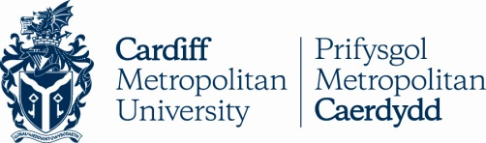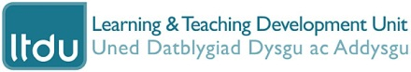

Opportunities for collaboration with Cardiff Metropolitan University in the field of sustainable development

Does your business face a sustainability oriented problem Cardiff Met could help solve?

Are you confronting a burning issue that would benefit from the attention of fresh eyes and minds?

Does your organisation harbour opportunities yet to be realised?

If any of the following forms of collaborative engagement with Cardiff Met could benefit your business please get in touch with Stuart Abbott (Learning Development Officer) who will be happy to progress your enquiry:
sabbott@cardiffmet.ac.uk or 029 2020 5736
Live projects

What is a live project?
A live project usually involves students working to a real world client brief, set by real world clients, who have real world needs and success criteria.

What are the aims of live projects?
Projects will often address real world sustainable development issues, problems or topics with a view to students devising prototype solutions or making practical recommendations for change which enhance current organisational practice.

How could a live project benefit your business?
Posing and supporting a live project client brief to Cardiff Met students will enable your business to access a wealth of cutting edge knowledge, talent and skills in disciplines relevant to your business. Set a real world brief, receive multiple proposals enabling you to work together to identify the ideal solution for you.

How do live projects benefit learners?
Live projects create valuable opportunity for students to engage in participatory approaches to the tackling of sustainability related issues in authentic professional settings, using local knowledge to devise innovative solutions.
Student placements

What would be a suitable work placement?
Ideally the placement would involve a project spanning about 20 working days, in addition to any routine work, which helps the student develop their employability skills.

Are there costs involved?
Employers are not asked to pay wages, travel or subsistence. However prolonged duties undertaken by a student for which
an employer would otherwise require a paid employee should be compensated. Unpaid placements exceeding 30 working days are discouraged.

How long does a placement last?
Most students complete 20 days around their studies either working one or two days a week during term time or full-time during holidays. Alternatively we run a 10 week summer module and an industrial year-out module.

Who selects the student?
The decision lies with the work placement provider. When the position is competitive the work based learning team will endeavour to help select suitable candidates for interview.

