Using Microsoft PowerPoint to create a PDF portfolio

PowerPoint can be used to create a simple but effective portfolio of your work. The slides of the PowerPoint presentation will become the pages of your portfolio.

Resizing your slides (optional)

When you open a PowerPoint presentation, you may want to customise the size of the slides that will eventually become the pages of your portfolio. To do this, click on the ‘design tab’ and look for the ‘slide size’. You will see a ‘customise’ option.

In there you can change the size of the slides to your own preferred size. You can even use pixel measurements by typing ‘px’ at the end of the number. For example I have set the width to 1280 pixels below:

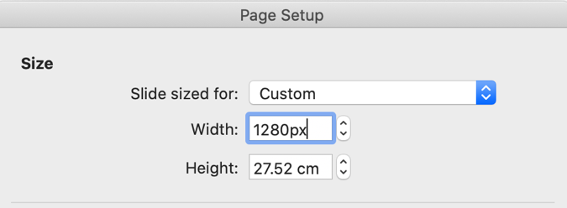

Your First Slide

On the first slide add your name, your UCAS number, and the programme or programmes you are applying for.

Adding a new slide

Every slide will become a page in your portfolio. To add a new slide, in the toolbar go to:

insert > new slide

Adding images to your PowerPoint presentation

Go to insert > picture > picture from file to load an image from your computer.

When using large high-quality images

If the images you are placing in your PowerPoint presentation are very high quality, that could make the file size (in megabytes or ‘MB’) too big to easily send over the internet.

If you encounter any problems sending your PDF to us and you think the PDF file size may be too big, try reducing the file size of the images. To do this, go to file > compress pictures and change the picture quality to onscreen (150ppi) before exporting the PDF.

Adding a link to your portfolio

It is not recommended that you try and add video files to your PDF portfolio, because this can make the file size of the PDF too big. Much better to upload your video to a video hosting website such as youtube or vimeo and create a link to the web page on your portfolio.
To turn text into a link, select the text you would like to turn into a link, then go to insert > link.

In the window that opens, add the web address of the page to which you would like to link.

Exporting your finished PowerPoint presentation as a PDF portfolio

When you’re ready to export your finished PDF, go to file > export.

Name the document as your name to make it easy for us to identify who it belongs to.
Choose the file format: PDF

