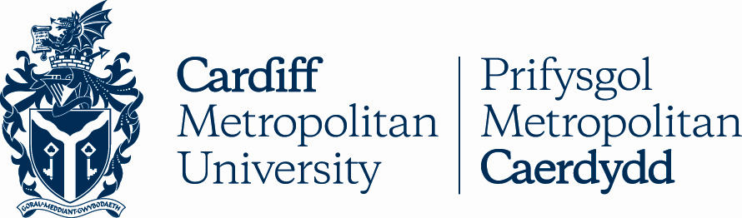

10.8

REGULATIONS FOR GRADUATE CERTIFICATES AND GRADUATE DIPLOMAS

Key Details
POLICY TITLE | Regulations for Graduate Certificates and Graduate Diplomas
DATE APPROVED | 19 Jun 2008
APPROVING BODY | Academic Board via AQSC
VERSION | 5
PREVIOUS REVIEW DATES | Sep 2008, Aug 2011, Mar 2012, Jul 2019
NEXT REVIEW DATE
OUTCOME OF EQUALITY IMPACT ASSESSMENT
RELATED POLICIES / PROCEDURES / GUIDANCE | Academic Handbook Ah1_10 (cardiffmet.ac.uk)
IMPLEMENTATION DATE | 19 Jun 2008
POLICY OWNER (JOB TITLE) | Director of Registry Services
UNIT / SERVICE | Registry Services
CONTACT EMAIL | regulations@cardiffmet.ac.uk

Version Control
VERSION | DATE | REASON FOR CHANGE

Regulations for Graduate Certificates and Graduate Diplomas
These regulations are subordinate to Cardiff Metropolitan University’s general Assessment Regulations.

General
- These regulations govern the award of Graduate Certificate and Graduate Diploma.

- Candidates may qualify for the award of a Graduate Certificate or Graduate Diploma offered by the University under these regulations upon successful completion of an approved modular programme of study provided either on a full-time or on a part-time basis at the University, or at another institution approved by the University for this purpose. The academic content of a part-time scheme shall be equivalent to that of a full-time scheme.

- Candidates admitted to a Graduate Diploma programme may qualify for the intermediate award of the Graduate Certificate, the structure of such programmes complying with the requirements of the University’s Modular Programmes Framework.

- All candidates must register as students of Cardiff Metropolitan University at the commencement of study and pay the appropriate fee.

Entry
- To be eligible for admittance to study for a Graduate Certificate or Diploma programme, a candidate shall:

  - have qualified for an initial degree of another University approved for the purpose, or hold another qualification which is recognised by Cardiff Metropolitan University as being of graduate equivalence;

  - have fulfilled any further entry conditions which may be required by the University and/or collaborative partner institution in respect of the programme in question.

Programme Structure
- Graduate Certificate and Diploma Programmes shall be offered on the basis of an approved one-year full-time equivalent period of study

- Candidates for a Graduate Certificate shall be required to pursue a minimum of 60 credits at CQFW Level 6 (HE Level 3) or above; candidates for a Graduate Diploma shall be required to pursue a minimum of 120 credits at CQFW Level 6 (HE Level 3) or above.

Credit Transfer
- Notwithstanding paragraphs 6 and 7 above, within the overall limits shown below, the performance of a student in either study previously pursued and/or any prior experiential learning may be deemed to count towards the requirements for the award of Graduate Certificate or Diploma. Such prior study or experiential learning shall be relevant to the programme to be pursued and shall be credit-rated at the discretion of the University. The prior study shall have been completed at another University or Institution whose programmes have been recognised by the University for the purpose of satisfying its policy on Credit Accumulation and Transfer.

- The maximum number of credits which may be accepted to count towards a Graduate Certificate or Diploma award shall be:

Graduate Certificate : 30 credits at CQFW Level 6 (HE Level 3) Graduate Diploma : 60 credits at CQFW Level 6 (HE Level 3)

Assessment
- Progress of a candidate will normally be assessed in the period immediately following completion of the unit of study.

- The pass-mark for units of assessment, modules and awards shall be 40%.

- Every candidate for a Graduate Certificate shall complete all units of assessments within the following periods:

  - Full-time mode: not more than two years from the start of the programme;

  - Part-time mode: not more than four years from the start of the programme.

Every candidate for a Graduate Diploma shall complete all units of assessments within the following periods:

- Full-time mode: not more than two years from the start of the programme;

- Part-time mode: except as in (iii) below, not more than four years from the start of the programme.

- Part-time mode: for named Post Qualifying Social Work CPD programmes of study, not more than six years from the start of the programme.
The above time limits may be extended in exceptional cases on application by the School to the University’s Special Cases Committee.

The above time-limits may be reduced pro rata at the outset of the candidature where a candidate has been admitted to study with transferable credit, as described in paragraphs 8 and 9, above.

Assessment shall be in accordance with the University's general Assessment Regulations.

Failure
- At the discretion of the Examination Board, candidates who have been unsuccessful in any units of study which contribute to the award may be permitted up to two further attempts to redeem the failure in each such unit, for the bare pass-mark (50%) only.

Award
- Graduate Certificates and Graduate Diplomas are awarded to candidates who have:

  - Pursued an approved programme of study at Cardiff metropolitan University or at a collaborative partner institution, except as provided by paragraph 8 above;

  - Successfully met the requirements as laid down in these regulations;

  - Fulfilled any further condition(s) required by the University and/or its collaborative partner institution.

- Graduate Certificate

  - Except as in (ii) below, a Graduate Certificate is awarded to candidates who have successfully completed a minimum of 60 credits at Level 6.

  - In exceptional cases, a Graduate Certificate may be awarded to candidates who have successfully completed a minimum of 60 credits, of which a maximum of 20 credits may be at Levels 3, 4, or 5, and a minimum of 40 credits must be at Level 6.

- Graduate Diploma

  - Except as in (ii) below, a Graduate Diploma is awarded to candidates who have successfully completed a minimum of 120 credits at Level 6.
  - In exceptional cases, a Graduate Diploma may be awarded to candidates who have successfully completed a minimum of 120 credits, of which a maximum of 30 credits may be at Levels 3, 4 or 5, and a minimum of 90 credits must be at Level 6.

- Candidates who have pursued a minimum of 120 credits of a Graduate Diploma programme but find themselves unable subsequently to complete (or are not permitted to do so) may be awarded the exit qualification of a Graduate Certificate, provided that the criteria in 16 above have been met.

- Compensation for failure in assessment shall be in accordance with the provisions of the University’s general Assessment Regulations.

- In determining whether the award of a Graduate Certificate or Diploma might be made to a candidate, Examination Boards shall follow the University’s general Assessment Regulations. An Examination Board may take account of the candidate’s academic development throughout the programme of study.

- An Examination Board may recommend that, on the basis of a candidate’s performance in the pursuit of those credits contributing to the award of Graduate Certificate or Graduate Diploma, he/she be deemed either to have passed or to have failed the programme. Candidates with an overall mark of 70% or greater may be eligible for the relevant award with Distinction.

