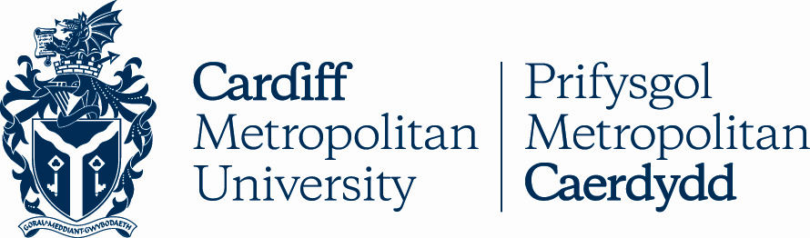

10.14

REGULATIONS FOR THE CARDIFF METROPOLITAN UNIVERSITY INTERNATIONAL FOUNDATION CERTIFICATE

Key Details
POLICY TITLE | Regulations for the Cardiff Metropolitan University International Foundation Certificate
DATE APPROVED | 01 Sep 2008
APPROVING BODY | Academic Board via AQSC
VERSION | 3
PREVIOUS REVIEW DATES | Dec 2015, Jun 2016, Jun 2022
NEXT REVIEW DATE | 2025
OUTCOME OF EQUALITY IMPACT ASSESSMENT
RELATED POLICIES / PROCEDURES / GUIDANCE | Academic Handbook Ah1_10 (cardiffmet.ac.uk)
IMPLEMENTATION DATE | 01 Sep 2008
POLICY OWNER (JOB TITLE) | Director of Registry Services
UNIT / SERVICE | Registry Services
CONTACT EMAIL | regulations@cardiffmet.ac.uk

Version Control
VERSION | DATE | REASON FOR CHANGE
Regulations for the International Foundation Certificate

Introduction

The International Foundation Certificate (IFC) provides academic and English language preparation for students wishing to enrol on an undergraduate degree programme at Cardiff Metropolitan University (or elsewhere).

Qualifying students receive a Cardiff Metropolitan University award and are normally offered a place on a Cardiff Metropolitan degree programme, subject to any other conditions attached to that progression.

Regulations

Admissions

The normal entry requirements for a student wishing to enter the IFC are that he/she must be able to demonstrate:

English language capability at a minimum level of or equivalent to an IELTS score of 4.5, with none of the four individual skills less than 4.0;

That he/she has successfully completed their high school education;

That he/she holds a relevant finishing certificate.

Structure

The programme shall be full-time and equivalent to one academic year of study. There would normally be two intakes in an academic year.

Compulsory Modules for the IFC will be equal to 60 credits

Optional Modules for the IFC and IFC (Pathways) will be equal to 60 credits. These credits may be generated from one of the following schools:
Cardiff School of Art & Design
Cardiff School of Education (including the ELTC) Cardiff School of Health Sciences
Cardiff School of Management Cardiff School of Sport

Assessment Regulations

The programme shall comply with the generality of Cardiff Metropolitan University’s Assessment Regulations.

Students will be deemed to have passed the programme to a level suitable for entry to degree level study if they achieve a pass mark of 40% in their assessments, subject to the compensation arrangements between and across modules as stipulated in the programme specification.

Students will receive a certificate and transcript.

Period of Candidature
This programme has a two year period of candidature.

